NEW SINGLE “BROKEN SON” – SEPT 3rd
24 DATE HEADLINE UK TOUR
PPL/PRSMOMENTUM FUND AWARD
GLASGOW / GRAVESEND SOLD OUT

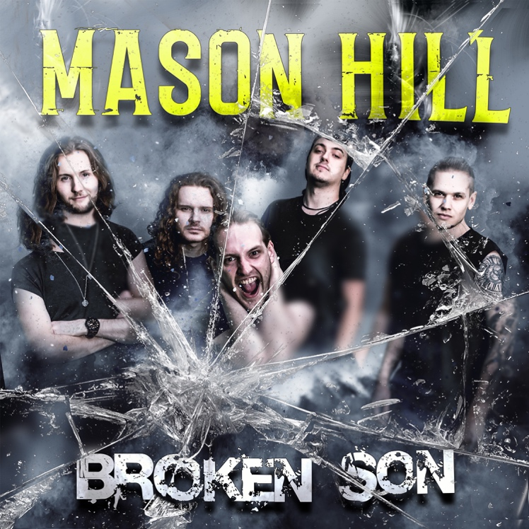

“The music really does the talking. Powered by enough energy to light up the national grid!” (Metal Hammer)
“Music supercharged by adversity. The long awaited, cathartic full length debut” (Kerrang!)
“Energetic, classy young hard rocker’s debut. It’s been worth the wait!” (Classic Rock Magazine)

Glaswegian rockers, Mason Hill, are fast becoming one of the new break through rock stories of 2021. Their debut album Against The Wall, released in March 2021, stormed the UK national album chart at number 19 and number 1 on the UK album rock chart, making it the first new British rock debut to chart in the top 20 since Royal Blood, 2014. The band are also thrilled to announce that they are to receive a PPL/PRS Momentum Fund award to enable them to record and market two new singles in 2022.

Not only do their album sales continue to sell well but the band’s second single D.N.A has now spent over 18 weeks in the German rock airplay chart and recently reached number 5 in the German national rock airplay chart, showing no signs of cooling off!

In support of their first ever UK headline club tour, the Mason Hill are now releasing a brand new single version of their track Broken Son, available on all DSP, September 3rd. With new guitar motifs, arrangements and new radio mix, the track will surely build on the US rock radio pick up which the track has been recently getting in the USA.

The UK Against The Wall headline tour will feature support from Hollowstar & Empyre, and is already looking like a great success with Gravesend and Glasgow selling out within weeks and many other venues close to sell out. Mason Hill recently blew their live performance cobwebs away with a highly acclaimed first performance in 18 months at the Steelhouse Festival and if that is anything to go buy, fans are in for a rollercoaster experience on the new tour!

It’s been an incredible achievement in 2021 for new British rock band, starting from an almost zero sales base and during a pandemic when there has been no traditional retail, no live shows or touring opportunities. With great reviews throughout the year, anticipation is now building for the band’s first ever UK headline club tour and it’s sure to be a highly charged, balls out return to power rock with raw attitude and passion.

BROKEN SON Single - Listen Here / Watch Here

UK headline Against The Wall tour dates and festival performances as follows:

Saturday 31st July BLACKPOOL Rockmantic Festival
Saturday 14th August SOUTHAMPTON Nozfest Festival
Sunday 22nd August FARNHAM Weyfest Festival
Thursday 2nd September ABERDEEN Tunnels
Friday 3rd September GLASGOW (SOLD OUT) Garage
Saturday 4th September GALASHIELS Macarts
Thursday 9th September DUBLIN Grand Social
Friday 10th September BELFAST Voodoo
Tuesday 14th September CAMBRIDGE Junction 2
Wednesday 15th September SHEFFIELD Corporation
Thursday 16th September BRISTOL Fleece
Friday 17th September BRIGHTON Patterns
Saturday 18th September GRAVESEND SOLD OUT) Leos
Monday 20th September CARDIFF Globe
Tuesday 21st September SOUTHAMPTON Joiners
Wednesday 22nd September BRADFORD Night Train
Thursday 23rd September BLACKPOOL Waterloo Music Bar
Friday 24th September LONDON Underworld
Saturday 25th September MANCHESTER Rebellion
Sunday 26th September WOLVERHAMPTON KK’s Steel Mill
Sunday 03rd October LEEDS Key Club
Monday 04th October NOTTINGHAM Rescue Rooms
Tuesday 05th October NORWICH Waterfront Studio
Wednesday 06th October NEWCASTLE Cluny 2
Thursday 07th October LIVERPOOL Arts Club
Friday 08th October DOVER Booking Hall
Saturday 09th October OXFORD Academy 2

Tickets are priced at from £12 and can be purchased via www.myticket.co.uk

Lead singer, Scott Taylor, has said: “This year has been totally bonkers! We knew we had an album we were very proud of but we’re extremely humbled at the reception Against The Wall has received; needless to say, it’s been an extremely bright light for us during this long COVID tunnel. We can’t wait for the Against The Wall tour to commence and are thrilled that we’ve already sold out Glasgow and Gravesend. See you all down the front!”

Mason Hill are Scott Taylor (lead vocals), James Bird (lead guitar), Marc Montgomery (guitar), Matthew Ward (bass) and Craig McFetridge (drums)

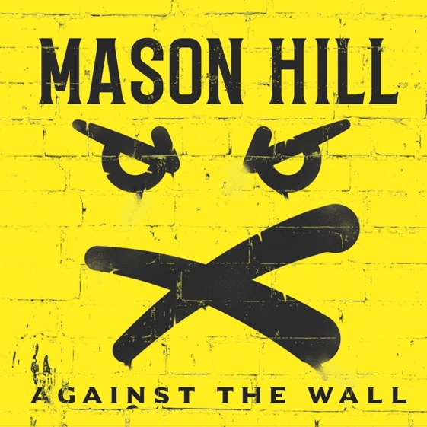

https://7hz.lnk.to/AgainstTheWallAlbum

For more information please contact Warren or Jenny @chuffmedia.com

