
SHARES NEW SINGLE
‘BOYS DON’T CRY’
OUT NOW
THIRD TRACK UNVEILED FROM FORTHCOMING ALBUM
‘EVERYWHERE I WENT LED ME TO WHERE I DIDN’T WANT TO BE’
SET FOR RELEASE AUGUST 15th 2025
HEADLINING RADIO 1’S BIG WEEKEND ON FRIDAY 23RD MAY
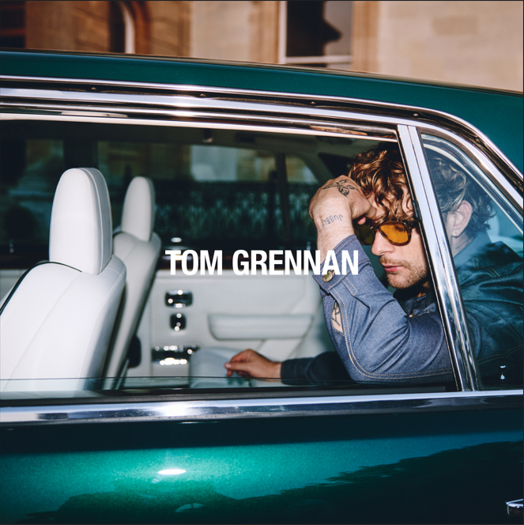
SINGLE ARTWORK
PRE-ORDER ALBUM HERE

TOM GRENNAN has today (March 14th) shared new single ‘Boys Don't Cry’, the third track to be unveiled from his upcoming album, ‘Everywhere I Went Led Me To Where I Didn't Want To Be’, which is released on August 15th via Insanity Records. The single coincides with the announcement earlier this week that TOM GRENNAN will headline Radio 1’s Big Weekend on May 23rd.
A stirring pop anthem with a swaggering 80s groove and warm synth melodies swirling around Tom’s rousing vocal delivery, ‘Boys Don’t Cry’ is another gem from an artist who possesses a gift for wrapping serious messages in euphoric singalong hooks, its lyric tackling mental health and men opening up about their feelings.

“I'm an emotional person,” Tom says. “In a lot of towns, especially where I come from, there's still this stigma around emotion. Men are told they need to be about football, beer, and zero emotions. Boys Don't Cry is the tonic to the negative “man up” usage, a term used by us lads who find it hard to deal with other vulnerability and infact our own. It’s the song that helped me go, ‘do you know what? I'm comfortable with being able to cry and process emotions, I call my mum or my missus and some friends who have also struggled but since passed the barrier . It’s a difficult situation being a lad around people when they get emotional, or being emotional yourself and talking about it. So let’s have that conversation.”

It follows recent singles ‘Higher’ and ‘Shadowboxing’ and further showcases the thrilling evolution of one of UK’s most exciting talents at his creative best. Tom teamed up with producer Justin Tranter for his fourth album, creating a state-of-the-art pop record. The 15-track album is the multi-platinum-selling artist’s fourth and serves as the eagerly awaited follow-up to 2023’s ‘What Ifs & Maybes’. Coinciding with the album release, Tom Grennan will embark on his biggest UK & Ireland arena tour to date this September, with 11 dates announced for the GRENNAN '25 tour.

With two number one albums under his belt alongside multiple Brit and Ivor Novello nominations, countless airplay smashes, sold-out arena tours and an MTV Award for Best UK Act, Tom Grennan is already one of the country’s biggest artists. Last August saw the Bedford-born artist headline his biggest show to date to a capacity crowd of 25,000 at Gunnersbury Park.

Keen to explore a new sound, Tom enlisted the songwriter and producer behind hits for Dua Lipa & Chappell Roan and found in Tranter a collaborator who understood exactly what he wanted to say and what he wanted to sound like: George Michael, Prince, Freddie Mercury. “So much of the new music is uplifting — it makes you dance, makes you sing,” Tom says.

“It's about my fight with a side of me I have a lot of trouble with. It’s still a daily battle. But I’ve learned how to fight all these demons and I’m mentally and physically prepared now. I’m in athlete mode.”

While the title alludes to a time when Tom faced challenges with his mental health, ‘Everywhere I Went Led Me To Where I Didn't Want To Be’ is a positive album about self-belief and having the confidence to take risks. “This album is about me, revived. Now I'm at a place where I DO want to be. And I'm ready to blow people's heads off.”

It is set to be a stunning addition to Tom Grennan’s already-impressive discography, which has seen him accumulate over 1.5 million album sales and 2.5 billion streams across his gold-selling debut Lighting Matches (2018), his first UK Number One album Evering Road (2021) and What Ifs & Maybes (2023), another Number One and Tom’s third gold-selling album in a row. Tom Grennan’s recent Top 3 festive smash ‘It Can’t Be Christmas (Amazon Music Original)’ immediately gained silver certification in its first run at the Christmas title. Tom achieved his highest ever singles chart for a solo release and was only narrowly held off the top spot by Christmas titans Wham! and Mariah Carey.

The album tracklisting is:
- Full Attention
- Cool With That
- Shadowboxing
- Boys Don’t Cry
- Somewhere Only We Go
- Shadows on the Ceiling
- Celebrate
- Higher
- Certified
- Diamond
- Dirty Dishes
- Cinnamon
- Drama Queen
- I Won’t Miss A Thing
- Lonely Dancer

GRENNAN ’25 UK & IRELAND TOUR DATES
September
Wed 3 Bournemouth - BIC
Thur 4 Birmingham - Utilita Arena
Sat 6 London – The O2
Tue 9 Cardiff – Utilita Arena
Wed 10 Nottingham – Motorpoint Arena
Thu 11 Glasgow – OVO Hydro
Sat 13 Dublin - 3Arena
Mon 15 Aberdeen - P&J Arena
Tues 16 Newcastle - Utilita Arena
Thur 18 Leeds - First Direct Arena
Fri 19 Manchester - Co-op Live


PRESS PHOTO (credit: Ed Cooke)

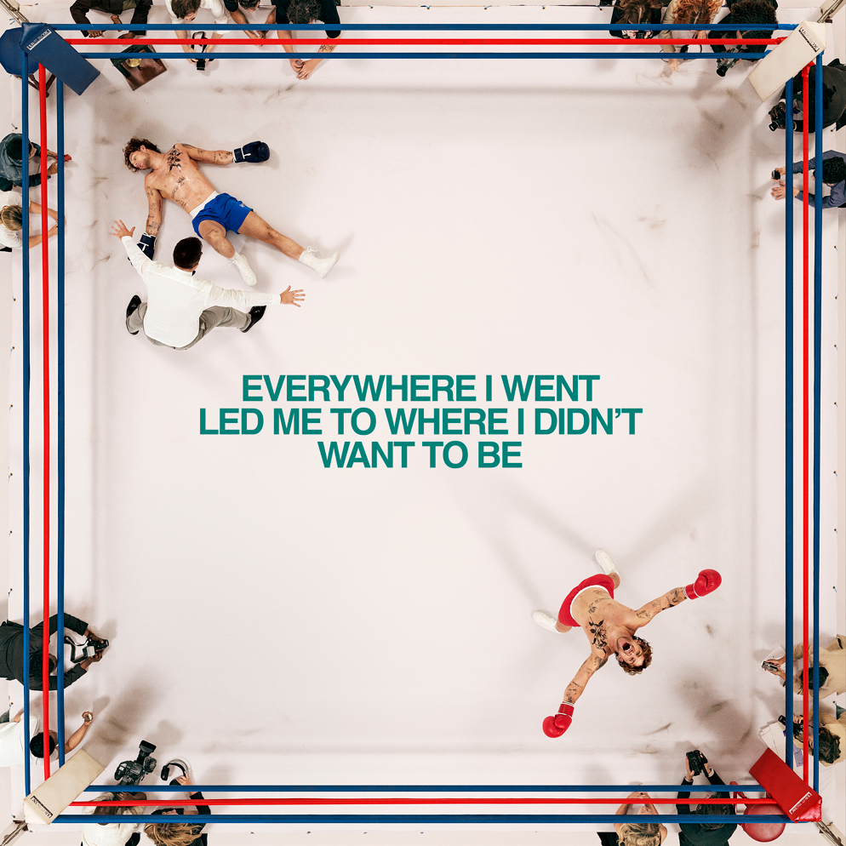
DOWNLOAD ALBUM ARTWORK

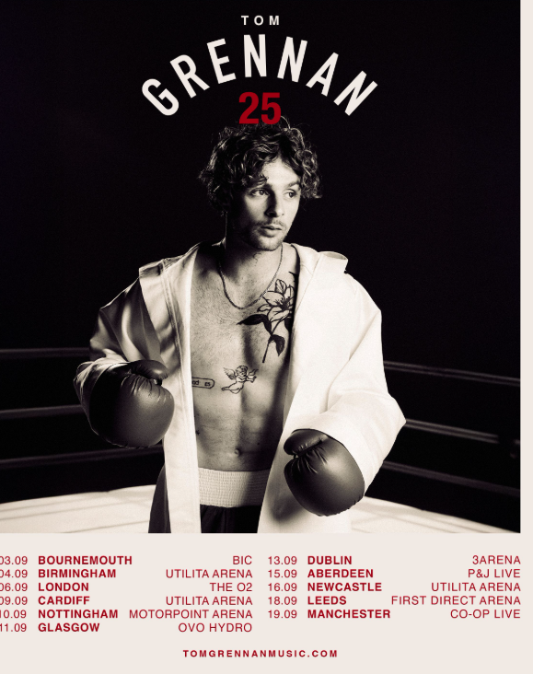

Connect with TOM GRENNAN

INSTAGRAM
TIK TOK
YOUTUBE
FACEBOOK
X

For more information and press enquiries for TOM GRENNAN please contact

Jenny Entwistle
Jenny@chuffmedia.com

