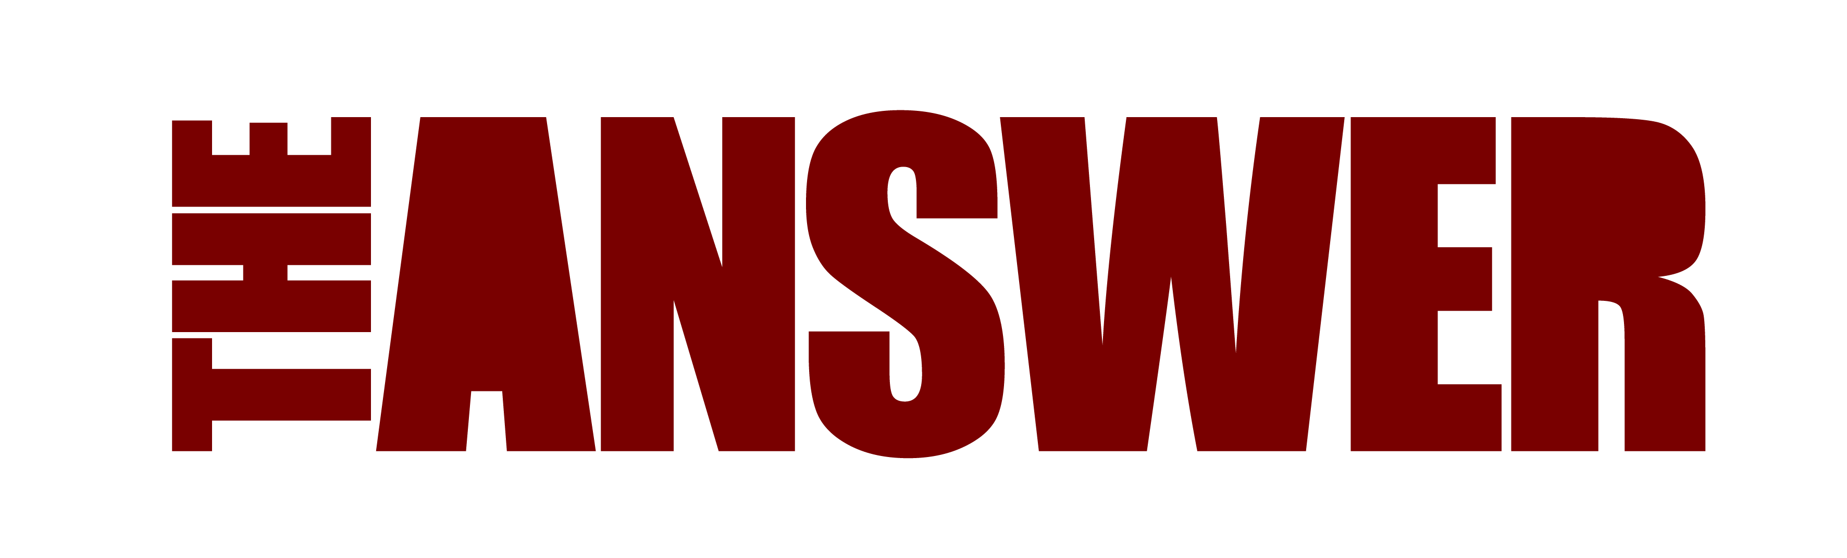
NEW SINGLE ‘BLOOD BROTHER’
RELEASED OCT 14th, 2022
New video for ‘Blood Brother’ released today
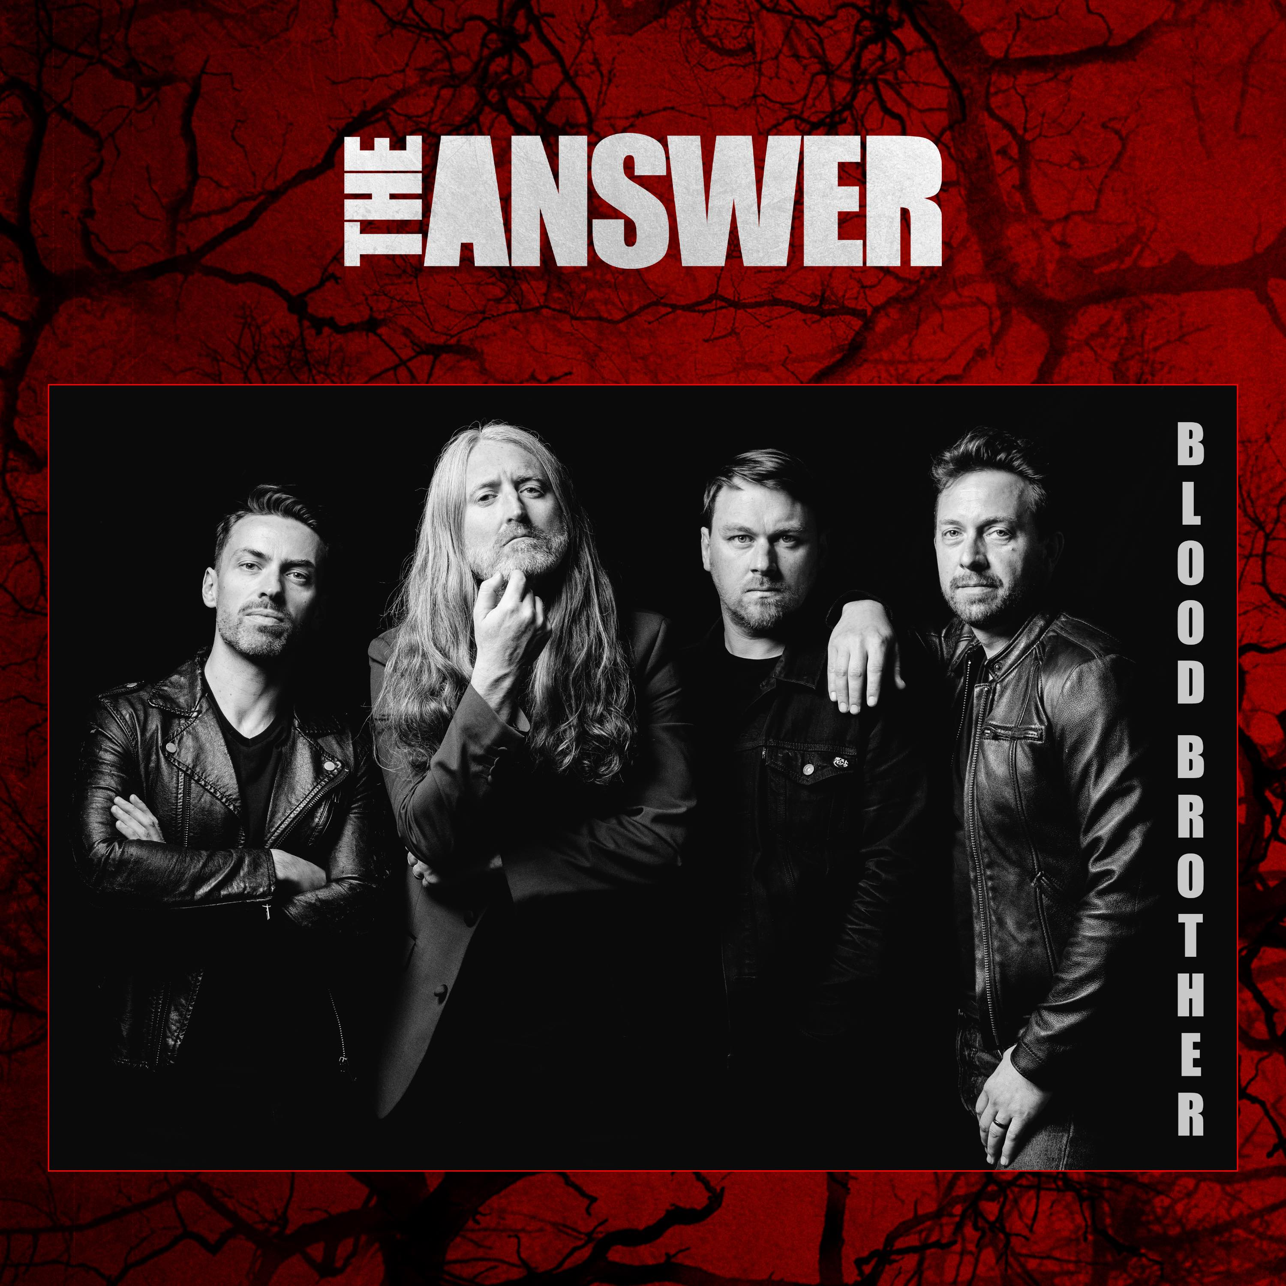
Blood Brother Video
On October 14th, Northern Irish rockers The Answer are set to make a spectacular and long-awaited return with their first studio single for almost seven years, ‘Blood Brother’. The band are delighted to give you the first listen to this fabulous track with their new video, released today.
The new track titled ‘Blood Brother’ has been produced and mixed by rising British rock producer Dan Weller (Enter Shikari, Bury Tomorrow) and will precede the bands comeback performance as special guests at the Planet Rockstock festival, Dec 3rd where fans will get their first taste of The Answer for a very long time with classic catalogue tracks as well as the latest music from their soon to be released new 7th studio album.
In support of this, the band have also announced a very special run of limited capacity UK and European album shows in March 2023 which will showcase the new album as well as classic The Answer tracks.
The new single ‘Blood Brother’ is power-keg anthem which sees the band hark back to their early 2006 sound but produced with a very contemporary alternative rock twist. It showcases a pounding minimalist rock groove with their trademark exceptional vocals from lead singer and front man Cormac Neeson.
Says Neeson “Our new track Blood Brother is a thundering slab of positive energy created by four brothers who quite frankly just really missed each other. We’re back and we had more fun writing and recording this new music than we’ve ever had. We truly believe this could possibly be the best album we’ve ever recorded and Blood Brother is a very special track for us!”

Undeniably, The Answer have achieved a great deal in their career to be proud of.

Emerging into the rock world spotlight in 2005, their debut single Keep Believin’ became the subject of critical acclaim and led The Answer to the ‘Best New Band’ award at that year’s Classic Rock Awards. The following year, the young band consolidated that early promise with ‘Rise’, a debut album that received universally great reviews went on to sell over 125,000 copies worldwide on the independent Albert Productions rock label, a startling debut achievement.

The ensuing years saw the band cement their fearsome reputation, both as an astonishing live band and as rock’s brightest hopes, securing high profile support slots with The Rolling Stones, Aerosmith, and a two-year stint on AC/DC’s 2008 Black Ice tour, which took them around the world and into some of the biggest venues on the planet.

“We were thrown to the wolves a lot of nights on the road with AC/DC and all we had to fall back on was the four of us playing together” recalls mercurial guitar hero Paul Mahon. “We had to make it work and dig in really hard. It was an incredible rock baptism”.

In 2019, long time uber fan and international independent hard rock label Golden Robot founder, Mark Alexander-Erber, fulfilled a life-long ambition by signing The Answer to his Golden Robot Records to secure a brand-new 7th studio album, due for release in 2023; a record which, in the words of Alexander-Erber will be The Answer’s “greatest balls out straight ahead rock album ever’, eclipsing the debut of Rise for power, songs and sheer attitude. To say I am excited is an understatement, for me it’s a life-long ambition and privilege to work with these guys”

With over 300,000 catalogue album sales under their belt and considered one of the forebearers of what is now colloquially known as the New Wave of Classic Rock, The Answer are thrilled to release Blood Brother, a track they feel represents a truly powerful comeback after a long time away from the scene.

Blood Brother: https://www.youtube.com/watch?v=Az1b2qJyeek

Spotify: https://ada.lnk.to/BloodBrother
Apple: https://music.apple.com/us/album/blood-brother/1640395077?ls=1

TOUR DATES

UK March 2023
Mar 16th Blackpool, Waterloo Bar
Mar 17th Birmingham O2 Institute.
Mar 19th Bristol Thekla
Mar 20th London 100 Club
Mar 21st Leeds Key Club
Mar 23rd Belfast Limelight 2

www.myticket.co.uk
www.ticketmaster.ie

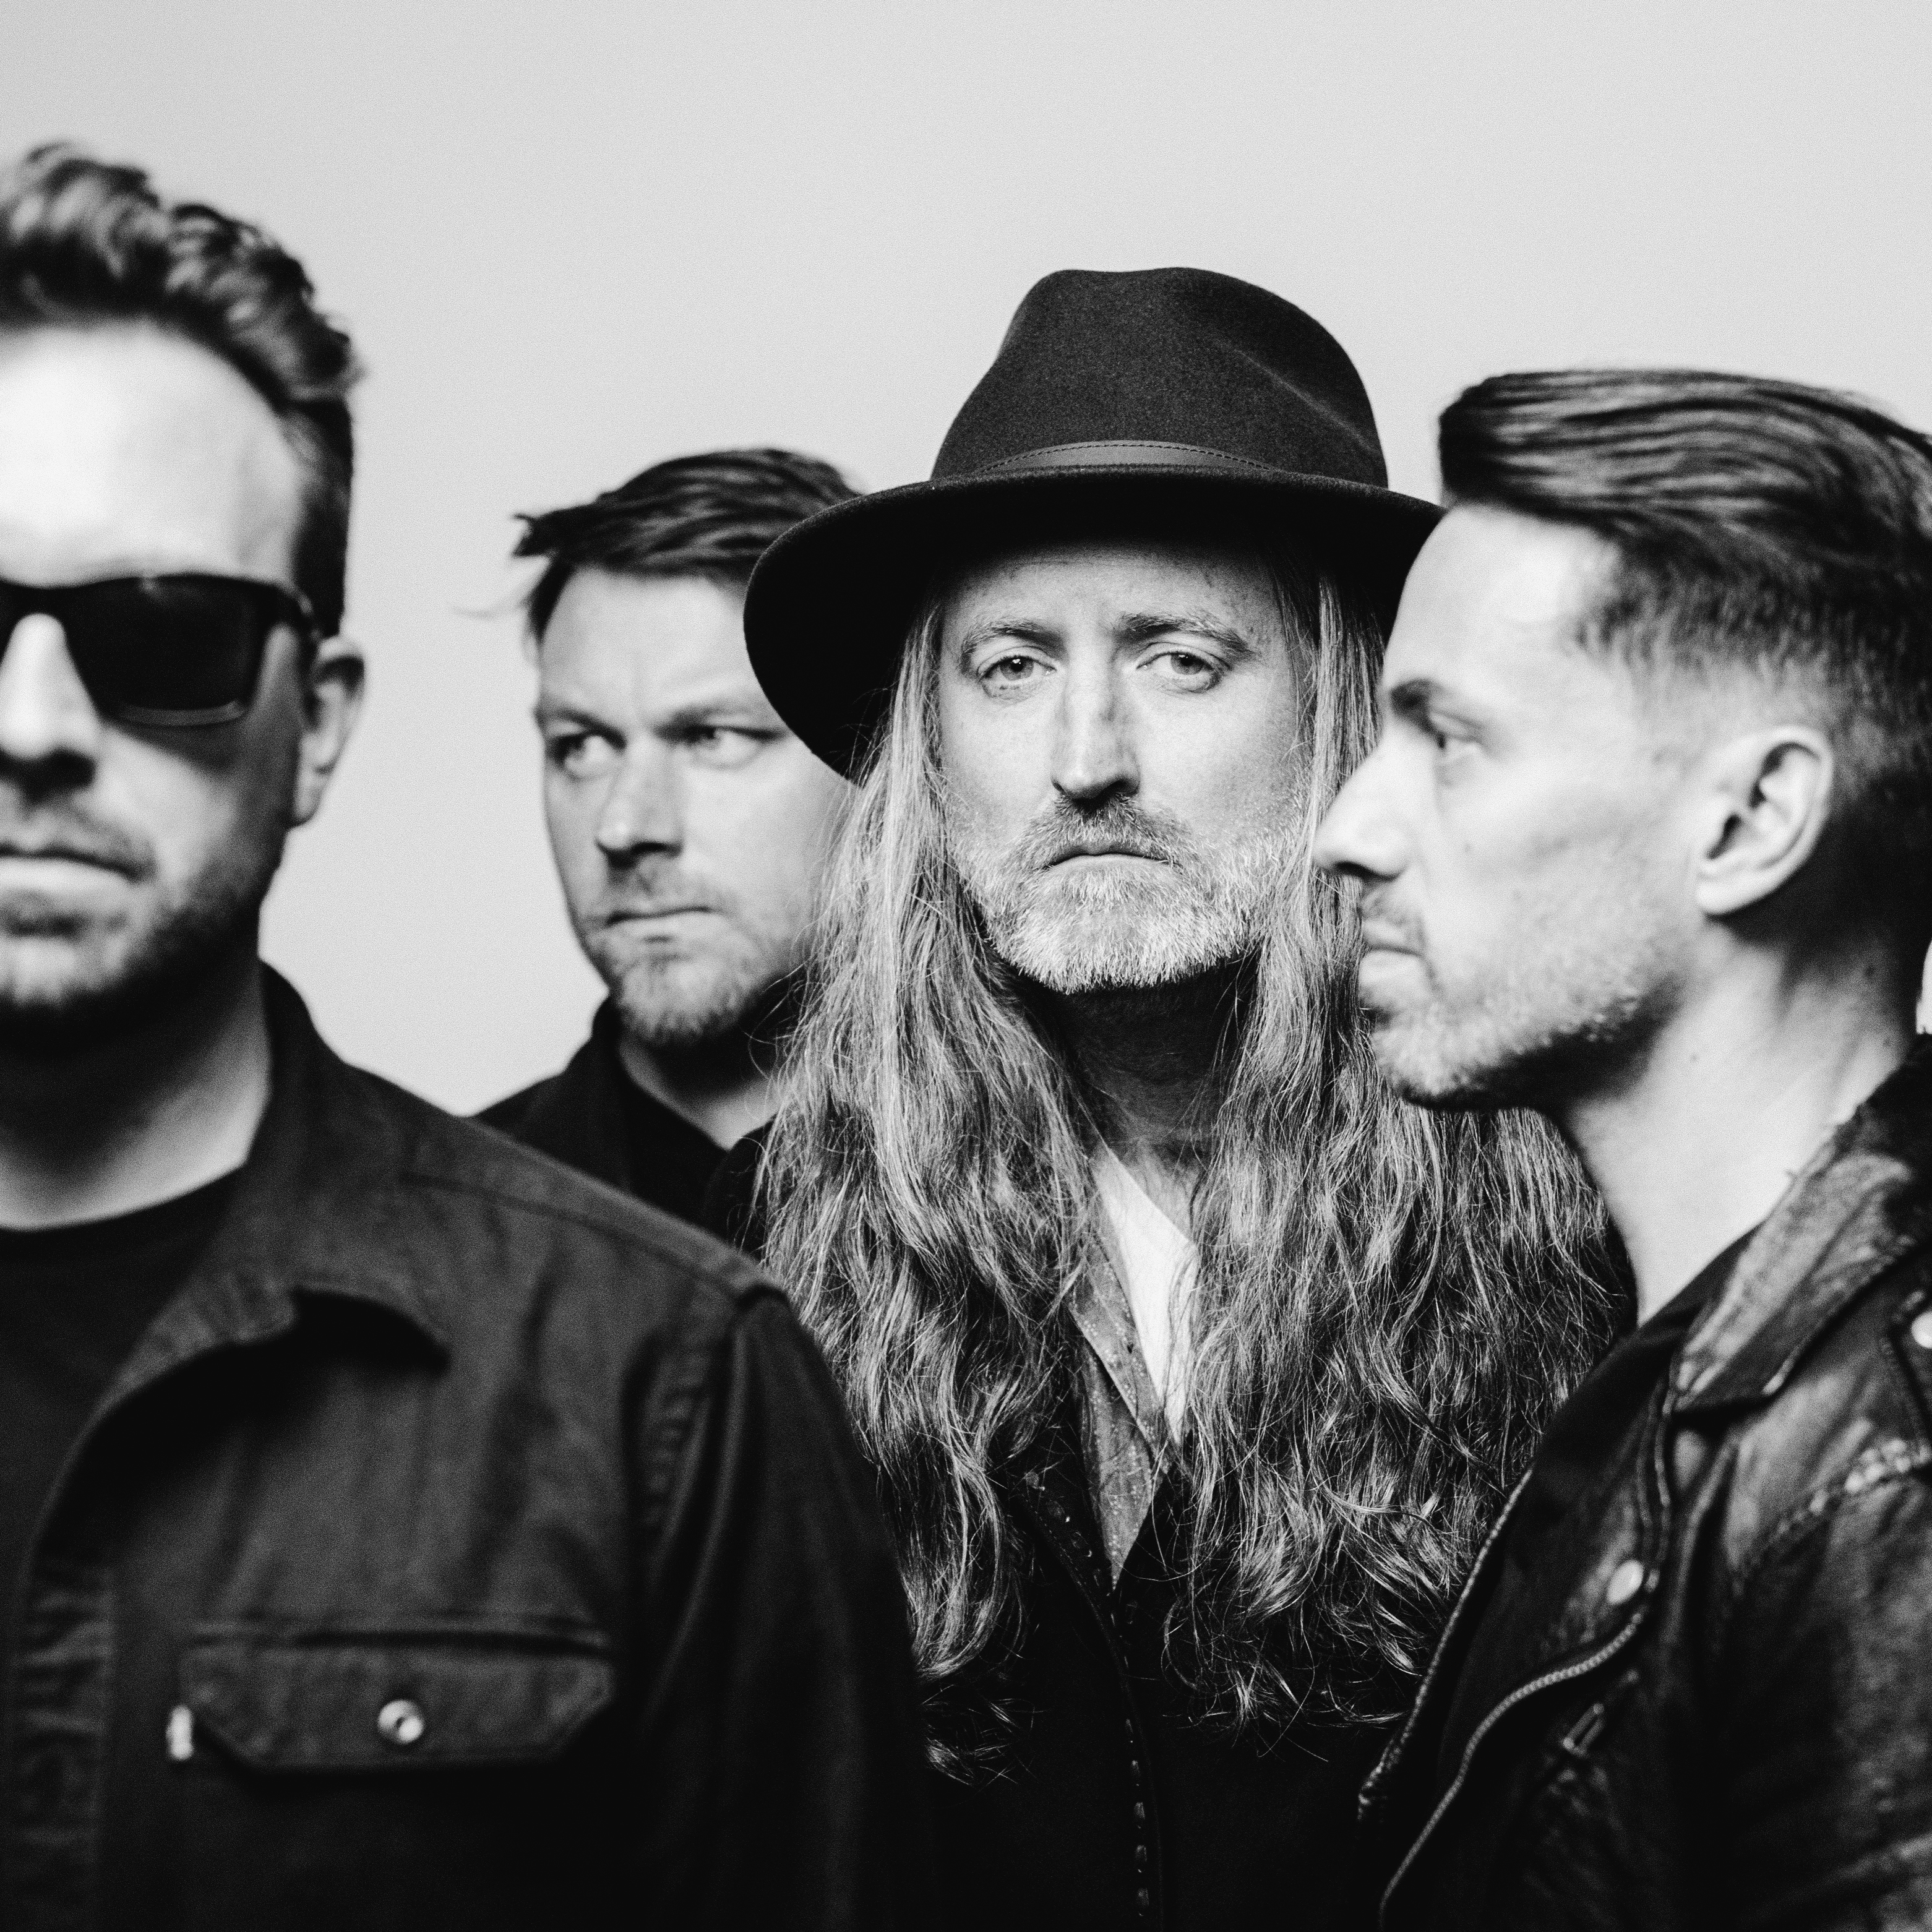

https://www.theanswerrock.com
https://www.facebook.com/theanswerrock
https://twitter.com/theanswerrocks
https://www.instagram.com/theanswerrock/?hl=en
https://open.spotify.com/artist/3STTKsLP1gSzGvOVCtNlWS?si=SYnSAgPTS3-Ji4AQvJbz4w

For more info contact Warren@chuffmedia.com

