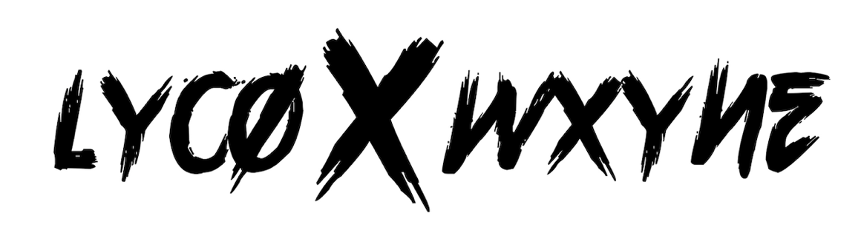

LYCO X WXYNE RETURN WITH NEW SUMMER DRENCHED SINGLE
‘BIRKIN PRICE’

WATCH HERE: lycoxwxyne.lnk.to/birkinprice

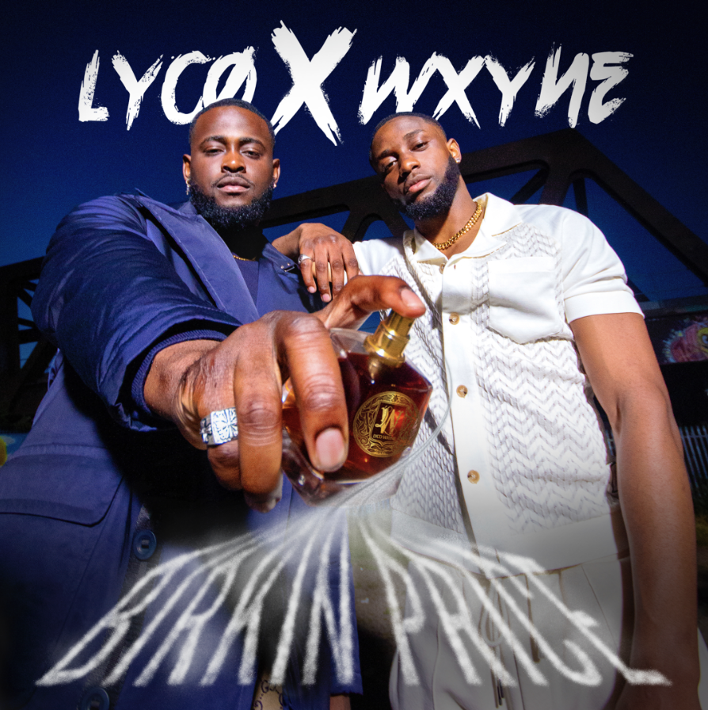

Breakout Birmingham duo LYCO X WXYNE are quickly rising to the top of the thriving midlands scene – making waves in the city and now nationwide. Posing as one of the most exciting and fresh acts to emerge from the East Midlands, the pair are gearing up for what is due to be another successful year ahead with their latest summer drenched release ‘Birkin Price.’
Set to be a staple in your soundtrack this summer, on the track LYCO X WXYNE say “Birkin Price is song that allows everyone and anyone to feel expensive we all deserve our moment to shine and this is it.”

Their recent single ‘Midlands’ created a viral moment across twitter racking up over 100,000 views on the teaser alone with the official video surpassing over 200,000 views and becoming one the most played songs on no signal radio to date. With a growing social presence the boys have also begun to amass serious numbers online for their tik toks & viral videos which are in the millions of views.

WXYNE, originally from Jamaica and LYCO, from Nigeria, discovered each other on Instagram and after swapping musical ideas over social media they decided they had to meet and began their musical journey. The music comes from a place of authenticity and melds different cultural influences to nail down a sound that’s true to them. WYYNE blesses the tracks with smooth melodies and Jamaican Patois, whilst LYCO offers soft sweet sounds mixed with his native Yoruba twang. Their a dynamic duo to keep your eyes and ears on.

FOLLOW LYCO
INSTAGRAM | TIK TOK | TWITTER

FOLLOW WXYNE
INSTAGRAM | TIK TOK | TWITTER

For more information please contact warren@chuffmedia.com on 07762 130510

