MULTI-PLATINUM-SELLING SINGER/SONGWRITER CALUM SCOTT DEBUTS NEW SINGLE “BIBLICAL” OUT NOW

WATCH THE “BIBLICAL” VIDEO HERE

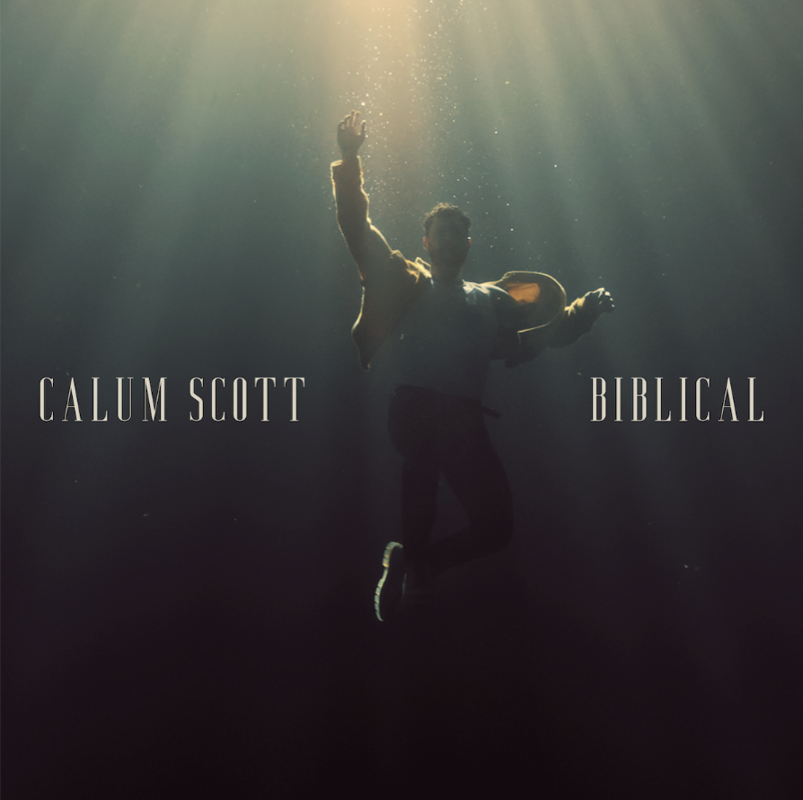

Multi-platinum-selling singer/songwriter Calum Scott returns with his soulful new single “Biblical” and its beautifully surreal video. The first single from his forthcoming sophomore album, “Biblical” is the artist’s first new music since his full-length debut Only Human — a 2018 release that hit No. 1 on the iTunes album chart in 21 countries across the globe, in addition to selling more than 3.6 million in adjusted album sales and amassing over 7.5 billion combined streams. Listen to “Biblical” HERE, and watch the video HERE.

Showcasing Scott’s soulful voice and deeply personal songwriting, “Biblical” speaks to the extraordinary power of unconditional love. “While I know it has spiritual connotations to many, ‘Biblical’ to me is about unquantifiable love, a love beyond description or measure, a love of biblical proportions that transcends everyone and everything,” says Scott. “If I can aspire for one thing for this song, it’s that the listener hears it and fits a name, a face, or a passion to the lyric and makes it their story.”

Directed by Franklin & Marchetta, the video for “Biblical” opens on Scott sitting alone in a desolate room, then cuts to an alternate reality in which various characters (including a ballet dancer, a violinist, and a bride and groom) drift along in an underwater reverie. By the end of the video, Scott has broken through the wall that separates him from that enchanted world, becoming blissfully submerged as well.

Produced by Jon Maguire and partly recorded at the legendary Abbey Road Studios, “Biblical” unfolds in moving piano melodies and delicate string work, building to a breathtaking cascade of harmonies at the bridge. “‘Biblical’ gave me contentment during a really awful time: it was a song that I had almost given up searching for, one that truly spoke to me. Finding a song you feel so connected to is the closest to magic you can get.” In sharing “Biblical” with the world, Scott hopes to provide listeners with the same sense of connection. “Lockdown had presented all of us a moment to realise how much people mean to us and how sometimes we take that for granted,” he says. “Singing that sentiment enabled me to release and reflect those emotions, immortalising them. The song means so much to me that I wanted to make it the first thing people hear when coming back with new music.”

With his sophomore album due out later this year, “Biblical” makes for a perfect introduction to the next era of Scott’s artistry, which finds him fully claiming his identity as a lyrical storyteller. “Having seen how my music had reacted with people over the last three years, it gave me an opportunity to absorb what I had experienced, to mature and become an artist with a mission,” says Scott. “I want to create something for people to feel seen, heard, and represented.”

To learn more about the inspiration behind “Biblical,” check out the song’s trailer HERE.

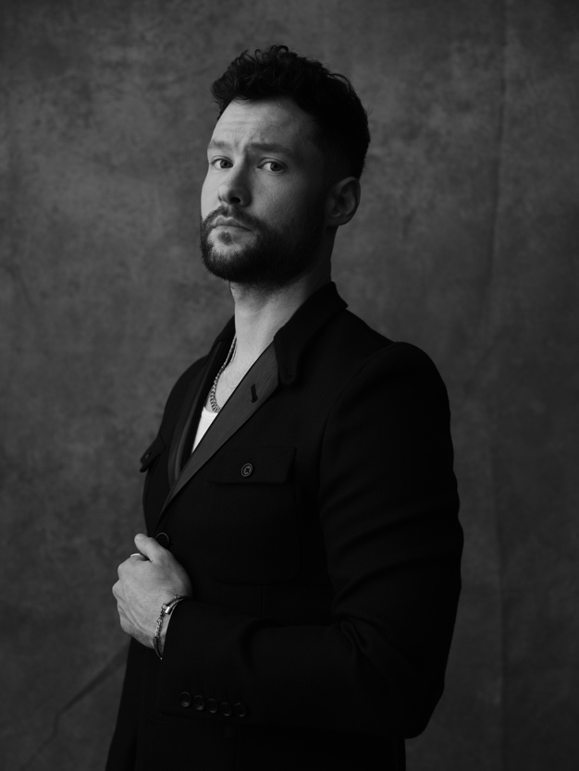
Download hi-res press image here, photo credit: Tom Cockram
Website // Instagram // Facebook // Twitter // YouTube

About Calum Scott:
With the arrival of his 2018 debut album Only Human, singer/songwriter Calum Scott landed at No. 1 on the iTunes album chart in over 20 countries around the world, amassing over 7.5 billion total global streams and counting. Now certified platinum or gold in 21 countries, Only Human includes his platinum-selling smash “You Are The Reason,” a track that cracked the top 25 on Spotify’s US Viral 50 and hit the top 10 on iTunes single charts in 38 countries. The album also features Scott’s stripped-back, platinum-certified cover of Robyn’s “Dancing On My Own,” which earned a Brit Award nomination in the category of Best British Single. His first new music since Only Human, Scott’s recent single “Biblical” marks an exciting evolution of his artistry, bringing even more raw emotion to his soulful and timeless sound. With its title referring to “a love of biblical proportions that transcends everyone and everything,” according to Scott, the piano-laced ballad is the first song released from his highly anticipated sophomore album, due out later this year. Over the last few years, his songs have appeared on countless TV shows (including “American Idol,” “The Voice,” “So You Think You Can Dance,” “Grey’s Anatomy,” and many more), while Scott has performed on such shows as “Late Night with Seth Meyers,” “Ellen,” “Good Morning America,” “Live with Kelly and Ryan,” and “Dancing With The Stars,” among others. In addition, he’s garnered acclaim from outlets including Billboard (who hailed his “stunningly pure voice”) The Huffington Post (who said “Scott makes an impressive splash…compelling” and Ones to Watch (who noted that Scott’s music “elegantly transforms pain into beauty”).

For more information and press enquiries please contact

Jenny Entwistle
Jenny@chuffmedia.com

