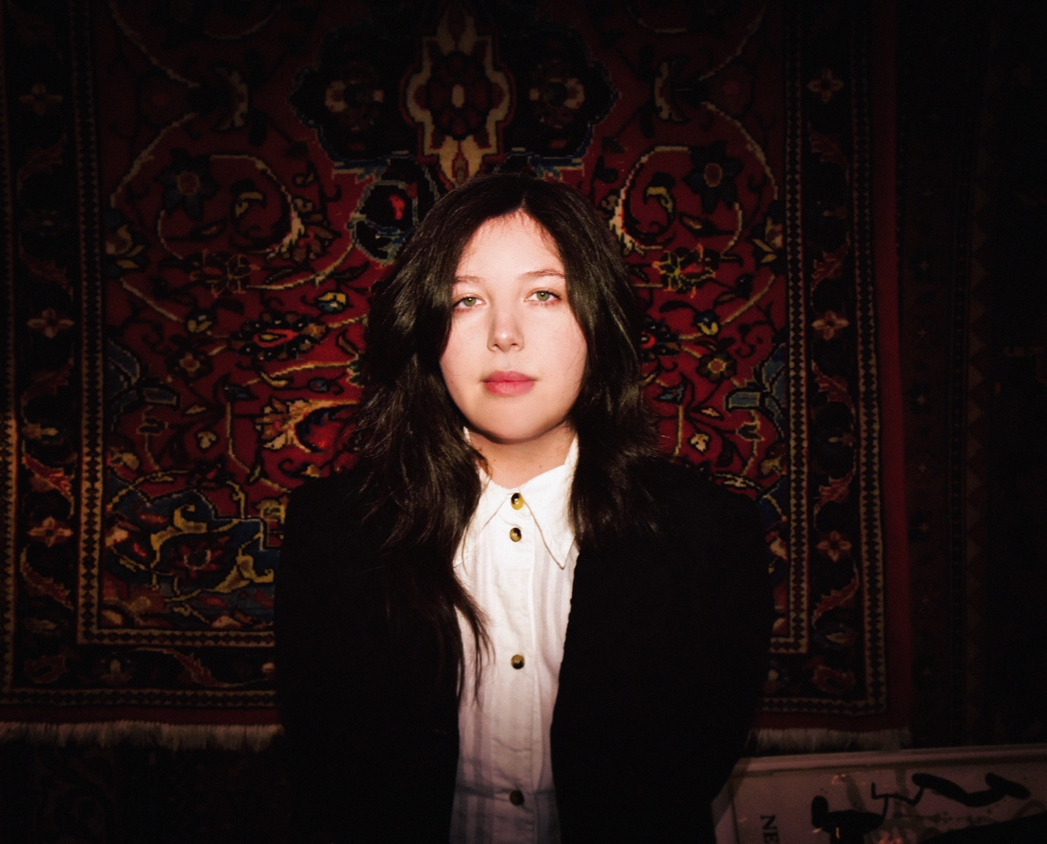
Credit: Shervin Lainez. Download high res HERE).

Lucy Dacus releases new single and video, ‘Best Guess’
Watch the video featuring Cara Delevingne, Towa Bird, Naomi Mcpherson + more

UK/EU Tour dates announced
Tickets on General Sale Friday 21st February at 10am local time
New album, Forever Is A Feeling, out March 28th

Lucy Dacus has released ‘Best Guess’, the third track taken from her highly anticipated new album Forever is a Feeling - out March 28th via Geffen Records/Polydor Label Group. Along with the track comes a self-directed video which, like the album’s striking, Renaissance-themed artwork, further subverts the classics: this time, a 90s CK ad, as reimagined alongside a cast of Naomi Mcpherson, Cara Delevigne, Towa Bird, ER Fightmaster, and other “hot mascs” that Dacus herself recruited via a social media open casting call last month.

WATCH ‘BEST GUESS’ MUSIC VIDEO HERE
STREAM ‘BEST GUESS’ HERE

‘Best Guess’ is Lucy Dacus’ unique take on a love song, an anthem of queer tenderness that captures that mix of excitement and uncertainty as two people take a romantic chance with one another.

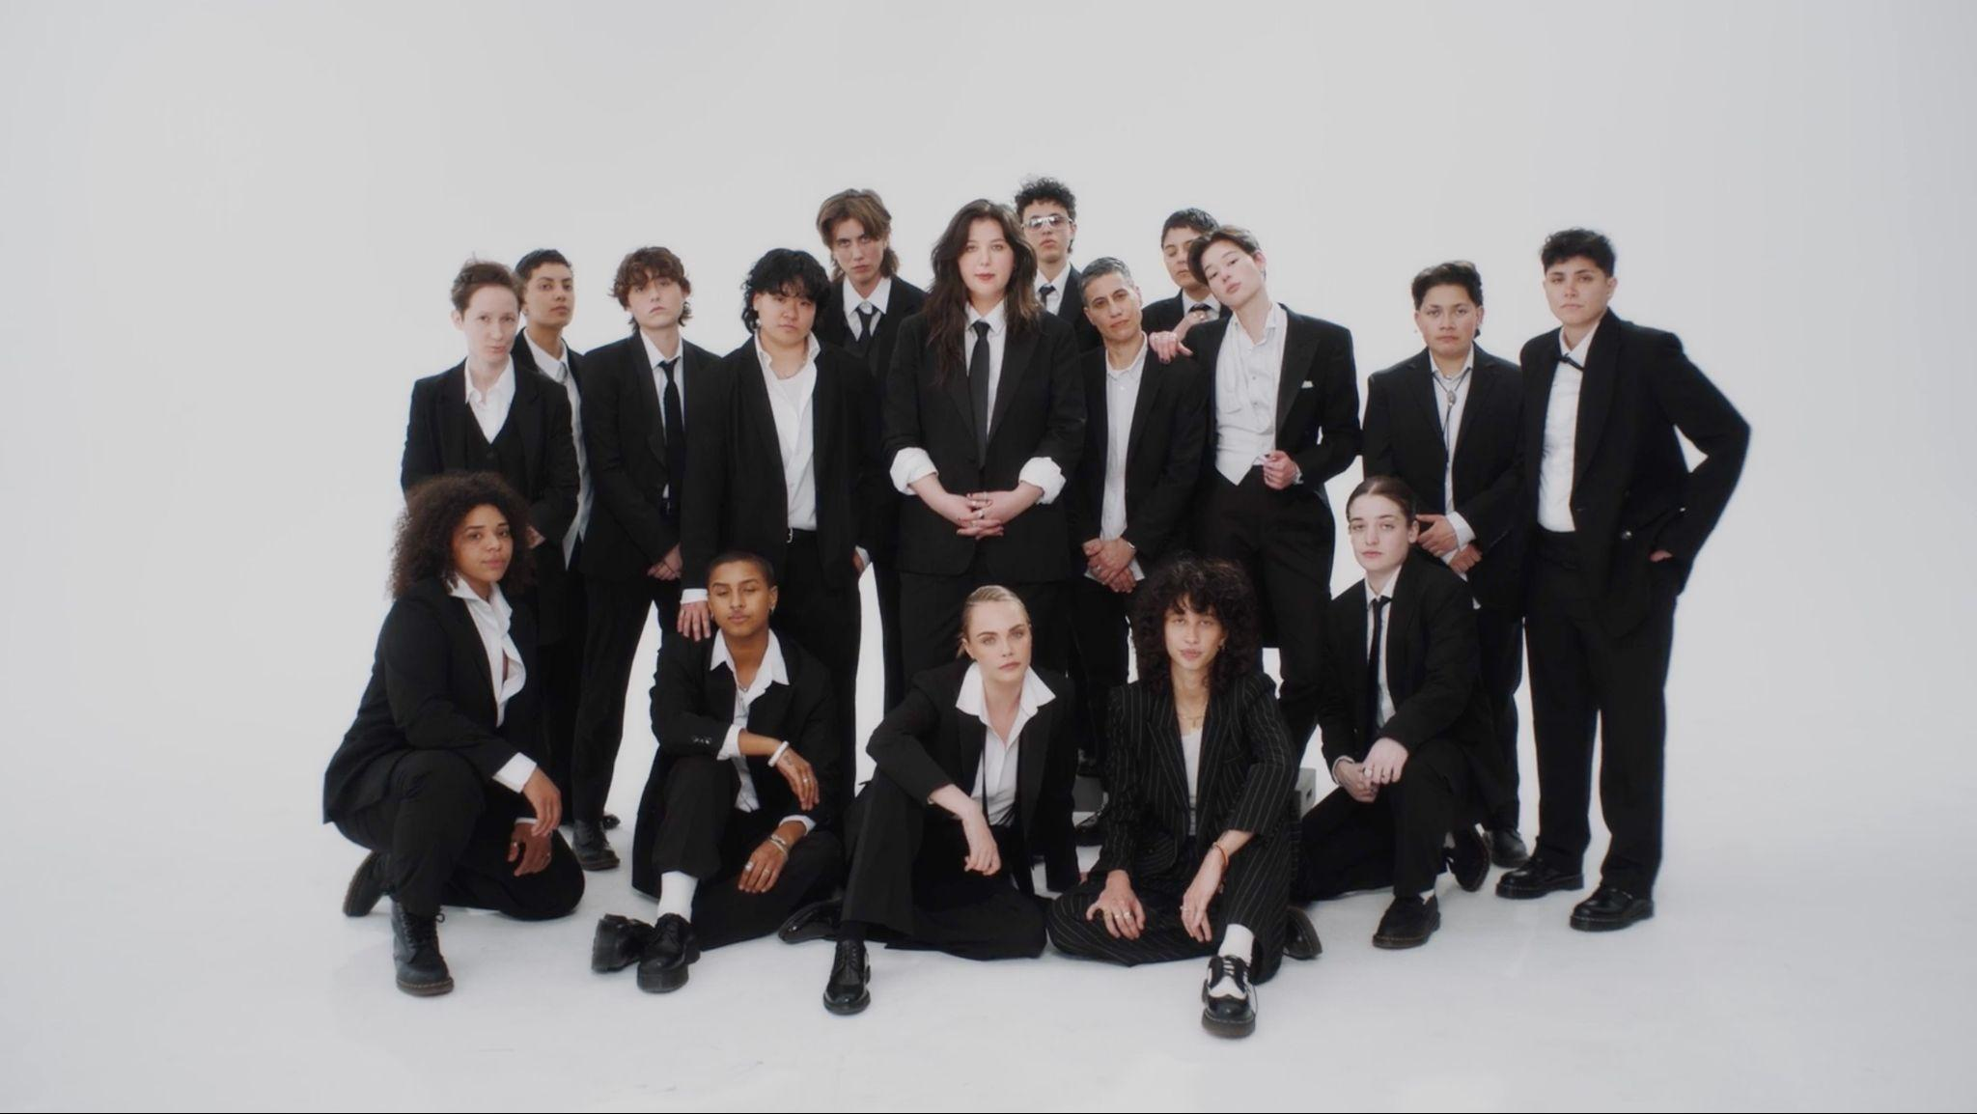
(video still)

The song follows first tracks ‘Ankles’ and ‘Limerence’ which were released in January. Dacus debuted the former in a dazzling performance on The Tonight Show Starring Jimmy Fallon wearing custom Rodarte, a nod to the song’s Parisian music video where she plays a painting that comes to life.

Following a run of intimate sold-out shows in February and March, the Forever Is A Feeling Tour begins in Philadelphia on April 16th, with more dates already added due to demand: support comes from special guest Katie Gavin (of Muna) and jasmine.4.t.

Today’s release also comes with news of additional UK/EU shows for the Forever Is A Feeling Tour: tickets are available on general sale on Friday February 21st, at 10AM local time.

For the North American leg, Dacus has partnered with PLUS1 so that $1 per ticket goes to providing critical relief and long-term recovery support for individuals, families, and communities impacted by the devastating LA wildfires via the PLUS1 LA Fires Fund.

WATCH THE VIDEO FOR ‘ANKLES’ HERE
STREAM ‘LIMERENCE’ HERE

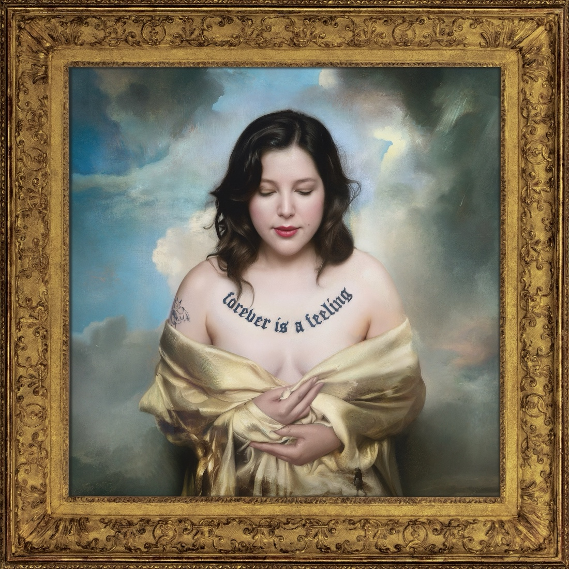
PRE-ORDER FOREVER IS A FEELING HERE

An Evening With Lucy Dacus

February 18th - St. Ann & the Holy Trinity Church - Brooklyn, NY *SOLD OUT*
February 20th - The Murphy Auditorium at the Driehaus Museum - Chicago, IL *SOLD OUT*
February 22nd - Legion of Honor - San Francisco, CA *SOLD OUT*
February 24th - Secret Location GBD- Los Angeles, CA *SOLD OUT*
March 10th - Saint Eustache Church, Paris, FR *SOLD OUT*
March 12th - Vondelkerk, Amsterdam, NL *SOLD OUT*
March 14th - Säälchen at Haltzmarkt, Berlin, DE *SOLD OUT*
March 18th - Sir John Soane’s Museum, London, UK (early and late show) *SOLD OUT*

Forever Is A Feeling Tour

April 16th - The Met - Philadelphia, PA - SOLD OUT #
April 18th - The Anthem - Washington, DC - SOLD OUT #
April 19th - The Anthem - Washington DC #
April 20th - MGM Music Hall - Boston, MA #
April 21st - MGM Music Hall - Boston, MA - SOLD OUT #
April 23rd - Radio City Music Hall - New York, NY - SOLD OUT #
April 24th - Radio City Music Hall - New York, NY - SOLD OUT #
April 25th - Massey Hall - Toronto, ON - SOLD OUT #
April 26th - Massey Hall - Toronto, ON #
April 29th - Ryman Auditorium - Nashville, TN - SOLD OUT #
April 30th - Ryman Auditorium - Nashville, TN - SOLD OUT #
May 1st - Chicago Theatre - Chicago, IL - SOLD OUT #
May 2nd - Chicago Theatre - Chicago, IL - SOLD OUT #
May 5th - Palace Theatre - St. Paul, MN - SOLD OUT #
May 6th - Palace Theatre - St. Paul, MN #
May 7th - Midland - Kansas City, MI #
May 9th - Winspear Opera House - Dallas, TX #
May 10th - Moody Amphitheatre - Austin, TX #
May 12th - Red Rocks Amphitheatre - Denver, CO #
May 14th - The Greek Theatre - Los Angeles, CA #
May 15th - The Greek Theatre - Los Angeles, CA #

UK & Europe

June 12th - Oslo, NO @ Rockefeller
June 16th - Amsterdam, NL @ Paradiso
June 19th - Berlin, DE @ Astra
June 24th - Brussels, BE @ Ancienne Belgique
June 25th - Paris, FR @ Trianon
June 26th - London, UK @ Brixton Academy
June 30th - Edinburgh, UK @ Usher Hall
July 2nd - Manchester, UK @ Academy
July 3rd - Dublin, IE @ Iveagh Gardens
July 5th - Roskilde, DK @ Roskilde Festival

# with Katie Gavin and jasmine.4.t.

KEEP UP WITH LUCY DACUS:
Instagram | Tiktok | Website

For more information please contact jenny@chuffmedia.com

