NAVOS BREAKTHROUGH DANCE TRACK ‘BELIEVE ME’
HITS THE OFFICIAL CHARTS

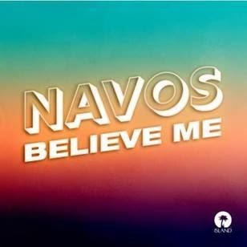

Listen to ‘Believe Me’ HERE

Following Island Record’s recent signing of his new dance anthem ‘Believe Me’, fast-rising producer NAVOS, is a newcomer worth paying attention to.

Hailing from humble beginnings in Liverpool where he worked in a furniture warehouse until late last year, NAVOS has spent the last 5 years honing his craft as a tech-house DJ.

Growing up as an introverted kid in a small town, some might say ‘dance producer’ wasn’t the obvious career choice for NAVOS (who rarely drinks or parties). However when he was just 14 years old he was left in awe after watching an Avicii show in Manchester and in that moment he knew he wanted to produce music. Fast forward several years and he began to release tracks on Soundcloud as a hobby after taking inspiration from Sonny Fodera and MK to create his sound.

More recently, the self-taught 21-year-old producer turned to Spotify after deciding to take the plunge to solely focus on music. He put out well received tracks such as ‘Foolin Me’ and ‘Outta Love’ which gained the attention of Island Records, resulting in the signing of ‘Believe Me’ – a dream come true for the scouse bedroom producer.

Fast becoming the breakout dance anthem of 2021, ‘Believe Me’ showcases NAVOS infectious production skills and is currently catapulting through the Shazam charts. Born out of lockdown following a chance discovery on Tik-Tok, the track instantly went viral and has since taken the internet by storm, surpassing over 4 million Spotify plays.

The record became a huge hit instantaneously and received over 300 national and regional radio plays in the first 3 weeks of its release. Speaking to MistaJam during his Capital Dance show, NAVOS explains how the summer inspired track came about; “thanks to all this time indoors I’ve been able to put more time into my music and it’s one of the many positives that’s come out of a negative situation.”

‘Believe Me’ continues to power through the UK charts and was most recently added to Mint, Hot Hits UK and Massive Dance Hits playlists on Spotify. When dance-floor lovers are finally reunited, this club-tinged banger will embody a feeling of freedom and togetherness that we’ve all been waiting for.

As NAVOS make waves throughout the industry, his explosive debut into the dance realm and punchy flare for feel-good production shows no sign of slowing down.

FOLLOW NAVOS ON SOCIAL MEDIA:
Instagram Twitter Tik Tok

For more contact warren@chuffmedia.com

