HI-RES ASSETS HERE

‘BEGIN AGAIN’
NEW SINGLE OUT NOW VIA FICTION RECORDS
STREAM HERE + WATCH THE VIDEO HERE

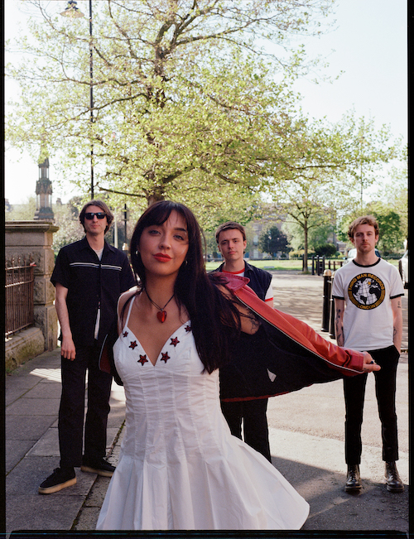
PHOTO CREDIT: CHARLES GALL

SUPPORTING ARCTIC MONKEYS ON THEIR 2023 UK STADIUM TOUR
TICKETS HERE

“Sounding like an angrier, tougher PJ Harvey, Lia Metcalfe takes on the world, one distorted guitar song after another.”
- The Times

"Metcalfe’s confident attitude is felt at every turn as she opens up on themes of self-destruction and love."- NME

"Few can match the levels of accessibility, seduction and intensity that The Mysterines have.." - The Line of Best Fit

Alt rock wunderkinds The Mysterines have returned with their new single ‘Begin Again’, an enthralling precursor to their monumentous support slots with the Arctic Monkeys on their stadium tour this summer. Stream the new single here and watch the video here.

Receiving its first play from Clara Amfo on BBC Radio 1 yesterday, ‘Begin Again’ is the first single to be taken from The Mysterines’ forthcoming LP, and sees the four piece build on their signature introspective lyricism, stripping instrumentation back for an incredibly powerful set up and delivery. It’s the sound of a band truly refining and maturing their craft, and speaking further about the single Lia Metcalfe says: “Written during a full moon in a barn in the West Country, ‘Begin Again’ felt like finding a key to the spirit realm the evening it arrived. It felt like I was embarking on a surreal journey of self dissolution; think of the first verse as a set of instructions, and see how far reality stretches.”

Riding high on the success of their critically acclaimed, UK Top 10 debut album ‘Reeling’ released March 2022, The Mysterines have been achieving remarkable success since the release, including two tours of the UK, two of North America and one in the EU, and now a tour with their personal heroes Arctic Monkeys across UK stadiums this summer. Tickets here.

‘Reeling’ saw stellar support across the board on release, from a TV appearance on Jools Holland (which Lia herself predicted as a teenager) to glowing reviews from leading indie tastemakers and national broadsheets. The Line of Best Fit’s 8/10 review said The Mysterines “draw you in with their seething words…mountainous rock tones…and humoured musings on life’s painful inevitabilities over thirteen glorious tracks”, with DIY commenting "their knack for melody is one of their greatest strengths, particularly when combined with frontwoman Lia Metcalfe's husky tones". NME declared ‘Reeling’ an “electrifying debut album” in their 4* review, comparing the powerful guitar ballad ‘On The Run’ to “a Celebrity Skin era Hole classic”, meanwhile The Telegraph commented “The Mysterines' default setting is fast and furious garage punk-rock to which Metcalfe adds a goth grandeur with doomy lyrics and a quality of brazen glee at the rebellious posturing of songs with statement titles.”

THE MYSTERINES SHOWS SUPPORTING ARCTIC MONKEYS

29th May - Ashton Gate Stadium, Bristol
31st May - Coventry Building Society Arena, Coventry
2nd June - Emirates Old Trafford, Manchester
3rd June - Emirates Old Trafford, Manchester
5th June - Middlesbrough FC, Middlesbrough
7th June - Carrow Stadium, Norwich
9th June - Hillsborough Park, Sheffield
10th June - Hillsborough, Sheffield
12th June - Swansea.com Stadium - Swansea
14th June - The Ages Bowl, Southampton
16th June - Emirates Stadium, London
17th June - Emirates Stadium, London
18th June - Emirates Stadium, London
20th June - Malahide Castle, Dublin
25th June - Bellahouston Park, Glasgow

The Mysterines are:
Lia Metcalfe (vocals/guitar)
George Favager (bass)
Callum Thompson (guitar)
Paul Crilly (drums)

THE MYSTERINES ON SOCIALS
INSTAGRAM | TWITTER | FACEBOOK | SPOTIFY

For more information please contact
Warren@chuffmedia.com on 07762 130 510

