DECLAN J DONOVAN
‘BEFORE YOU LET ME GO’

Out March 12th on Polydor Records

Credit Ryan Saradjola

Declan J Donovan has announced details of a new single. The Essex singer-songwriter will release ‘Before You Let Me Go’ via Polydor on 12th March. A powerful ballad, ‘Before You Let Me Go’ is the first release of 2021 for an artist who looks set to be one of the year’s breakthrough stars. Donovan’s distinctive soulful voice is the uplifting centrepiece of this stirring anthem, the song gently building to a bombastic crescendo. Donovan has a knack of turning tales of everyday life and of love and loss into universal anthems and his tracks are connecting on a big scale. ‘Before You Let Me Go’ will no doubt resonate with a fanbase that already counts over three million in global listeners. “I love talking to people and seeing how their mind works,” says Donovan, “seeing what they’re going through. A lot of my songs are other people’s stories.”

‘Before You Let Me Go’ is a poignant tale of heartbreak. “It’s a song about the end of a relationship and all the ‘what if’s?’ you ask yourself after it has ended to find closure for yourself,” he says. It’s the follow-up to ‘Perfectly Imperfect’, which went viral across Instagram and TikTok after its body-positive message emotionally chimed with listeners. There have been over 97 million combined views of the track and it has racked up 26 million plays on Spotify.

Born and raised in Harlow, Essex, Donovan initially caused a stir when the first track he ever wrote, Fallen So Young, found a big audience on Soundcloud in 2017. In the years since, he has honed his songwriting craft and garnered a diehard fanbase over the course of several mesmerising singles. He was first inspired to write by Ed Sheeran and Bon Iver but he is ever more becoming an artist following his own vision. His blend of euphoric pop singalongs and honest lyricism are breaking through on a huge scale.

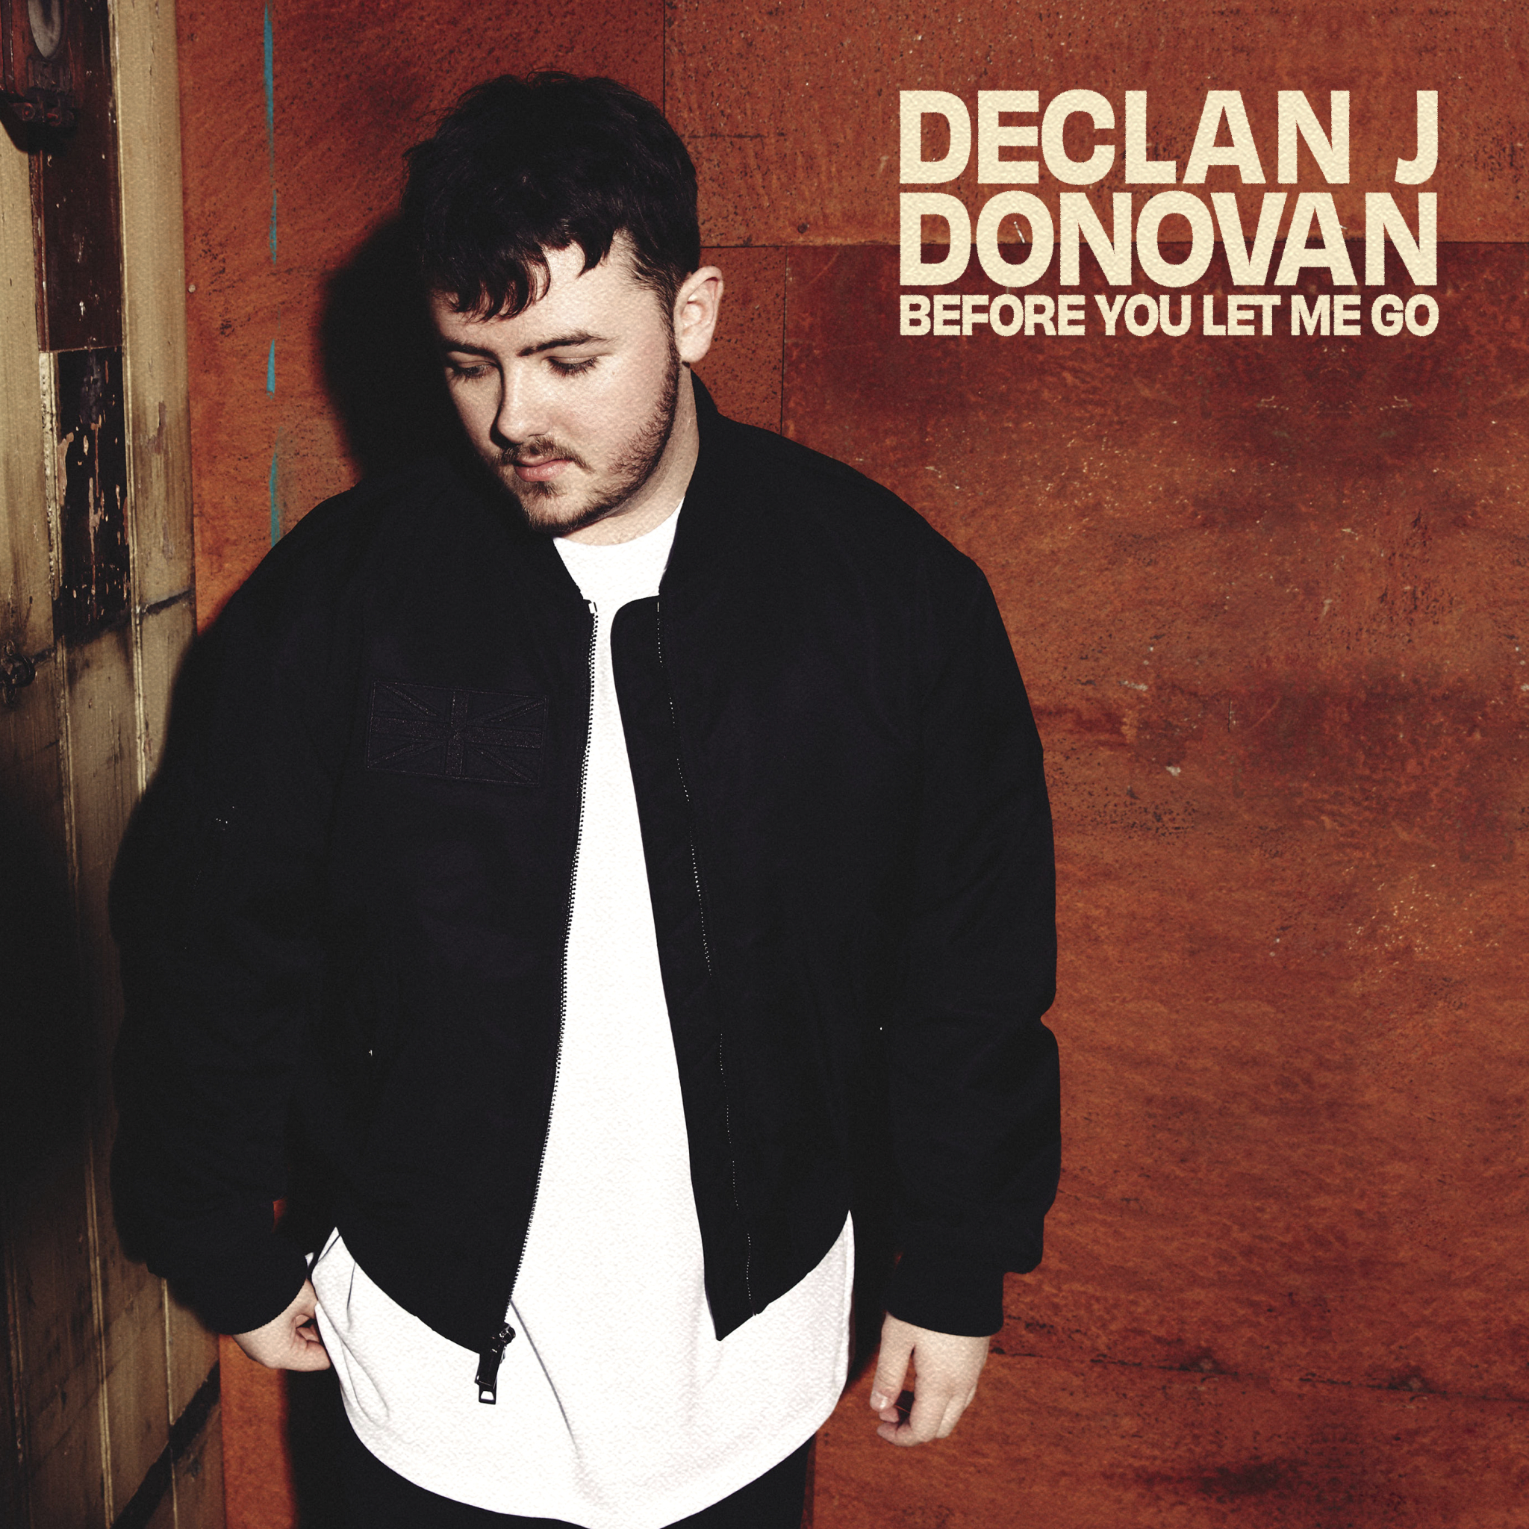

https://www.instagram.com/declanjdonovan
https://www.facebook.com/DeclanJDonovan
https://twitter.com/declanjdonovan

For more information and press enquiries please contact
Jenny Entwistle
Jenny@chuffmedia.com

