PALOMA FAITH RELEASES SECOND SINGLE
‘BAD WOMAN’
LISTEN HERE

UPCOMING ALBUM ‘THE GLORIFICATION OF SADNESS’, OUT 16TH FEBRUARY
AVAILABLE TO PRE-ORDER HERE TODAY

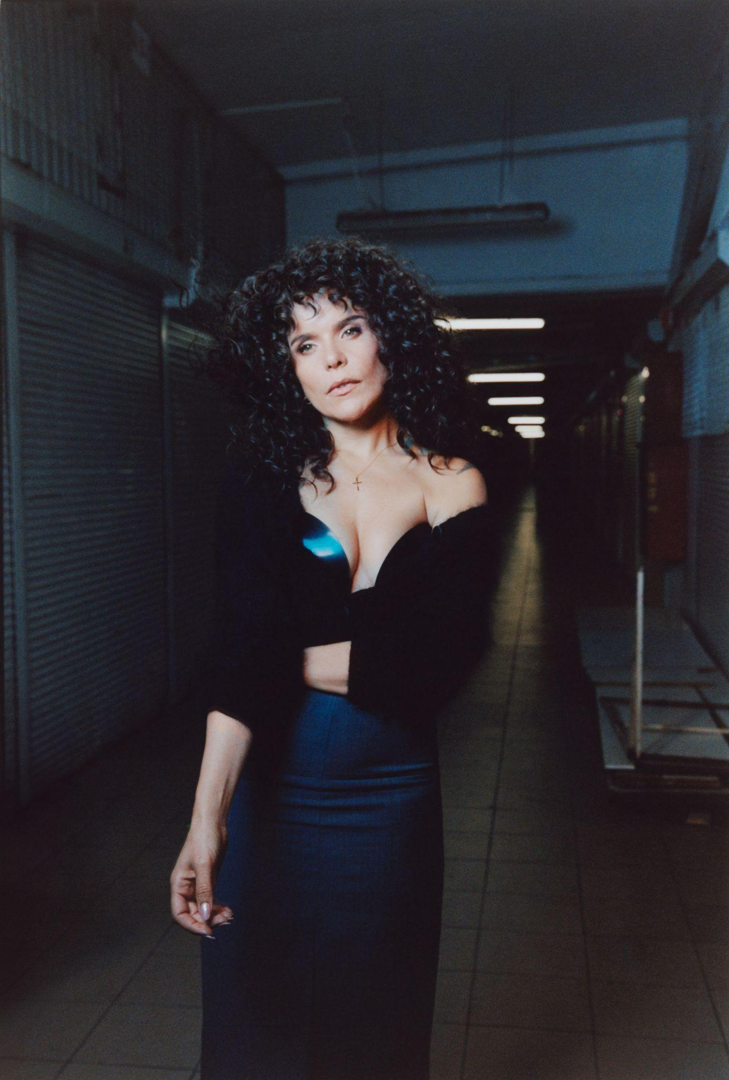
Download Assets HERE
Photo credit Yan Wasiuchnik.

PALOMA ALSO ANNOUNCED HER 2024 UK ARENA TOUR - 14 DATES ALREADY SOLD OUT
TICKETS ON SALE NOW HERE

British superstar and pop visionary Paloma Faith has released her second single ‘Bad Woman’, taken from her highly anticipated sixth studio album ‘The Glorification of Sadness’ via RCA Records.

Listen to ‘Bad Woman’ here.

In her latest offering, Paloma leaves with the sunset in a strikingly cinematic portrayal of confidence, driving onwards into her new era. ‘Bad Woman’ is an epic power anthem, following its dynamic predecessor ‘How You Leave A Man’, and carrying a message of female empowerment at its very forefront. The track follows the Brit Award winning singer on a gritty journey of new-found independence, beaming with feminine energy.

Speaking of the song, Paloma says…"This song, 'Bad Woman,' stands out as a personal favourite from the album. It delves into the myriad societal challenges women confront, illustrating the exhausting struggle to meet expectations. The pressure to conform or risk being labelled 'incompetent' or a 'Bad Woman' can be overwhelming. My hope is that women embrace their authenticity, feel comfortable in their own skin, and understand that imperfection is a part of being human. Let's free ourselves from the societal pressures that label us and encourage each other to stay true to our authentic selves."

This is the first new music from Paloma since the release of her fifth studio album ‘Infinite Things’ in November 2020 and is the first time in her career that she has executively produced a record. The album is produced by Swedish born but LA native Martin Wave who made a name for himself within the Hollywood film space. Having started work together on a track for the new album and enjoying Martin’s cinematic style production he quickly became a cornerstone of the album. It also features collaborators Chase & Status, Kojey Radical, Maverick Sabre, Lapsley, MJ Cole, Fred Cox, Amy Wadge, Liam Bailey and Jaycen Joshua. ‘The Glorification of Sadness’ is available for pre-order at all physical and digital retailers and will be released on the 16th February via RCA Records. Pre-order here.

On the album Paloma comments, “‘The Glorification of Sadness’ is more than an album about relationships. The celebration of finding your way back after leaving a long term relationship, being empowered even in your failures and taking responsibility for your own happiness. It is her most personal album to date, drawing on her own experiences with Paloma acting as the anchor to direct a deeply personal narrative and album.”

Fans will also be delighted to hear that, to celebrate this next era in style, Paloma will embark on the ‘The Glorification Of Sadness Tour 2024’ tour across the UK & Ireland. The 26 date tour kicks off in Reading, with a headline show at The Hexagon and includes a headline show at London’s Eventim Apollo concluding with a show in Lincoln. Tickets are on sale now and available here.

Paloma Faith hasn’t been busy enough, in recent years she’s released five albums, a flourishing acting career including a role as Bet Sykes in the Batman prequel series Pennyworth and starring as Florence De Regnier in Lionsgate's Dangerous Liaisons; ambassadorships for Greenpeace and Oxfam and more recently launched her own interior brand called Paloma Home.

This is a new Paloma Faith, recharged, empowered and back in control.

HEADLINE TOUR DATES 2024

APRIL
3rd - Reading, The Hexagon - SOLD OUT
5th - Nottingham, Royal Concert Hall - SOLD OUT
6th - Blackpool, The Blackpool Opera House - SOLD OUT
8th - Liverpool, Liverpool Empire Theatre
9th - Sheffield, Sheffield City Hall - SOLD OUT
11th - Manchester, The Bridgewater Hall - SOLD OUT
12th - Manchester, The Bridgewater Hall
14th - Plymouth, Plymouth Pavilions
15th - Bristol, Bristol Beacon
17th - London, Eventim Apollo
19th - Cardiff, Cardiff Utilita Arena
20th - Brighton, The Brighton Centre
29th - Newcastle, O2 City Hall - SOLD OUT
30th - Glasgow, SEC Armadillo

MAY
2nd - Dunfermline, Alhambra Theatre - SOLD OUT
3rd - Hull, Bonus Arena
5th - Birmingham, Symphony Hall - SOLD OUT
6th - Birmingham, Symphony Hall
8th - Ipswich, Ipswich Regent Theatre - SOLD OUT
9th - Bath, The Forum - SOLD OUT
11th - Stockton, Globe Theatre - SOLD OUT
12th - York, York Barbican - SOLD OUT
14th - Oxford, New Theatre Oxford
15th - Southend, Cliffs Pavilion - SOLD OUT
17th - Bournemouth, International Centre
18th - Swansea, Swansea Arena - SOLD OUT
19th - Marlow Pub in the Park

JUNE
21st - Llangollen, Llangollen International Musical Eisteddfod
22nd - Lincoln, Lincoln Castle

Connect with Paloma Faith
Instagram | Twitter | Facebook | YouTube

For all media enquiries please contact warren@chuffmedia.com

