BIG SPECIAL share rousing new single
'BLACK DOG / WHITE HORSE'

Debut album POSTINDUSTRIAL HOMETOWN BLUES out 10th May via SO Recordings

UK tour dates begin this week

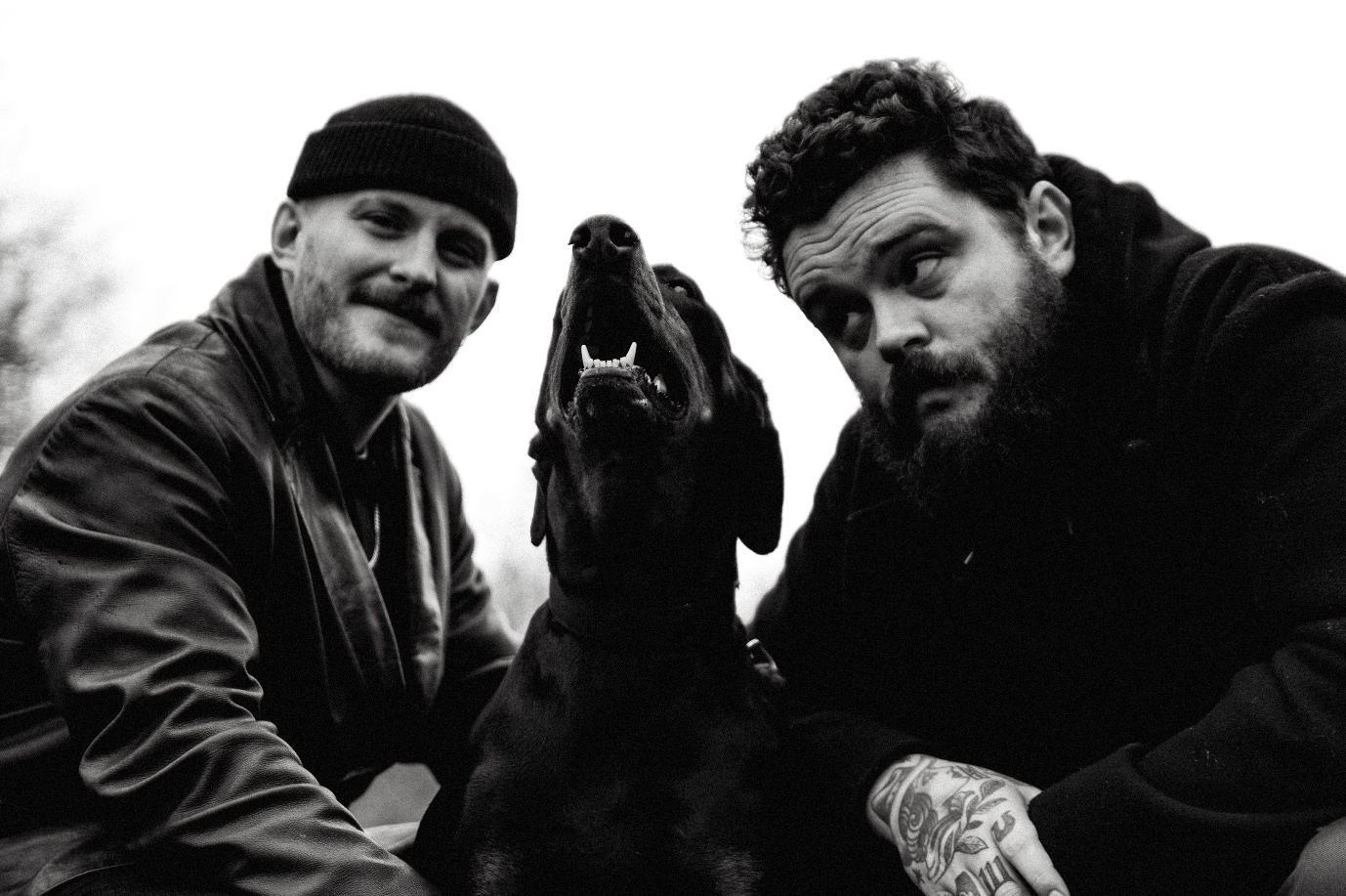

BIG SPECIAL | Photo credit: Isaac Watson | Download image here

////

BIG SPECIAL are today sharing 'BLACK DOG / WHITE HORSE', the latest single to be taken from their forthcoming debut album POSTINDUSTRIAL HOMETOWN BLUES, out 10th May via SO Recordings. It's their first official single since they revealed 'DUST OFF / START AGAIN', which remains on the BBC 6 Music playlist.

'BLACK DOG / WHITE HORSE' showcases BIG SPECIAL at their most brooding and contemplative, walking a tightrope of deliberation as lead singer Joe Hicklin brings his stirring vocals to a song that charts the path from fear to salvation. Of the new song he says:

"BLACK DOG / WHITE HORSE is about fear, about rumination, intrusive thoughts and cycles of depression. It’s about trying to figure out how to reach out when feelings of guilt and shame take hold. It’s about recognising these things in others, noticing the lost and undervalued, and their increasing numbers.

It comes from a thing I wrote years ago, about a burning snake traveling in the hot sun and a small wren flying high above it to block the heat and give it shade, taking the burden of the sun, because the little bird loves the snake and won’t see it defeated, for whatever reason."

Continuing about the album he says: “POSTINDUSTRIAL HOMETOWN BLUES is an album about depression. It's about the different shapes it takes; personal, social, generational... and it's about coming face to face with those ghosts and what we do or how we feel when that happens.

The album offers no answers, it is just an honest expression of a working-class experience in modern England through the eyes of ill mental health, a pursuit of art and political disenchantment; a story of rumination, realisation and reaction.

POSTINDUSTRIAL HOMETOWN BLUES is about learning that we are connected by our common struggles and though dark and rageful, the album holds a quiet sentiment of love and hope. It's about laughing at the face of the void, recognising its oppressive weight, holding hands and moving forward.”

Pre-order debut album POSTINDUSTRIAL HOMETOWN BLUES here.

Listen to 'BLACK DOG / WHITE HORSE' on streaming services here.

////

BIG SPECIAL 2024 TOUR DATES

Tickets on sale now here.

03 Apr - Clwb Ifor Bach, Cardiff, UK (DIY Now & Next tour)
04 Apr - Bullingdon, Oxford, UK (DIY Now & Next tour)
05 Apr - Yellow Arch Studio, Sheffield, UK (DIY Now & Next tour) - SOLD OUT
06 Apr - Green Door Store, Brighton, UK (DIY Now & Next tour) - SOLD OUT
07 Apr - Joiners, Southampton, UK (DIY Now & Next tour)
12 Apr – New Century Hall, Manchester, UK (supp. Antony Szmierek)
13 Apr – Lafayette, London, UK (supp. Antony Szmierek)
07 May – District, Liverpool, UK
08 May – The Key Club, Leeds, UK
09 May – XOYO, Birmingham, UK
10 May – King Tuts, Glasgow, UK
12 May – Strange Brew, Bristol, UK
16 May – Jazz Café, London, UK - SOLD OUT
17 May – Horatio’s, Brighton, UK (The Great Escape 2024)
18 May – Deaf Institute, Manchester, UK
20 May – Kasbah Club, Limerick, Ireland
21 May – Workman’s Cellar, Dublin, Ireland
22 May – Ulster Sports Bar, Belfast, Norther Ireland
24 May - Netherlands, Den Haag, Zwarte Ruiter (Sniester Festival)
26 May – Bearded Theory Festival, Derbyshire, UK
27 May – Paradiso Upstairs, Amsterdam, Netherlands
28 May – Effenaar, Eindhoven, Netherlands
30 May – Block Party Festival, Paris, France
31 May – Vestrock, Hulst, Netherlands
01 Jun - Dauwpop Festival, Hellendoorn, Netherlands
26 Jul – Low Festival, Benidorm, Spain
28 Jul – Latitude Festival, Suffolk, UK
15 - 18 Aug - Green Man Festival, Bannau Brycheiniog, UK
23 Aug – Reading Festival, Reading, UK
24 Aug – Leeds Festival, Leeds, UK
29 Aug - 01 Sep - End Of The Road Festival, Dorset, UK
30 Nov - O2 Forum, Kentish Town, London, UK

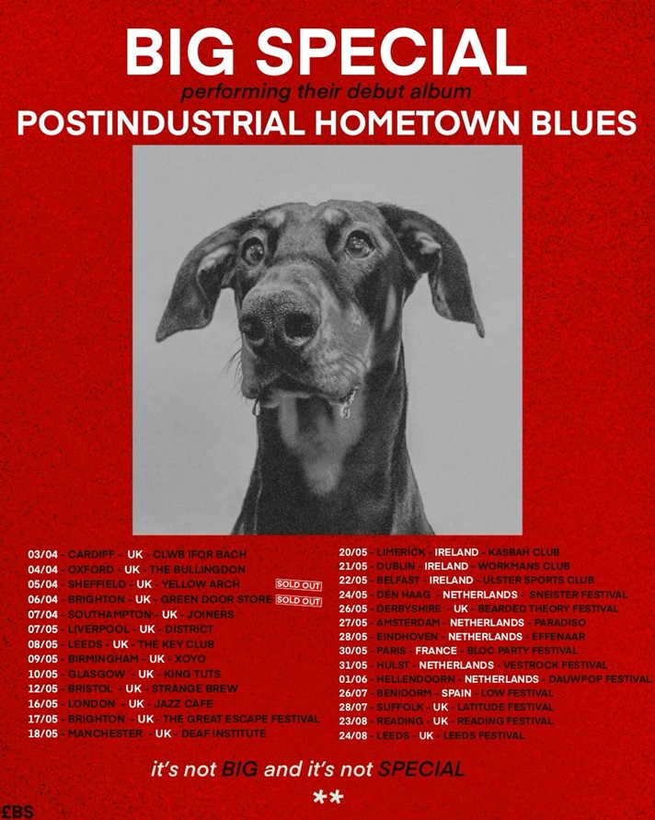

BIG SPECIAL - 2024 live poster | Download image here

////

More about BIG SPECIAL and debut album POSTINDUSTRIAL HOMETOWN BLUES

Words are not to be taken for granted. Especially when they’re being bellowed, full blast, by a broad-shouldered poet with the brimstone fire of a preacher and the honesty and wisdom of a layman, over ground-shaking live beats and between anthemic blasts of melody and rousing riffage.

Words matter. History matters. People matter. And BIG SPECIAL matter.

For BIG SPECIAL - Joe Hicklin (vocals) and Callum Moloney (drums) - their sound is one that comes from vital, frustrated young working-class voices that don’t always get heard on the scale they should do. It’s a frustration that comes to the fore through a voice that is at times coarse and raw, but sensitive, desperate and soulful at others. Hicklin's brimstone-fired voice marches from guttural punk barks and serrated spoken word to soaring soul and back again, arriving siphoned from their forebears, crushed under the weight of history, and retooled for a new generation. It’s wrought, raw and angry at a world lacking options, the thinning of the common understanding between the social classes of England, exasperation at repeating cycles, and the feeling that you’re watching your own life unfold from the outside.

These are songs that channel that voice you hear when you look in the mirror and see your true self – fight songs for a world gone wrong.

Download the band's latest biography here.

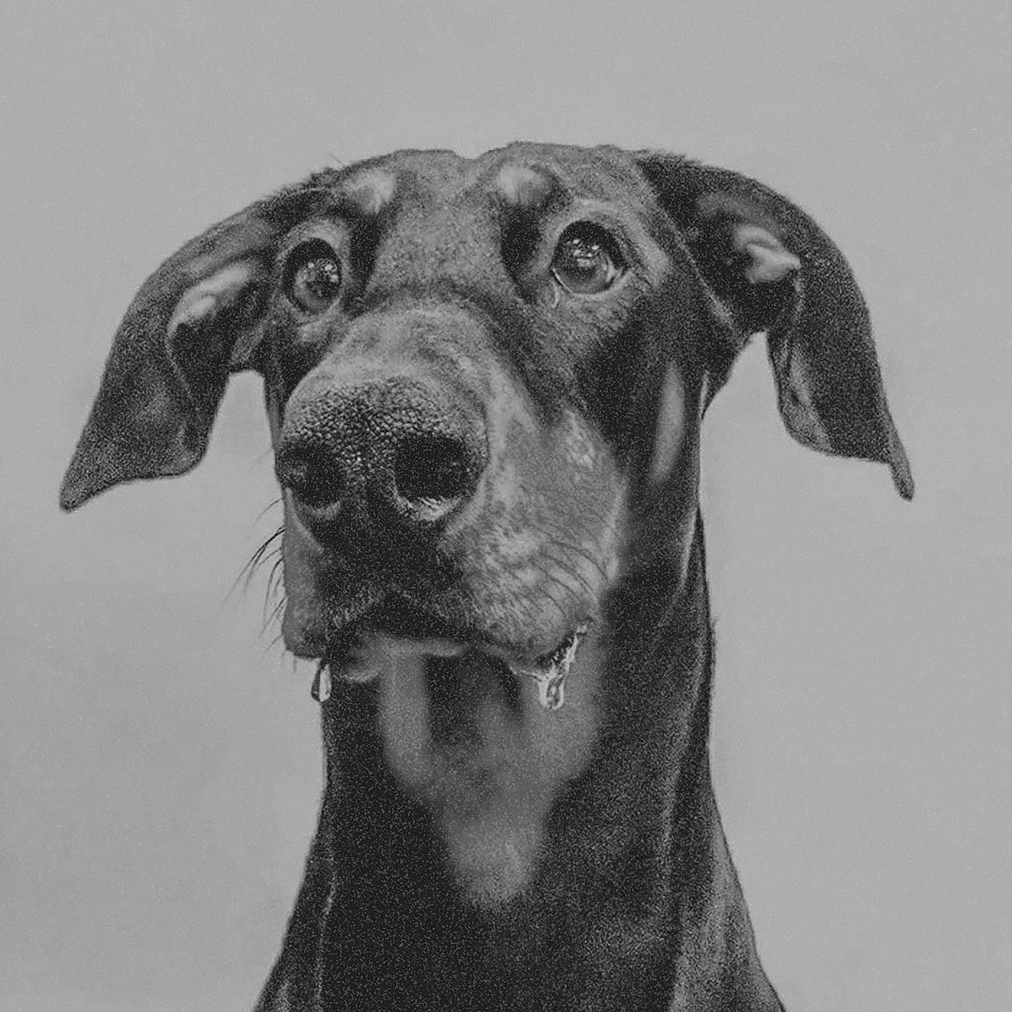

BIG SPECIAL - POSTINDUSTRIAL HOMETOWN BLUES album artwork | Download image here

////

BIG SPECIAL - POSTINDUSTRIAL HOMETOWN BLUES tracklisting

1. BLACK COUNTRY GOTHIC
2. I MOCK JOGGERS
3. DESPERATE BREAKFAST
4. SHITHOUSE
5. THIS HERE AIN’T WATER
6. MY SHAPE (BLOCKING THE LIGHT)
7. BLACK DOG / WHITE HORSE
8. BROADCAST: TIME AWAY
9. iLL.
10. MONGREL
11. BUTCHER’S BIN
12. DUST OFF / START AGAIN
13. TREES
14. FOR THE BIRDS
15. DiG!

Follow BIG SPECIAL: Website | Facebook | Instagram | Spotify | Twitter | YouTube

For more information & media enquiries, please contact Warren
warren@chuffmedia.com

