THE HORRORS

RELEASE NEW SINGLE “ARIEL”
INSTORE TOUR MARCH DATES

NEW ALBUM ‘NIGHT LIFE’ OUT MARCH 21ST

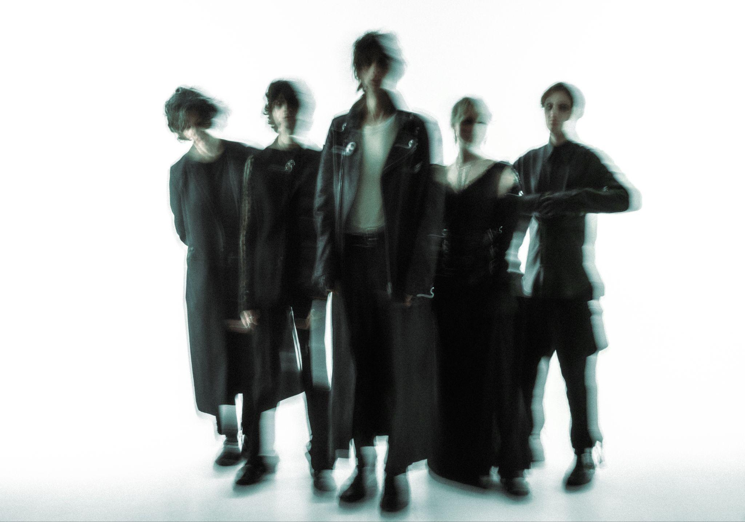
Credit: Vessel Video (Paris Seawell)

Today ‘The Horrors’ release a brand new single ‘Ariel’, the brooding opening track from their forthcoming sixth album ‘Night Life’, out March 21st via Fiction Records. The band have also announced a run of UK instore dates including Rough Trade East on album release day, ahead of a string of Spain and Portugal live shows - see full dates below.

LISTEN TO “ARIEL” HERE

“‘Ariel’ is a particularly special track, and a group favourite.” explains the band; “It’s probably unlike any song we’ve written before, and kind of marks the beginning of a new chapter. We are always looking to explore new sonic territories and find new ways for the band to sound, it’s probably what we enjoy most about being in The Horrors. Ariel was very much a studio creation - we put a distortion-heavy demo down at home and started moulding it into something more subtle at Holy Mountain with Yves. Amelia then added her world of chopped-up rhythms and vocal splices and it felt like we’d reached a new place. The Horrors of the future.’

As The Horrors approach their 20th anniversary as a band, ‘Night Life’ sees them shapeshift into a new form, with a new sonic outlook and a new line up centred around the core duo of vocalist Faris Badwan and bassist Rhys Webb, now joined by Amelia Kidd on keys and Telegram’s Jordan Cook on drums, making the new album the band’s first to not feature all 5 original members.

The resulting album is a record of weight and space, of melancholy and euphoria; a record that has the ability to make bedfellows of seemingly disparate ideas as only The Horrors can. The ‘Night Life’ here is not the vim and vigour of pubs and clubs. It’s the thoughts that happen under the cover of darkness; the places your mind takes you when the rest of the world is asleep. A record born out of a desire to revive the raw, instinctive spirit of the band’s early work.

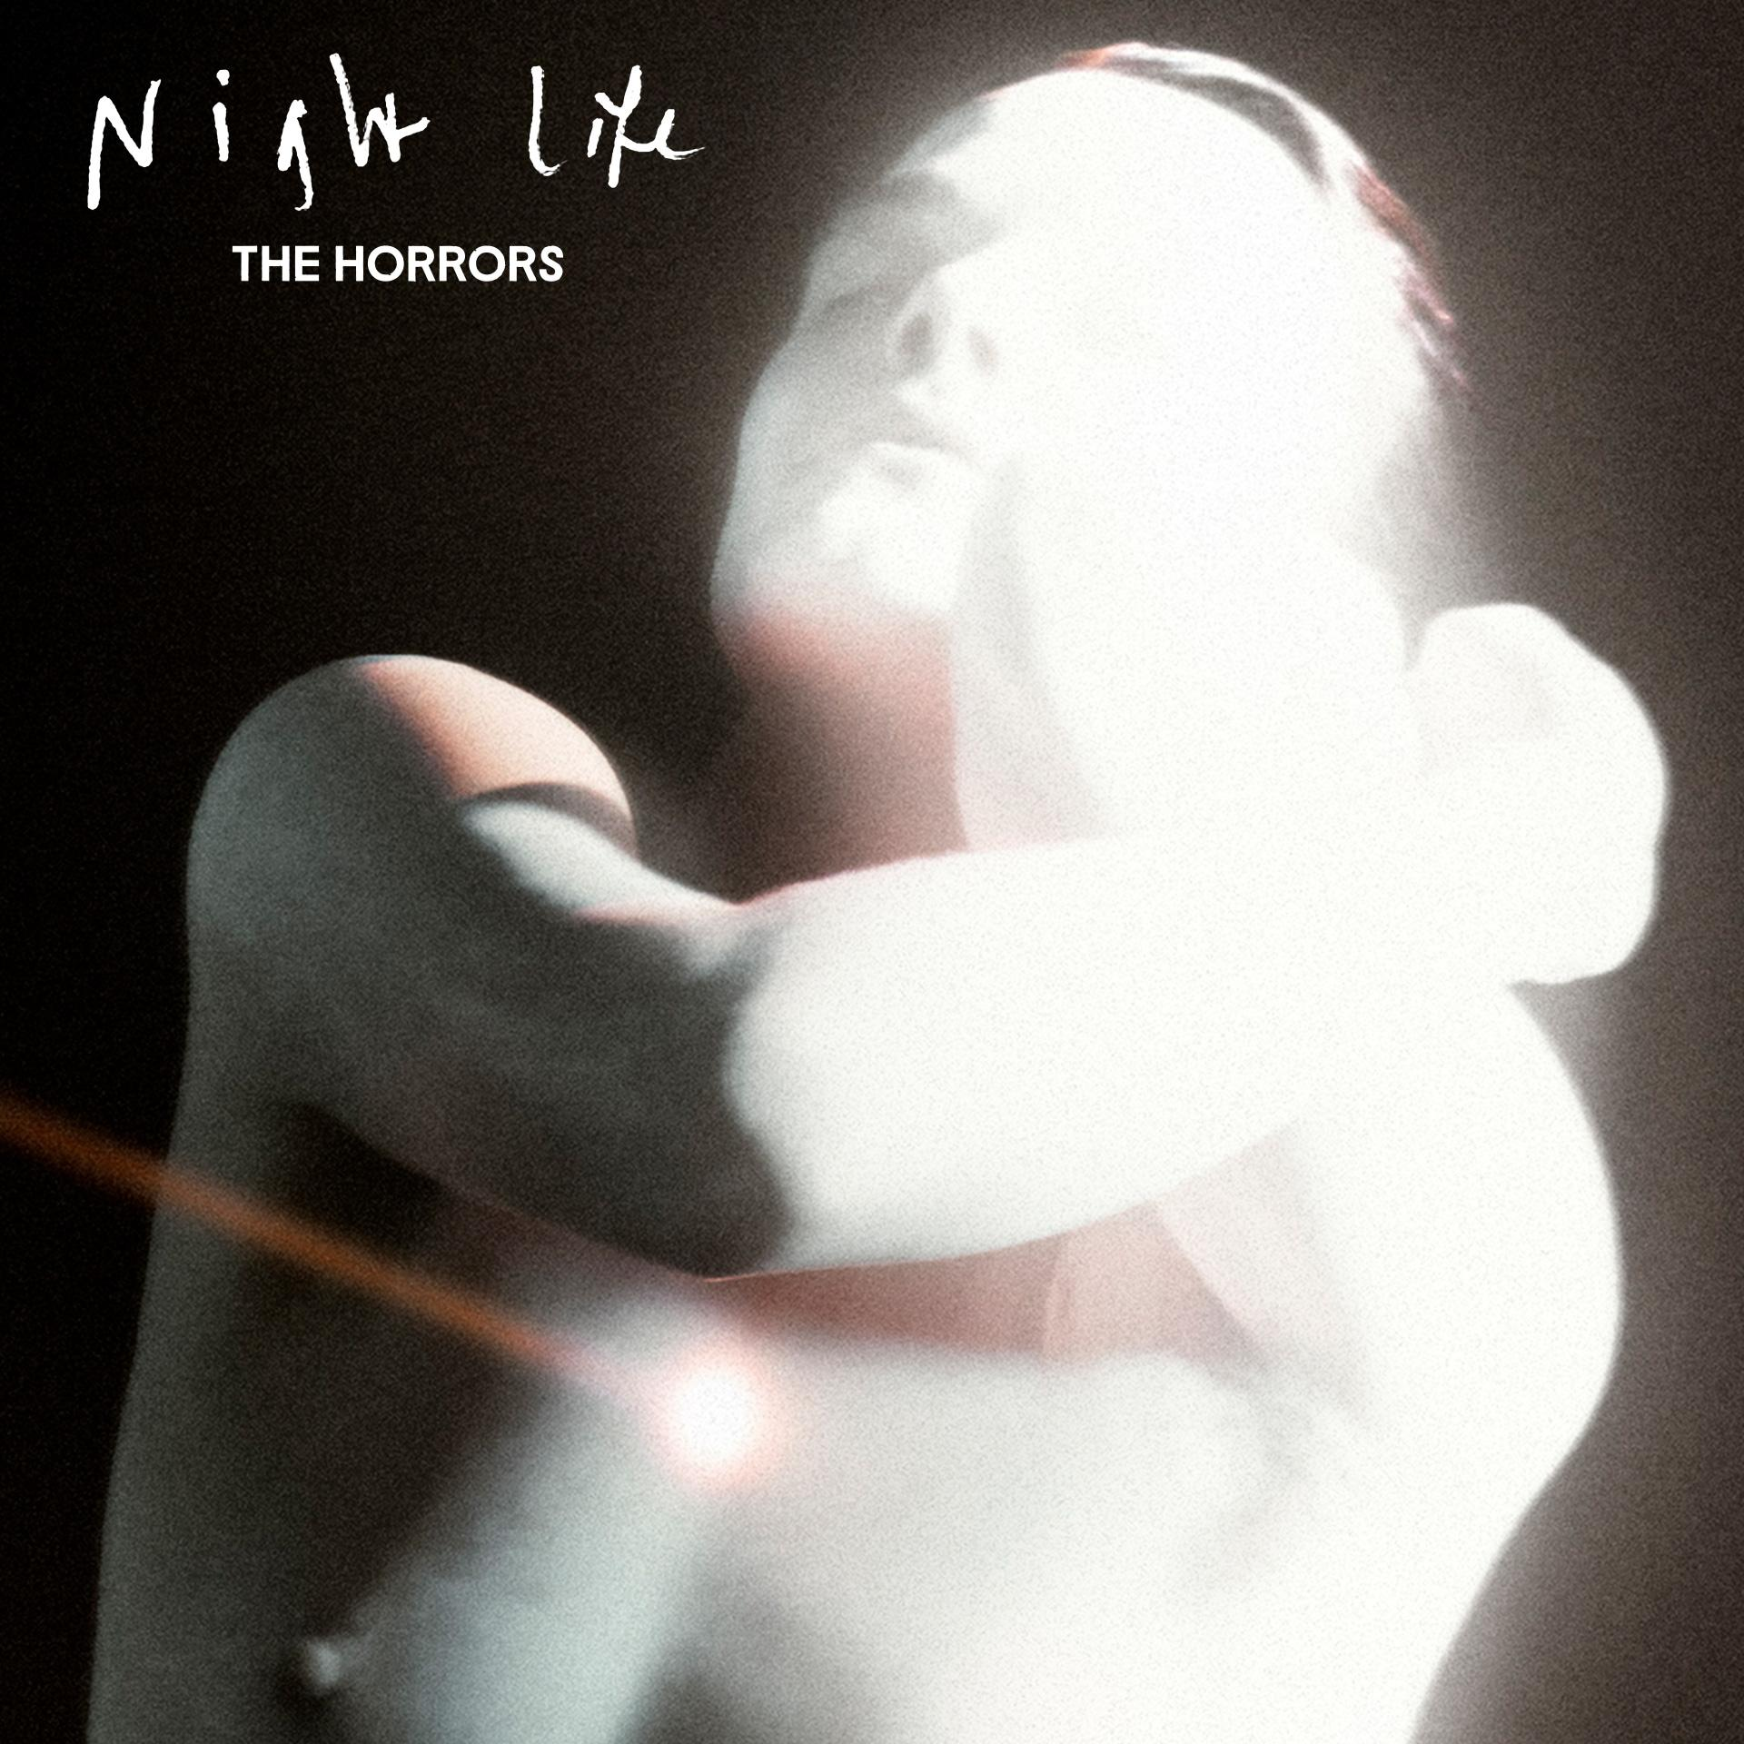
‘Night Life’ artwork

After nearly 20 years making music, there are few bands who’ve created a canon as determinedly innovative and consistently critically-acclaimed as The Horrors. Emerging as zeitgeist-shaking garage-goths on their 2007 debut ‘Strange House’, before taking a sharp left turn for their Mercury-nominated follow up ‘Primary Colours’, since the beginning they’ve roamed freely between genres. 2011’s ‘Skying’ won the NME Award for Best Album; ‘V’ was heralded as “a triumph” in a five-star Guardian review, while 2021’s pair of EPs - ‘Lout’ and ‘Against The Blade’ - marked a new chapter with their most industrial, uncompromising output yet.

PREORDER / PRESAVE 'NIGHT LIFE' HERE

THE HORRORS LIVE DATES:
Thu 20th Mar - Banquet, Pryzm, Kingston (Instore)
Fri 21st Mar - Rough Trade East, London (Instore)
Sat 22nd Mar - Resident, Brighton (Instore)
Sun 23rd Mar - Rough Trade, Bristol (Instore)
Tue 25th Mar - Rough Trade Liverpool (Instore)
Wed 26th Mar - Piccadilly, Night & Day Cafe, Manchester (Instore)
Thu 27th Mar - Crash, Brudenell Social Club, Leeds (Instore)
3rd April - Sala Capitol, Santiago de Compostela
5th April - Barcelona Psych Fest, Paral-lel 62, Barcelona
6th April - Sala Mon, Madrid
7th April - Sala Moon, Valencia
9th April - Hard Club, Porto
10th April – Republica Da Musica, Lisbon
24th/25th May - Dot To Dot Festival (Headline)

www.thehorrors.co.uk

For more info contact warren@chuffmedia.com

