**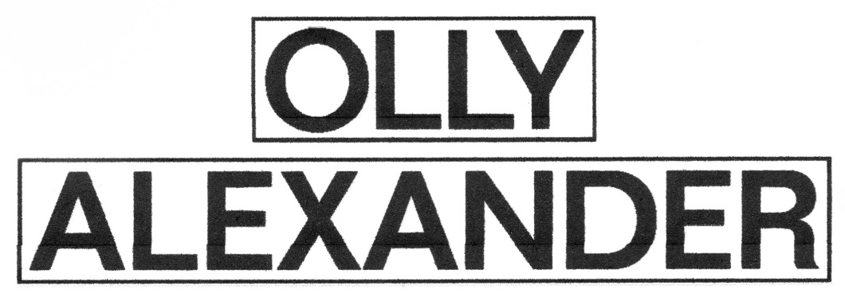**

**OLLY ALEXANDER SHARES LATEST SINGLE, ‘ARCHANGEL’   
   
*POLARI*, THE ALBUM - OUT FEBRUARY 7**

******

[LISTEN](https://highrisepr.us14.list-manage.com/track/click?u=e1881ce6fa06ce0191b442b67&id=07ffa0450a&e=5660f7bbcf)**|**[LYRIC VIDEO](https://highrisepr.us14.list-manage.com/track/click?u=e1881ce6fa06ce0191b442b67&id=51d93d7487&e=5660f7bbcf)  
**‘ARCHANGEL’**  
   
[**PRE-ORDER/ADD/SAVE**](https://highrisepr.us14.list-manage.com/track/click?u=e1881ce6fa06ce0191b442b67&id=778330b054&e=5660f7bbcf)  
**POLARI**  
   
‘Last Night an Angel Saved My Life’ could be the twist-on-a-classic title of this new single from UK pop trailblazer **Olly Alexander** who has today shared another cut from his forthcoming new album ‘**Polari’**, due **February 7th, 2025,** via Interscope Records.  
   
‘**Archangel**’ sees Olly look back at a magical and life affirming moment when he felt saved by the love and care of a companion and follows emotive lead single ‘[**Cupid’s Bow**’](https://highrisepr.us14.list-manage.com/track/click?u=e1881ce6fa06ce0191b442b67&id=8f4a5c198b&e=5660f7bbcf) and more recently the album’s punchy title track and opener ‘[**Polari**](https://highrisepr.us14.list-manage.com/track/click?u=e1881ce6fa06ce0191b442b67&id=7ad851bec0&e=5660f7bbcf),’ which [Queerty](https://highrisepr.us14.list-manage.com/track/click?u=e1881ce6fa06ce0191b442b67&id=286cf24b03&e=5660f7bbcf" \t "_blank) hailed “*pure ’80s adrenaline*” and “*a turbocharged rush that harkens back to early Paula Abdul and Janet Jackson.*” This third offering, also created alongside pop maestro **Danny L Harle**, is awash with 80’s synths and drum patterns reminiscent of Olly’s pop heroes of the same era - warm, euphoric production shines over a pulsating beat that you can’t help dance to.  
   
**Listen to ‘Archangel’**[HERE](https://highrisepr.us14.list-manage.com/track/click?u=e1881ce6fa06ce0191b442b67&id=6c11bd8074&e=5660f7bbcf)**. Watch the lyric video**[HERE](https://highrisepr.us14.list-manage.com/track/click?u=e1881ce6fa06ce0191b442b67&id=d9dd9a5c99&e=5660f7bbcf)**.**  
   
Speaking about the single Olly shares, “*This is a song about how an angel saved me at my darkest moment, I don’t mean a mythical angel (or do I?) but rather someone in my life who picked me up when I was down. I’m really grateful to him, and to all the other angels (divine and non-divine) who I’ve encountered along the way. I loved making this song with my musical partner Danny L Harle, our goal was to create something that sounded eternally optimistic, redemptive and like anything is possible. This is such a special song for me and I’m really happy to be putting it out and to show another side to Polari.”*  
   
Across the new album Olly explores themes of desire, intimacy, voyeurism and fate all wrapped up in a pounding club soundscape. ***Polari*** was crafted alongside writer and producer **Danny L Harle** and is a pop album for the ages. **Olly Alexander**’s first album under his own name takes as its primary inspiration the (almost) lost art of Polari. Originating around Europe and the Romani community as early as the 1600s, this coded slang became in effect a secret language for homosexuals and the stigmatized during the twentieth century. It’s a concept Olly first came across when coming out, and resonated more deeply with when playing Richie in the critically acclaimed HBO Max series ‘**It’s A Sin’**, where he grappled with questions about identity, self-expression and community. The kinds of which have always populated British life, and have long been threaded through the history of pop music - you just had to know where to look.  
   
*“In the ‘lost gay language’ of Polari, “Polari” means ‘to speak’,”***Olly**explains.*“I was very inspired by how we communicate with each other and what it means to speak a secret language, something I think we all do in some form or another with the people we’re close to. In our hyper connected world of fractured communication, it’s not easy to trust that anything is what it seems, I felt that a song about vernacular should be as wild and unpredictable as the history of Polari itself. I had such a great time making this bijou song with Danny and taking musical inspiration from the past, the present and the distant future. Please enjoy and thank you for listening!”*  
   
After a decade releasing music as **Years & Years**, ***Polari*** is literally **Olly Alexander** talking the talk. He bonded with **Danny L Harle** over a mutual love of 80s club music, that period of uncompromising, avant-garde pop which nonetheless snuck into the mainstream. Polari remained a north star throughout the creative process, a language likewise lacking widespread recognition but still influential in plain sight (see such colloquialisms as “drag”, “naff” and “trade”). The album arrives alongside audio-visual world-building in which Olly is in complete control, from its anarchic Derek Jarman-inspired aesthetic to Olly even writing a short play accompanying its release, full of cowboys, gods, and the occasional music industry exec. And after a long history of secrets and subtext, *Polari*is ultimately an open and universal pop record about those needs that transcend time, sexuality, and self: what it means to belong, to be loved, and to connect.  
   
Stay tuned for more music and news from **Olly Alexander**.

***‘Archangel’ is***[*available everywhere now.*](https://highrisepr.us14.list-manage.com/track/click?u=e1881ce6fa06ce0191b442b67&id=adc4d97ba5&e=5660f7bbcf)

***Pre-Order Olly Alexander’s forthcoming album, Polari,***[***HERE***](https://highrisepr.us14.list-manage.com/track/click?u=e1881ce6fa06ce0191b442b67&id=edc56c61d7&e=5660f7bbcf)***. Out February 7.***

******

**Tracklisting**  
Polari  
Cupid’s Bow  
I Know  
Shadow Of Love  
Make Me A Man  
Dizzy  
Archangel  
Miss You So Much  
When We Kiss  
Whisper  
Beautiful  
Heal You  
Language  
  
  
[OFFICIAL WEBSITE](https://highrisepr.us14.list-manage.com/track/click?u=e1881ce6fa06ce0191b442b67&id=b60b1d5c59&e=5660f7bbcf) | [FACEBOOK](https://highrisepr.us14.list-manage.com/track/click?u=e1881ce6fa06ce0191b442b67&id=22289b3a53&e=5660f7bbcf) | [TWITTER / X](https://highrisepr.us14.list-manage.com/track/click?u=e1881ce6fa06ce0191b442b67&id=a64be4bcea&e=5660f7bbcf) | [INSTAGRAM](https://highrisepr.us14.list-manage.com/track/click?u=e1881ce6fa06ce0191b442b67&id=5c01f5b37b&e=5660f7bbcf) | [TIKTOK](https://highrisepr.us14.list-manage.com/track/click?u=e1881ce6fa06ce0191b442b67&id=4073aafc21&e=5660f7bbcf) | [YOUTUBE](https://highrisepr.us14.list-manage.com/track/click?u=e1881ce6fa06ce0191b442b67&id=91595ff78b&e=5660f7bbcf)

**For more information and press enquiries please contact**

**Jenny Entwistle**

[**Jenny@chuffmedia.com**](mailto:Jenny@chuffmedia.com)