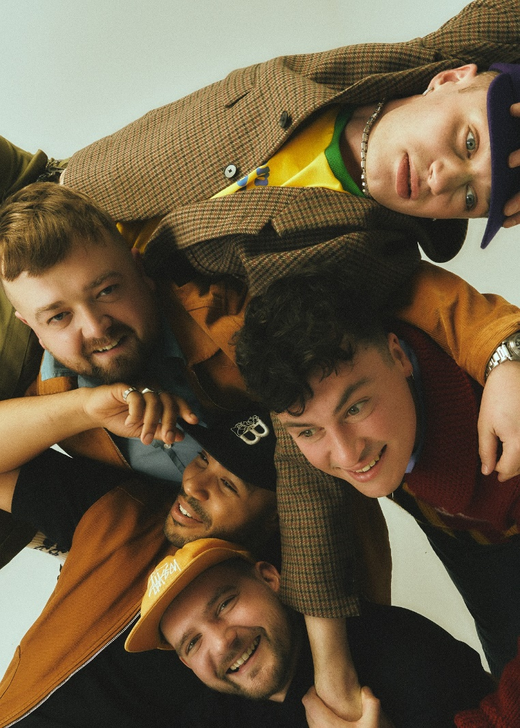

HI-RES IMAGE / ARTWORK

KAWALA RETURN WITH NEW ANTHEM 'AMERICAN ADRENALINE'
LISTEN HERE

Following last year’s successful run of sold-out UK dates to showcase new music, KAWALA enter 2024 with a slice of indie-pop optimism in new single ‘American Adrenaline’.

Back with their infectiously sounding harmonies blended seamlessly with mixtures of buoyant soundscapes, the North London five-piece yet again spotlight a signature sound that earned them an inundation of praise for their debut album Better With You.

Harmonising over sleek production with an overtly energetic chorus, accompanied with lines such as “I want the sun-kiss, overhead, high speed, mindset…” ‘American Adrenaline’ sets the scene as a glorious refresh for the band, and fans agree by instantly connecting with the track at live shows and furthering it as a bonafide crowd pleaser.
It sees the band’s distinctive song writing qualities shine in ways they haven’t before, marking a new and improved version of KAWALA; one that’s ready to take the new year by storm.

“We wrote American Adrenaline about the constant struggle we all face every day chasing this mythical unreachable idea of what often gets described as the ‘American dream’” they explain. “The glitz, the glamour & in reality it all feels miles away… but maybe that’s okay.”

Prepare to see a lot more of KAWALA with plenty more releases and live dates up their sleeve for the rest of the year.

Since releasing their debut album in 2022, KAWALA have seen praise from the likes of The Independent, describing the record as “a confident debut, the ideal summer-ready soundtrack”, Dork who claim “KAWALA step onto their own feet … their most self-assured” plus acclaim from CLASH “Consistent and fluid harmonies” and Far Out Magazine “Pocket-sized anthem after pocket-sized anthem”.
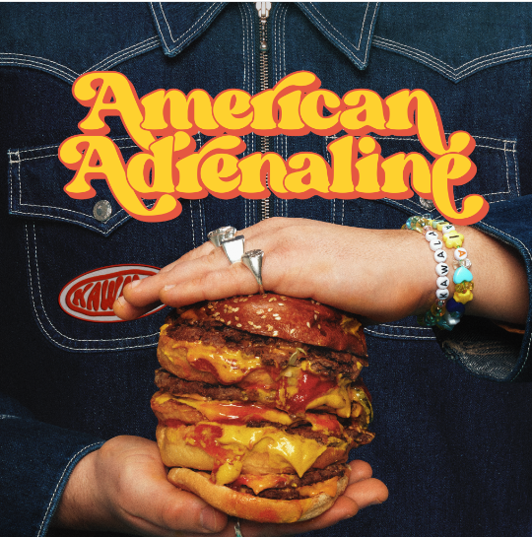

‘American Adrenaline’ kickstarts a brand-new era for KAWALA, watch this space…

https://www.tiktok.com/@tiktokawala
https://www.instagram.com/kawalagram
https://twitter.com/KawalaOfficial
https://www.facebook.com/KawalaOfficial

For more information please contact warren@chuffmedia.com

