BRADLEY SIMPSON

SHARES HIS LATEST SINGLE ‘ALWAYS LIKE THIS’ - LISTEN HERE

EUROPEAN AND UK HEADLINE TOUR STARTS NEXT MONTH

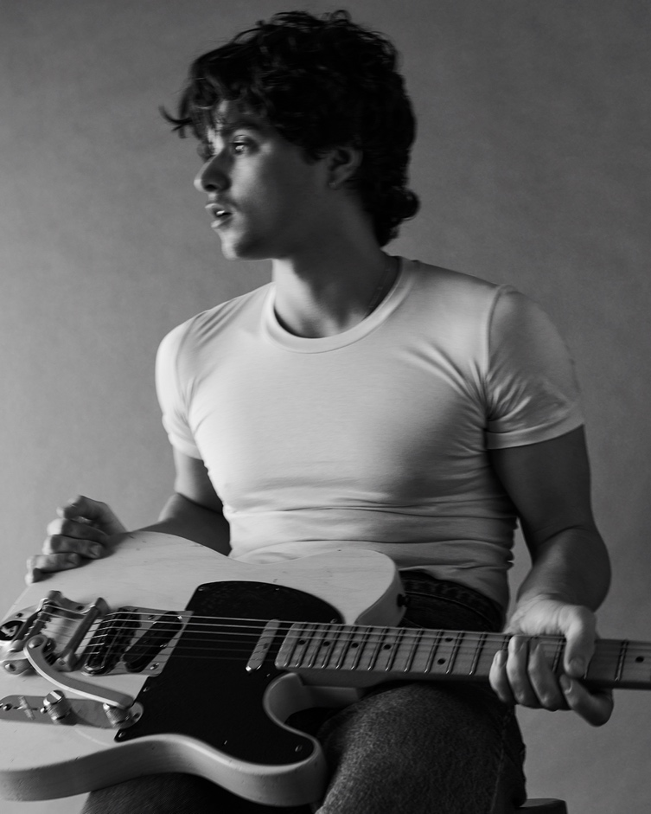

After spending this summer playing to huge crowds at Reading & Leeds festivals, Latitude and the Isle of Wight festival, Bradley Simpson now shares his new solo single, ‘Always Like This’.

Firing up with the energy of his live shows, ‘Always Like This’ is detonated with driving, propulsive drums and full on gritty guitars which recall his love of The Black Keys and The White Stripes. His voice commands centre-stage as he builds into the raw power of his full-blooded delivery, conveying the urgency of the lyrics which wrestle with the angst of uncertainty in a relationship.

The track was produced by Bradley’s main collaborators throughout his solo work, the Grammy winner BOOTS (Run the Jewels) and Andrew Wells.

Bradley says, “Always Like This was written and recorded in Paris at Motorbass studios, with Andrew Wells and Freddy Sheed. It was my first time working in Paris, and in Motorbass so it was a really special week. The studio has so much history and is a beautiful place to write. The song started with me and Freddy just jamming in the live room, and then built the whole structure up. The song has this distorted musicality and frantic feel to it, which I felt really suited lyrically where it went which was the feeling of not knowing when or if you’re going to pull yourself out of a dark place. It’s also one of my favourites to play live.’

Next month Bradley Simpson will take his band on his widest European headline tour to date before heading back home to the UK for a run of headline dates which all swiftly sold-out. An extra date at London’s Heaven was added after the two London gigs at the Village Underground sold out in a day (limited tickets for Heaven available HERE). In addition to his headline shows, Bradley will also play Manchester’s Neighbourhood Festival on October 5th.

The dates are:

OCTOBER - HEADLINE TOUR
17th - Barcelona, Wolf
18th - Madrid, Chango
21st - Paris, La Maroquinerie
22nd - Zurich, Mascotte
23rd - Milan, Santeria Toscana 31
25th - Munich, Backstage Halle
27th - Warsaw, Klub Niebo
28th - Berlin, Gretchen
29th - Hamburg, Bahnhof Pauli
31st - Amsterdam, Melkweg Max

NOVEMBER - HEADLINE TOUR
1st - Antwerp, Trix Club
2nd - Cologne, Luxor
6th - Dublin, Academy Green Room
8th - Birmingham, O2 Institute 2 (SOLD OUT)
9th - Liverpool, Arts Club (SOLD OUT)
10th - Newcastle, Riverside (SOLD OUT)
12th - Glasgow, The Garage (SOLD OUT)
13th - Leeds, Brudenell Social Club (SOLD OUT)
15th - Manchester, Band On The Wall (SOLD OUT)
16th - Nottingham, Rescue Rooms (SOLD OUT)
18th - London, Village Underground (SOLD OUT)
19th - London, Village Underground (SOLD OUT)
21st – London, Heaven (ADDED DATE – LOW TICKETS)

Follow Bradley Simpson:
Spotify | Apple Music | TikTok | Instagram

For more information please contact
Warren Higgins warren@chuffmedia.com

