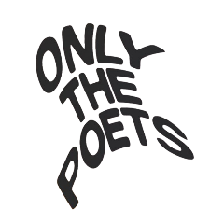
ONLY THE POETS SHARE NEW SINGLE
‘ALL THIS TIME’
FROM ‘ONE MORE NIGHT’ EP OUT 31ST MAY
LISTEN HERE / PRE-ORDER HERE
UK DATES IN JUNE
HI-RES IMAGE / ARTWORK
Edging closer to the release of their highly anticipated ‘One More Night’ EP out May 31st, alt-pop four-piece Only The Poets provide the next exuberant instalment, ‘All This Time’
Listen HERE / Pre-Order EP HERE.
Featuring the euphoric singles, ‘I Don’t Wanna Be Your Friend’, ‘One More Night’ & ‘Gone By Now’ plus three other rip-roaring songs, the ‘One More Night’ EP sees the band at their most captivating, consolidating their electrifying synth-pop sound and illuminating the heartfelt emotion in their lyrics.
“We’ve taken a lot of our influences from stuff we’re listening to now intertwined with Brit-pop and experimented with vocal layers and harmonies,” says frontman Tommy Longhurst. “At the back of our minds we’re constantly thinking about how these songs will sound live. We really wanted to go for that big, expansive stadium filler sound.”
The EP’s fourth release, co-written with The Nocturns (Tom Grennan, Cian Ducrot) and produced by the band themselves, is a melodic banger equip with pulsating synths and intensified guitar arrangements – a recipe that has earned them ‘Tune of the Week’ on Radio 1 plus a sold-out headline EU tour.
Travelling from country to country, the new EP was recorded on the road, the band setting up recording equipment and cutting vocals whilst touring “We’re excited that so much of this EP was done just the four of us, and a lot of the production was done by Marcus (drums) and Clem (guitar). Feeling inspired and recording whilst playing shows was a cool way of working, we’d not done that before.”
Only The Poets, comprising of Tommy Longhurst, bassist Andy “Roo” Burge, guitarist Clem Cherry and drummer Marcus Yates, have established themselves in just a few short years as one of the UK’s biggest emerging live acts. Unsigned until the start of 2023, the band’s DIY ethos saw them build things from the ground up, from playing student house parties, pub circuits and small venues to selling out 1,600-capacity venues in the UK and across Europe last year.
2024 has already seen the band kick off a massive run of 22 European shows taking in venues across the continent including Milan, Krakow, Berlin, Prague, Oslo and Krakow. In June the band will play a string of shows across London, Birmingham, and Oxford, with further dates scheduled for August around their appearance at Reading & Leeds Festivals.
The band have an initiative to provide tickets low and no income fans – please see the bands post here for more information.

UK Dates
Wed 5 June 2024 – London, KOKO
Fri 7 June 2024 – Birmingham, O2 Academy 2
Sat 8 June 2024 – Oxford, O2 Academy 2
Thur 22 August 2024 – Glasgow, St Lukes
Fri 23 August 2024 – Leeds, Festival
Sun 25 August 2024 – Reading, Festival
Tue 27 August 2024 - Manchester, Gorilla
Wed 28 August 2024 – Bristol, Thekla
Thur 29 August 2024 – Southampton, Engine Rooms

PRE-ORDER THE ‘ONE MORE NIGHT’ EP HERE
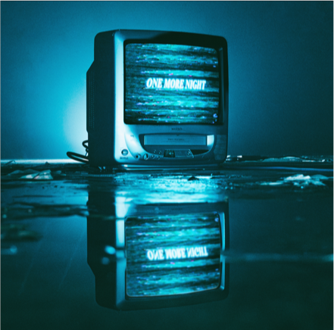
ONE MORE NIGHT EP TRACKLIST
Digital EP:
One More Night
Gone By Now
I Don't Wanna Be Your Friend (explicit)
All This Time
It's Okay (Not to Be Okay)
Change
One More Night (alt version)
One More Night (live version)

Physical EP:
One More Night
Gone By Now
I Don't Wanna Be Your Friend (explicit)
All This Time
It's Okay (Not to Be Okay)
Change
Black and Blue (demo)
One More Night (alt version)
One More Night (live version)

FOLLOW ONLY THE POETS:
OTP // INSTA // TWITTER // FB

For more information and press enquiries please contact
Jenny Entwistle
Jenny@chuffmedia.com

