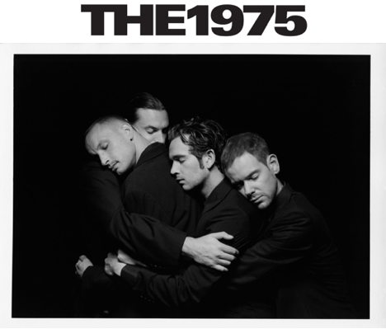
[Photo credit: Samuel Bradley]

[Wednesday 21st September, London]

The 1975 today release ‘All I Need To Hear’ - the fourth track from their highly anticipated forthcoming new album ‘Being Funny In A Foreign Language’.

You can listen to ‘All I Need To Hear’ and watch the Samuel Bradley-directed live performance video HERE.

‘All I Need To Hear’ follows recent releases ‘I’m In Love With You’, ‘Happiness’ and ‘Part Of The Band’. All four tracks will feature on ‘Being Funny In A Foreign Language’, the band’s fifth studio album, released Friday 14th October via Dirty Hit and available to pre-order now at the1975.com.

In support of ‘Being Funny In A Foreign Language’, the band will be taking their brand new ‘At Their Very Best’ tour on the road with dates across the US in November and December before a run of shows in the UK and Ireland in January 2023. Tickets are on sale now HERE.
In addition, the band have just announced the Japanese leg of their ‘At Their Very Best’ tour, taking in shows in Yokohama, Nagoya and Osaka in April 2023. Tickets are available via fan presale from Sunday 25th September. You can find more information HERE.

The 1975 made their long awaited live comeback last month, headlining Japan’s biggest rock festival Summer Sonic 2022 in Tokyo and Osaka before returning for two triumphant homecoming headline slots at Reading & Leeds Festival.

Formed in Manchester in 2002, The 1975 have established themselves as one of the defining bands of their generation with their distinctive aesthetic, ardent fanbase and unique sonic approach.

The band’s previous album, 2020’s ‘Notes On A Conditional Form’, became their fourth consecutive No. 1 album in the UK, landing at No. 1 in Australia too. The band were named NME’s ‘Band of the Decade’ in 2020 after being crowned ‘Best Group’ at the BRIT Awards in both 2017 & 2019. Their third studio album, ‘A Brief Inquiry Into Online Relationships’, also won ‘Mastercard British Album of the Year’ at the 2019 ceremony.

The 1975 ‘At Their Very Best’ Tour Dates:

Thu 11/3/22 - Uncasville, CT - Mohegan Sun Arena
Fri 11/4/22 - Boston, MA - MGM Music Hall at Fenway - Sold Out
Sat 11/5/22 - Boston, MA - MGM Music Hall at Fenway - Sold Out
Mon 11/7/22 - New York, NY - Madison Square Garden - Sold Out
Wed 11/9/22 - Camden, NJ - Freedom Mortgage Pavilion
Thu 11/10/22 - Washington, DC - The Anthem - Sold Out
Sat 11/12/22 - Atlanta, GA - State Farm Arena
Sun 11/13/22 - Nashville, TN - Nashville Municipal Auditorium - Sold Out
Tue 11/15/22 - Grand Prairie, TX - Texas Trust CU Theatre
Wed 11/16/22 - Houston, TX - 713 Music Hall
Thu 11/17/22 - Austin, TX - Moody Center
Sun 11/20/22 - Mexico City, MX - Corona Capital Festival - Sold Out
Wed 11/23/22 - Phoenix, AZ - Arizona Financial Theatre - Sold Out
Fri 11/25/22 - Las Vegas, NV - The Theater at Virgin Hotels
Sat 11/26/22 - San Diego, CA - Cal Coast Credit Union Open Air Theatre - Sold Out
Mon 11/28/22 - Los Angeles, CA - Kia Forum
Tue 11/29/22 - San Francisco, CA - Bill Graham Civic Auditorium - Sold Out
Thu 12/1/22 - Portland, OR - Moda Center
Fri 12/2/22 - Seattle, WA - WAMU Theater - Sold Out
Thu 12/8/22 - Independence, MO - Cable Dahmer Arena - Sold Out
Sat 12/10/22 - Milwaukee, WI - The Eagles Ballroom - Sold Out
Mon 12/12/22 - Toronto, ON - Scotiabank Arena
Wed 12/14/22 - Minneapolis, MN - Armory
Fri 12/16/22 - Newport, KY - PromoWest Pavilion at OVATION - Sold Out
Sat 12/17/22 - Pittsburgh, PA - UPMC Events Center - Sold Out

Sun 08/01/23 - Brighton - The Brighton Center - Sold Out
Mon 09/01/23 - Bournemouth - Bournemouth International Center
Tue 10/01/23 - Exeter - Westpoint Arena
Thu 12/01/23 - London - The O2 - Sold Out
Fri 13/01/23 - London - The O2
Sun 15/01/23 - Birmingham - Resorts World Arena
Mon 16/01/23 - Cardiff - Motorpoint Arena - Sold Out
Tue 17/01/23 - Cardiff - Motorpoint Arena
Thu 19/01/23 - Glasgow - SSE Hydro
Fri 20/01/23 - Manchester - Manchester Arena
Sun 22/01/23 - Nottingham - Motorpoint Arena
Mon 23/01/23 - Leeds - First Direct Arena
Weds 25/01/23 - Newcastle - Utilita Arena
Thu 26/01/23 - Liverpool - M&S Bank Arena
Sun 29/01/23 - Dublin - 3Arena
Mon 30/01/23 - Belfast - The SSE Arena

Wed 26/04/23 - Yokohama - PIA Arena
Thu 27/04/23 - Yokohama - PIA Arena
Sat 29/04/23 - Nagoya - Aichi Sky Expo
Sun 30/04/23 - Osaka - Jo Hall

​​‘Being Funny In A Foreign Language’ Tracklist:

1. The 1975
2. Happiness
3. Looking For Somebody (To Love)
4. Part Of The Band
5. Oh Caroline
6. I’m In Love With You
7. All I Need To Hear
8. Wintering
9. Human Too
10. About You
11. When We Are Together

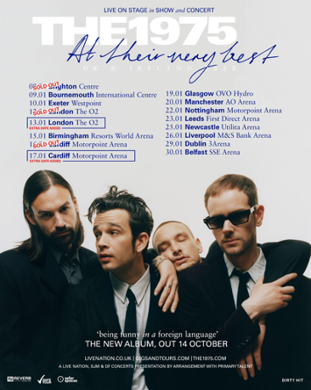
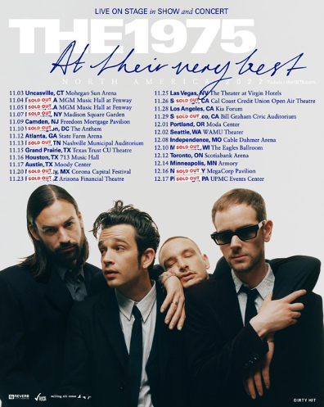
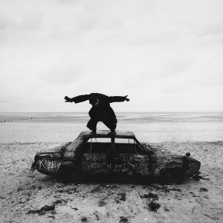
Being Funny In A Foreign Language Artwork [Photo credit: Samuel Bradley]

##

https://the1975.com/
https://twitter.com/the1975
https://www.instagram.com/the1975
https://www.tiktok.com/@the1975

www.instagram.com/trumanblack
https://www.instagram.com/bedforddanes75
https://www.instagram.com/1975adam
https://www.instagram.com/rass1975

For more on info contact warren@chuffmedia.com

