**DIVORCE share new single 'Antarctica'  
  
Debut album *Drive to Goldenhammer*out March 7th 2025 via Gravity / Capitol**

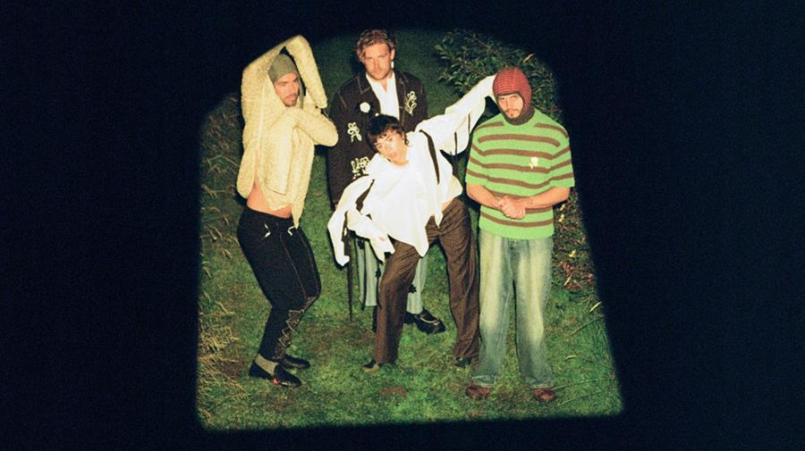

Divorce | Photo credit: Flower Up & Rosie Sco | Download hi-res image [here](https://prescriptionpr.createsend1.com/t/j-i-ghdtttt-l-y/)

DIVORCE are today sharing new single 'Antarctica'. It is the latest new music to be taken from the band's highly-anticipated forthcoming debut album *Drive to Goldenhammer*, which arrives on March 7th 2025 via Gravity / Capitol.  
  
Released on the heels of radiant lead single '[All My Freaks](https://prescriptionpr.createsend1.com/t/j-i-ghdtttt-l-j/)' - the band's fastest streaming single so far and one that continues to make a big impact on the BBC 6 Music playlist - 'Antarctica' is a wash of quiet yearning that wrangles breezy guitar interplay and vivid lyricism to poignantly capture the sometimes fleeting nature of love, loss, and life.  
  
It comes as the band caps a flurry of fruitful Autumnal activity, including four sold-out hometown residency shows at Nottingham's Bodega, their biggest ever sold-out headline show at London's Islington Assembly Hall, plus a much-talked-about performance at Pitchfork Music Festival Paris last week. The band were also recently announced among the first wave of artists to open for The Maccabees at next year's All Points East festival.  
  
Commenting on the new single, co-vocalist and guitarist Felix Mackenzie-Barrow says:  
  
*"I wrote 'Antarctica' at the end of a long and deeply important relationship as a way to self-soothe and make sense of the loss I was feeling whilst touring non-stop. Thinking of the silent indifference of that vast continent at the bottom of the world was and still is something of a meditation for me. Barry Lopez describes Antarctica as “utterly remote, even as you stand in it. The light itself is aloof.”  
  
The song also recounts an event that Tiger and I experienced, encountering a newborn calf in the middle of the road on a late night drive. It felt urgent; the calf’s defenceless was impossible to ignore and we carried it back into the farm. There was a choice there. Did we rescue it from the road where it could have been hit by a human in a car or did we just send it back to be killed by a different human further down the line?  
  
Neither option feels good or makes any sense to me, but the feeling of its fur covered in afterbirth and the desperate cries of its mother is something I will never forget."*  
  
Listen to new single 'Antarctica' on streaming services [here](https://prescriptionpr.createsend1.com/t/j-i-ghdtttt-l-t/) and share the video via YouTube below.  
  
**Pre-order the album**[**here**](https://prescriptionpr.createsend1.com/t/j-i-ghdtttt-l-i/)**.**

](https://prescriptionpr.createsend1.com/t/j-i-ghdtttt-l-d/)

**The band have also announced their Drive to Goldenhammer tour for this spring:**

Oxford – The Bullingdon – March 27th

Bristol – Strange Brew – March 28th

Birmingham – The Castle & Falcon – March 29th

Belfast – Ulster Sports Club – March 31st

Manchester – Gorilla – April 3rd

Leeds – Brudenell Social Club – April 4th

Glasgow – Stereo – April 5th

Brighton – Chalk – April 8th

London – KOKO – April 9th

**More about Divorce's debut album *Drive to Goldenhammer***  
  
Initially meeting as teenagers through the city’s close-knit DIY scene, the band – completed by members Tiger Cohen-Towell (vocals / bass), Felix Mackenzie-Barrow (vocals / guitar), Adam Peter Smith (guitar / synth) and Kasper Sandstrøm (drums) - came together as Divorce in mid-2021, releasing a slew of genre-defiant singles that quickly caught the attention of tastemakers the world over. Last year they signed to Gravity Records (Universal Music) for their acclaimed *Heady Metal EP*, before filling 2024 with a raft of international festivals and tours with Bombay Bicycle Club, The Vaccines and Everything Everything. They have since sold out their own upcoming four-night residency at hometown venue Bodega (the first band to do so) and wrapped up their UK tour with their biggest headline show to date at a sold out Islington Assembly Hall.  
  
Adjusting to life as a touring, transient entity began to leave the band feeling *“like we were being dragged through a hedge backwards – in a nice way!”* and as a result searching to carve out a place that they can call home within their music. The result is a pastoral blend of country, indie-rock, folk and chamber pop that traces the upheaval of the last few years while planting roots in their own sound. Influenced by location, memory, warmth and a deep-seated love for their post-industrial Midlands, they explore themes of transformation across 12 meticulously crafted tracks that balance heart-on-sleeve sentiments and tongue-in-cheek humour, devastation, playfulness and all-consuming feelings. Sonically rich and lyrically open-hearted, it sees Divorce assemble a shelter for themselves amid the chaos and leave the front door open to everyone.  
  
*Drive to Goldenhammer* was written and demoed across four recording stays at rural North Yorkshire outpost The Calm Farm. Sessions spanned the spring, summer, autumn and winter - the band writing night and day - before the completed songs were brought to life with producer Catherine Marks (boygenius, Foals, Wolf Alice) at Real World Studios. As a result, the record has a well-worn and lived-in feeling, with a natural warmth, something they deliberately wanted to bake into the album to reflect the band’s identity as it relates to the Midlands, but also as – in a nod to the fantasy location of Goldenhammer - a fictional refuge from the world at large.  
  
Still refusing to box themselves into a genre, *Drive to Goldenhammer* lays the Divorce “stamp” across a breadth of influences. Across songs that waltz around weaving riffs and vocal acrobatics, moody acoustic introspection, walls of alt-rock, shape-shifting electronic glitches, with string flourishes, these are songs that build, bloom and release, fittingly always finding their way home under the influence of the band’s stewardship. It is an album that much like its writers, leaves the door open to discovery, and actively reaches out for connection.  
  
Tiger says of the album: *"We’re very proud of Drive to Goldenhammer. We got to make an album the way we wanted to, kept the weird parts in, followed the warmth and didn’t overthink it. This album pays homage to seeking place and home; one of the great human levellers. Much of life feels at odds with this particular need. And to Goldenhammer; you are a reason to keep driving. We will find you again and again!"*

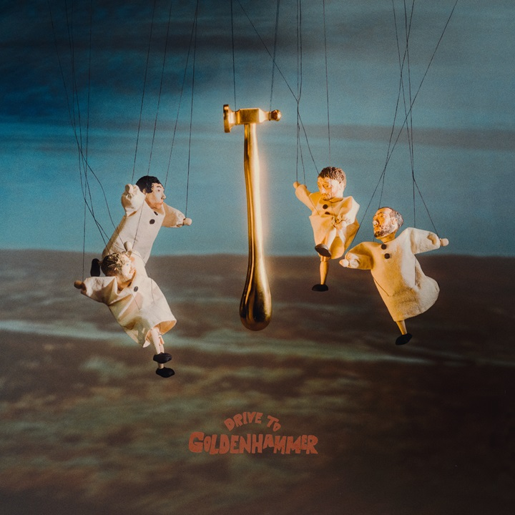

Divorce - *Drive to Goldenhammer* album artwork | Download image [here](https://prescriptionpr.createsend1.com/t/j-i-ghdtttt-l-h/)

**Divorce:**[**Website**](https://prescriptionpr.createsend1.com/t/j-i-ghdtttt-l-k/)**|**[**Facebook**](https://prescriptionpr.createsend1.com/t/j-i-ghdtttt-l-u/)**|**[**Instagram**](https://prescriptionpr.createsend1.com/t/j-i-ghdtttt-l-c/)**|**[**TikTok**](https://prescriptionpr.createsend1.com/t/j-i-ghdtttt-l-q/)**|**[**X**](https://prescriptionpr.createsend1.com/t/j-i-ghdtttt-l-a/)**|**[**YouTube**](https://prescriptionpr.createsend1.com/t/j-i-ghdtttt-l-f/)

**For more information & media enquiries, please contact:**

**Warren Higgins**

[**warren@chuffmedia.com**](mailto:warren@chuffmedia.com)