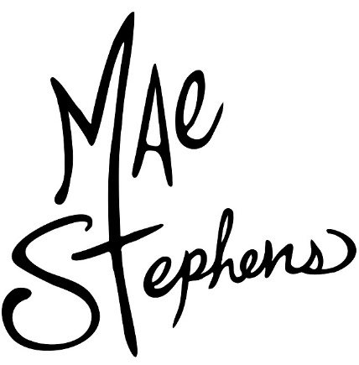

DROPS CATCHY NEW TRACK ‘ADHD’
LISTEN HERE

HI-RES IMAGE / ARTWORK

FOLLOWS GLOBAL SUCCESS OF DEBUT SINGLE ‘IF WE EVER BROKE UP’ WITH ACCUMULATED AUDIO STREAMS OF NEARLY 1 BILLION

2023 was undoubtedly a huge year for rising star, Mae Stephens. Few artists release their debut single and have their world turned upside down, yet for the Kettering born 20-year-old her infectious, attitude-filled alt-pop bop, ‘If We Ever Broke Up’ connected with audiences around the world. ‘If We Ever Broke Up’ became a global smash scoring accumulated audio streams of nearly one billion and was named the second most popular song on TikTok globally in 2023!

Over the summer Mae performed at festivals including Glastonbury, The Great Escape (where NME included her in their ‘10 Best New Artists’ at the festival) BST Hyde Park supporting BLACKPINK, All Points East and headlined the BBC Radio 1 Introducing stage at Reading & Leeds.

Connecting with fans across the year, Mae has accumulated over 10 million monthly listeners on Spotify and has racked up impressive accolades along the way, with ‘If We Ever Broke Up’ recently reaching Gold in the UK and US.

Speaking about the year Mae says,
“Where do I even start. 2023 gave me everything I ever wanted. I have so many people to thank, from the people who supported me from the beginning to the fans that streamed the song to my family who have been the biggest support to me this last year. It has been one hell of a whirlwind and definitely a year I won’t forget. 2023 you gave me hope that in dark times you can push through and succeed to enjoy the simple things in life. But moving on 2024 is the time and place for some new tunes and a new turn in my musical journey. Expect some weird and wonderful surprises and maybe some hidden gems at the end. 2024 is going to be an incredible year but to send 2023 off with a bang. If we ever broke up…. I’d be 100% be sad. Thankyou 2023 you gave me my dream. Cheers! ”

Featured as one of VEVO’s ‘Artists To Watch’ for 2024, Mae is kicking off the year with the catchy funk-laden single ‘ADHD’, which fuses a catchy bassline with candid lyrics detailing her experiences of ADHD, overstimulation and OCD. Speaking about the track, Mae says,

“ADHD is a really important track for me. It's about my process of going through understanding myself, and how the word 'disorder' is the wrong term for it, as it's my normality. To anyone with ADHD, you are seen, and you are loved."

It was only a year ago that Mae Stephens was finding solace and sanctuary in her music-making between working shifts at her local Asda. A songwriter since the age of twelve, she had used music to guide her through the hardships of teenage life and her own mental health journey, pouring her heart out in emotional, impactful songs penned on her nan’s old piano,

The target of cruel bullying, Mae’s school years were far from easy, with her at first picked on for being the “loud, quirky kid” – but with the icon Freddie Mercury as one of her biggest musical influences, Mae is on a journey of embracing what makes her unique and learning not to care about other people’s opinions. In Mae Stephens, Gen Z has found a new champion; she’s ready to use her voice to help others and provide the same kind of sanctuary in her music that it gave her while making it.

Mae Stephens is poised to own 2024!

Don’t miss a thing:
TIKTOK | INSTAGRAM | YOUTUBE | SPOTIFY

For more information and press enquiries please contact

Jenny Entwistle
Jenny@chuffmedia.com

