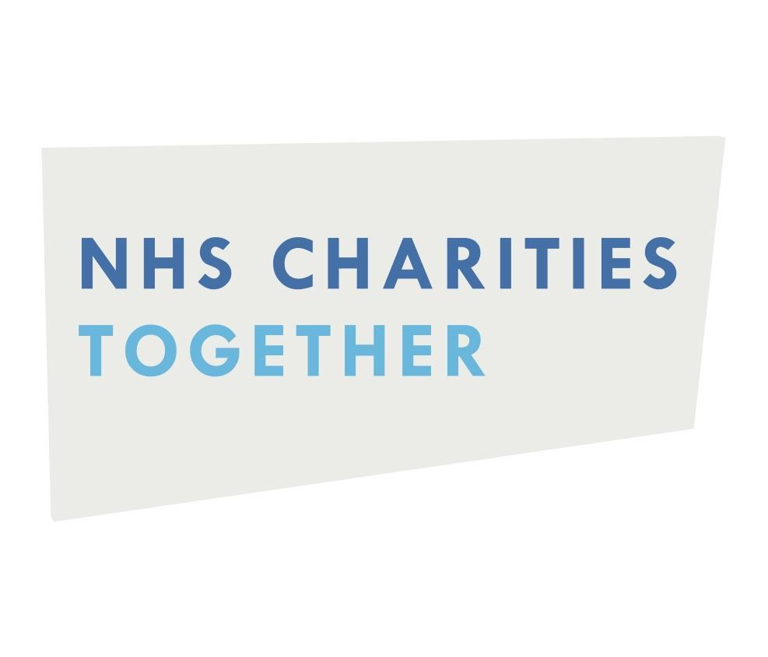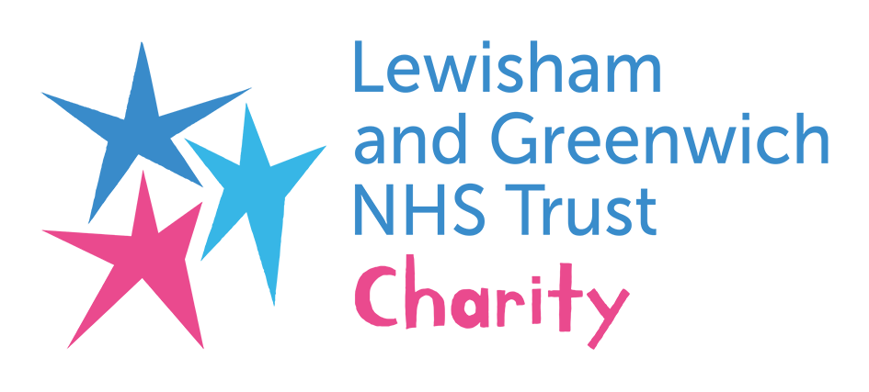
Rag‘n’Bone Man & P!nk Release
Charity Single

‘Anywhere Away From Here’ ft. Lewisham & Greenwich NHS Choir
OUT NOW

DOWNLOAD / STREAM HERE

International Nurses Day today, May 12th 2021

After a rapturous closing performance at last night’s BRIT Awards, Rag’n’Bone Man & P!nk have released an incredible version of ‘Anywhere Away From Here’ with the Lewisham & Greenwich NHS Choir as a charity single. Money raised will go to the Lewisham and Greenwich NHS Charity and NHS Charities Together, who represent the charities of all NHS Trusts in the UK.

The track is available to stream and download NOW!

Raising collective goosebumps from audiences both in the arena and at home, last night’s collaboration will go down as a true BRITs standout. With backing from the Lewisham and Greenwich NHS Choir, and P!nk performing remotely from the U.S, it was an emotional tribute to the many NHS colleagues across the UK who have done such extraordinary work during these unprecedented times. Notably today, Wednesday May 12th marks International Nurses Day.

The choir do their singing and rehearsing in their spare time, all while providing amazing care for the residents of their local boroughs. Disciplines from Physiotherapy to Sexual Health to Chemotherapy are all represented in the Trust Choir’s diverse group of singers. Members include soprano pair Ozioma Obi and Elem Nnachi, who work together on the Neonatal Intensive Care Unit, with midwife Lizzie Farrant fitting the Choir around her clinical work and marathon-running. In the true spirit of bringing people together, Tom Jackson and Zoe Davies – a Trauma Surgeon and a Consultant Endocrinologist respectively – met through the Trust Choir and are now married.

For more info on each choir member, read their powerful stories HERE.

Margarita Vidiella, head of the Lewisham and Greenwich NHS Trust Charity, says: “It is only thanks to generous donations that we are able to make a difference to our amazing colleagues and our communities - such as comfortable wellbeing hubs for clinicians to have a well-deserved rest, and psychological counselling for when our staff need that support. Thanks to all you generous Rag‘n’Bone Man fans, we’ll be able to do even more for our corner of south east London and, through NHS Charities Together, the NHS as a whole!”

Since winning The BRIT Rising Star award in 2017 Rag’n’Bone Man has won a total of three BRIT Awards. In 2003 the multi-million selling global pop icon P!nk won her first BRIT Award for International Female, and in 2019 she was honoured with the prestigious Outstanding Contribution to Music Award.

Three years after his groundbreaking, award winning debut, ‘Human’, Rag’n’Bone Man has now released his stellar new album ‘Life By Misadventure’ and is on course to hit the top of the charts once again according to the official charts midweeks. This special charity single is a fresh new take on his latest single - ‘Anywhere Away From Here’ (with US superstar P!nk) which features on the album alongside the album’s other incredible single ‘All You Ever Wanted’.

NHS Charities Together have recently launched a new appeal urging the public to be ‘there for them’ as NHS staff face the triple challenge of dealing with the continuing impact of Covid, tackling the backlog of other patients who desperately need treatment and making sure their own mental health isn’t a casualty of the crisis.

NHS Charities Together will use the funds raised through the new appeal to significantly ramp up the mental health and wellbeing programmes and facilities available for staff across the UK.

nhscharitiestogether.co.uk | The Trust Choir |
ragnboneman.com | pinkspage.com |Choir Member Biogs
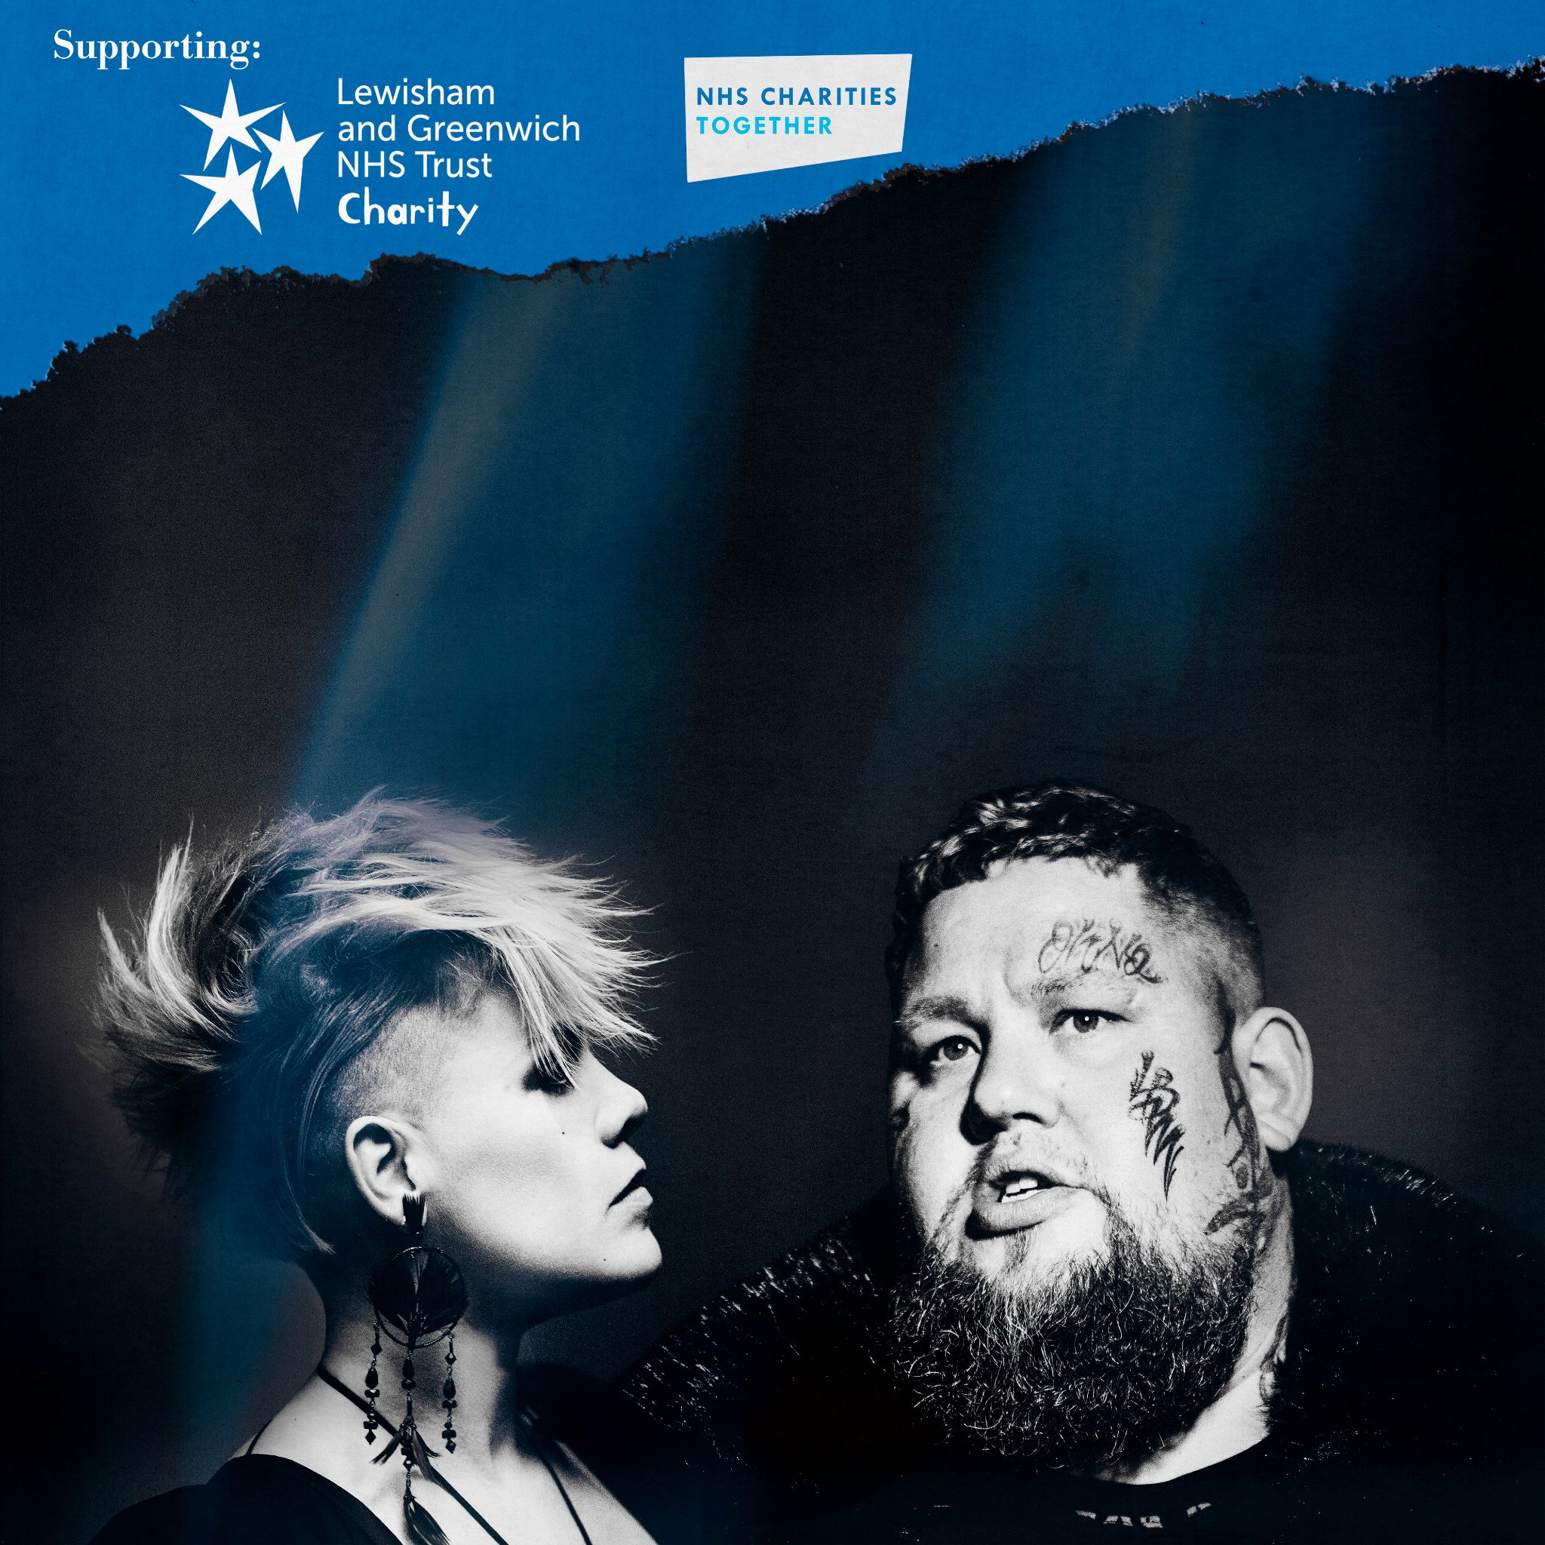

For more information and press enquiries please contact
Jenny Entwistle
Jenny@chuffmedia.com

