Another Sky Release New Single

Listen To ‘A Feeling’

+ Announce Headline Show At London’s Lafayette for 8th November

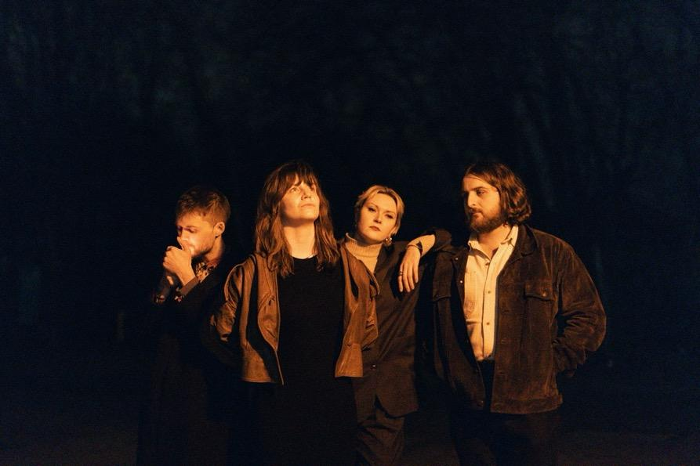
Download
Credit Darina

Another Sky’s return earlier this year heralded an exhilarating step forward for the South London quartet. After a three-year absence from the spotlight, the band’s long-awaited single “Psychopath” was a far more punchy and direct rock song than anything from their 2020 debut record, “I Slept On The Floor”. “Psychopath” received widespread acclaim across media including support at Radio 1, 6 Music and Radio X, and landed alongside a raw acoustic B-Side “Watching Basinski”, recorded in the band’s bedrooms during lockdown.

Today Another Sky are excited to release ‘A Feeling’, another huge creative step forward for the band. Melding richly textured percussion and rhythm sections with squalling, Soundgarden-esque guitars and the furious vocals of vocalist Catrin Vincent, Another Sky are fully embracing their electrifying new era.

Listen To ‘A Feeling’ Here

Vocalist Catrin Vincent says of the track:

“‘A Feeling’ was written after a conversation with an ultra-capitalist. I lost my job in lockdown and they said I should accept it was my punishment for “just not working hard enough.”

It was around the time of Mollie May and Kim Kardashian saying things like, “everyone has the same 24 hours in a day”. With everyone in lockdown, social media exploded. We were all hunting each other, lecturing each other and telling each other how to survive, without thinking of the different circumstances people live in.

The song is bitter, but hopefully something a lot of people can relate to and find catharsis in. I was reminded of all my least favourite bosses and authority figures. I felt like I’d lost the strength to argue facts, and all I was left with was a feeling”

‘A Feeling’ Artwork’
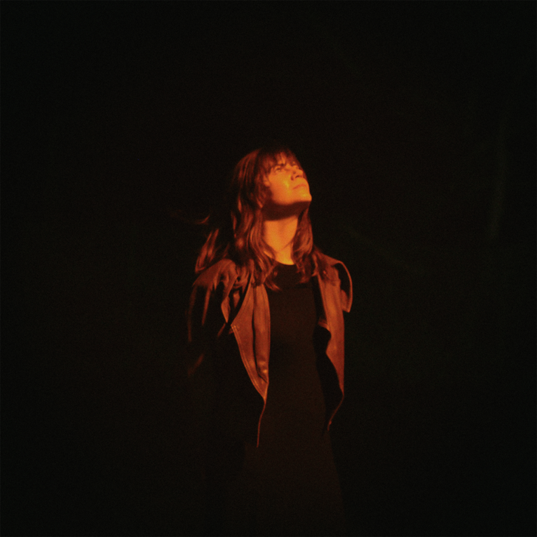
Download
Credit Darina

The band have also announced a headline show at London’s Lafayette for 8th November 2023. Tickets are on sale now via xx

Catrin adds:

“The new music explores duality and polarity; fear and love, facts and feelings, outer chaos and inner peace.

Our London show is going to be a full visual representation of that. We’re doing something we’ve never done before to really try and create a unique experience for our fans.”

In their three-year absence, the band (Vincent, Jack Gilbert, Naomi Le Dune & Max Doohan) have not only been writing and producing new music but have built a brand-new studio from scratch in the crypt of a Church. More info to follow on that new music soon.
The news of their return came with an announcement of their signing to Republic Records in the US. “Who knew a song in 5/4 timing [‘Psychopath’] would get you signed to a US major label?” quips Vincent. The band continues to work with Fiction Records in the rest of the world.

Live Dates:
8th November Lafayette, London

For more on info contact warren@chuffmedia.com

