***“The one thing I hate, cos I can’t concentrate,***

***no I just can’t abide, yeah I’ve never the time, to 69”***

**HAPPY VALENTINE’S DAY FROM**

**SELF ESTEEM**

**WATCH & LISTEN TO THE NEW SONG ‘69’**

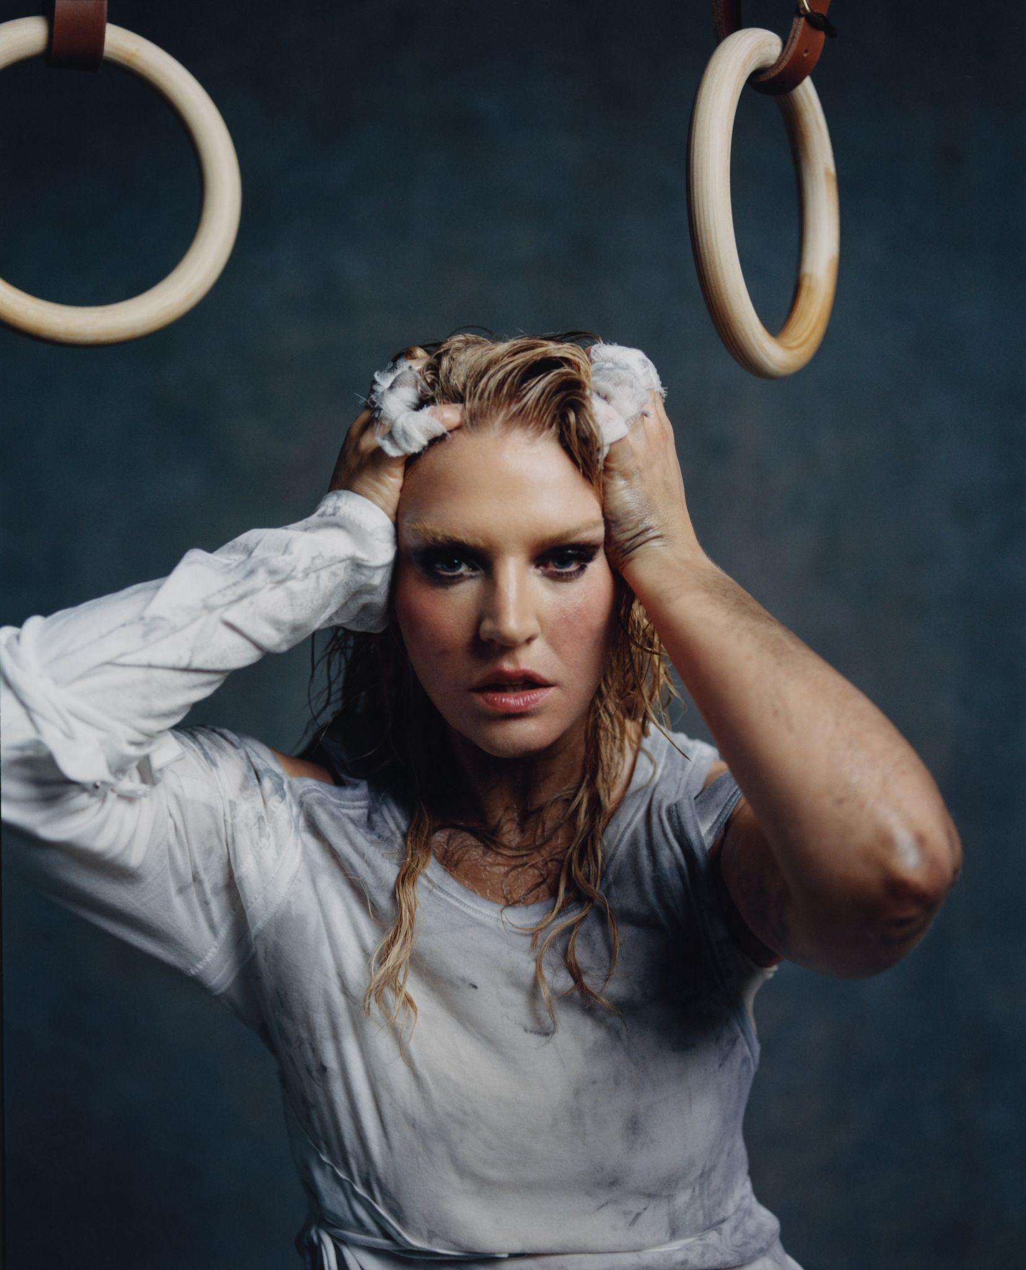

**Self Esteem - photo credit: Scarlett Carlos Clarke (download assets** [**here**](https://drive.google.com/drive/folders/1PzHuReSTjuJiNgaqbggCcYvcYShnbD6l)**)**

**LIFTED FROM *A COMPLICATED WOMAN***

**DUE 25 APRIL VIA POLYDOR RECORDS**

***A COMPLICATED WOMAN LIVE***

**SOLD OUT 16-19 APRIL AT DUKE OF YORK’S THEATRE**

Self Esteem AKA Rebecca Lucy Taylor celebrates Valentine’s Day with the release of her new song ‘69,’ available to stream and download now, alongside a video by Piers Dennis.

“I always wanted to write a song that lists sex positions and rates them,” explains Taylor. “A lot of my music is saying the things I struggle to say in real life. I like the idea of clearly communicating your needs in one quick, three-minute house song. It is also political – women still are expected to cater to others sexually; I can’t hear another discussion about ‘faking it’, it upsets me too much! There’s enough inequality in the male/ female dynamic as it is. Our bodies go through so much more pain and suffering, please god let us get the pleasure where we can!”

The song features a guest appearance from a legendary drag queen: “I’d already written the song and then months later my all-time favourite drag queen Meatball said pretty much the same on her podcast Sloppy Seconds, and I knew it had to make the album!”

[**Stream / download / watch ‘69’**](https://selfesteem.lnk.to/69_)

‘69’ is the second song to be lifted from Self Esteem’s eagerly anticipated new album *A Complicated Woman*, due for release 25 April in digital, CD, cassette and vinyl formats - including limited editions - via Polydor Records. The album is the follow up to the hugely acclaimed BRIT and Mercury Prize-nominated 2021 album *Prioritise Pleasure* - an album of the year everywhere from the Guardian to the Sunday Times.

[**Pre-order / pre-save *A Complicated Woman***](http://selfesteem.lnk.to/AComplicatedWoman)

Described by the Guardian as “her best yet”, *A Complicated Woman* contains all Taylor’s musical thumbprints – complex thought processes unfolding in real time, an effortless knack of exposing the feelings women are required to labour under – but set on a larger, brighter landscape that is nothing short of exhilarating. Running through the album is a jubilant choir constructed of dozens and dozens of mostly female voices - “a community of people. I want you to hear and feel the connection” - including close friends, her band and collaborators, that includes - but is not limited to - singer-songwriters Nadine Shah, Moonchild Sanelly and Sue Tompkins from Life Without Buildings; Meatball and a bona fide Lancaster legend, the actress Julie Hesmondhalgh.

*A Complicated Woman* is about taking control of your life, summed up in the astonishing first single ‘Focus Is Power’. Inspired by words Taylor wrote on a sticker, working from her mum and dad’s shed in the pandemic - “*You see, it wasn’t up to me but now it could be / But now I see it clear with every passing of each year / I deserve to be here…”* - the lyrics become an incantation when shared between the choir, something the accompanying music video (shot by long time collaborator Piers Dennis) echoes in its community hall performance.

[**Listen / watch ‘Focus Is Power’**](http://selfesteem.lnk.to/FocusisPower)

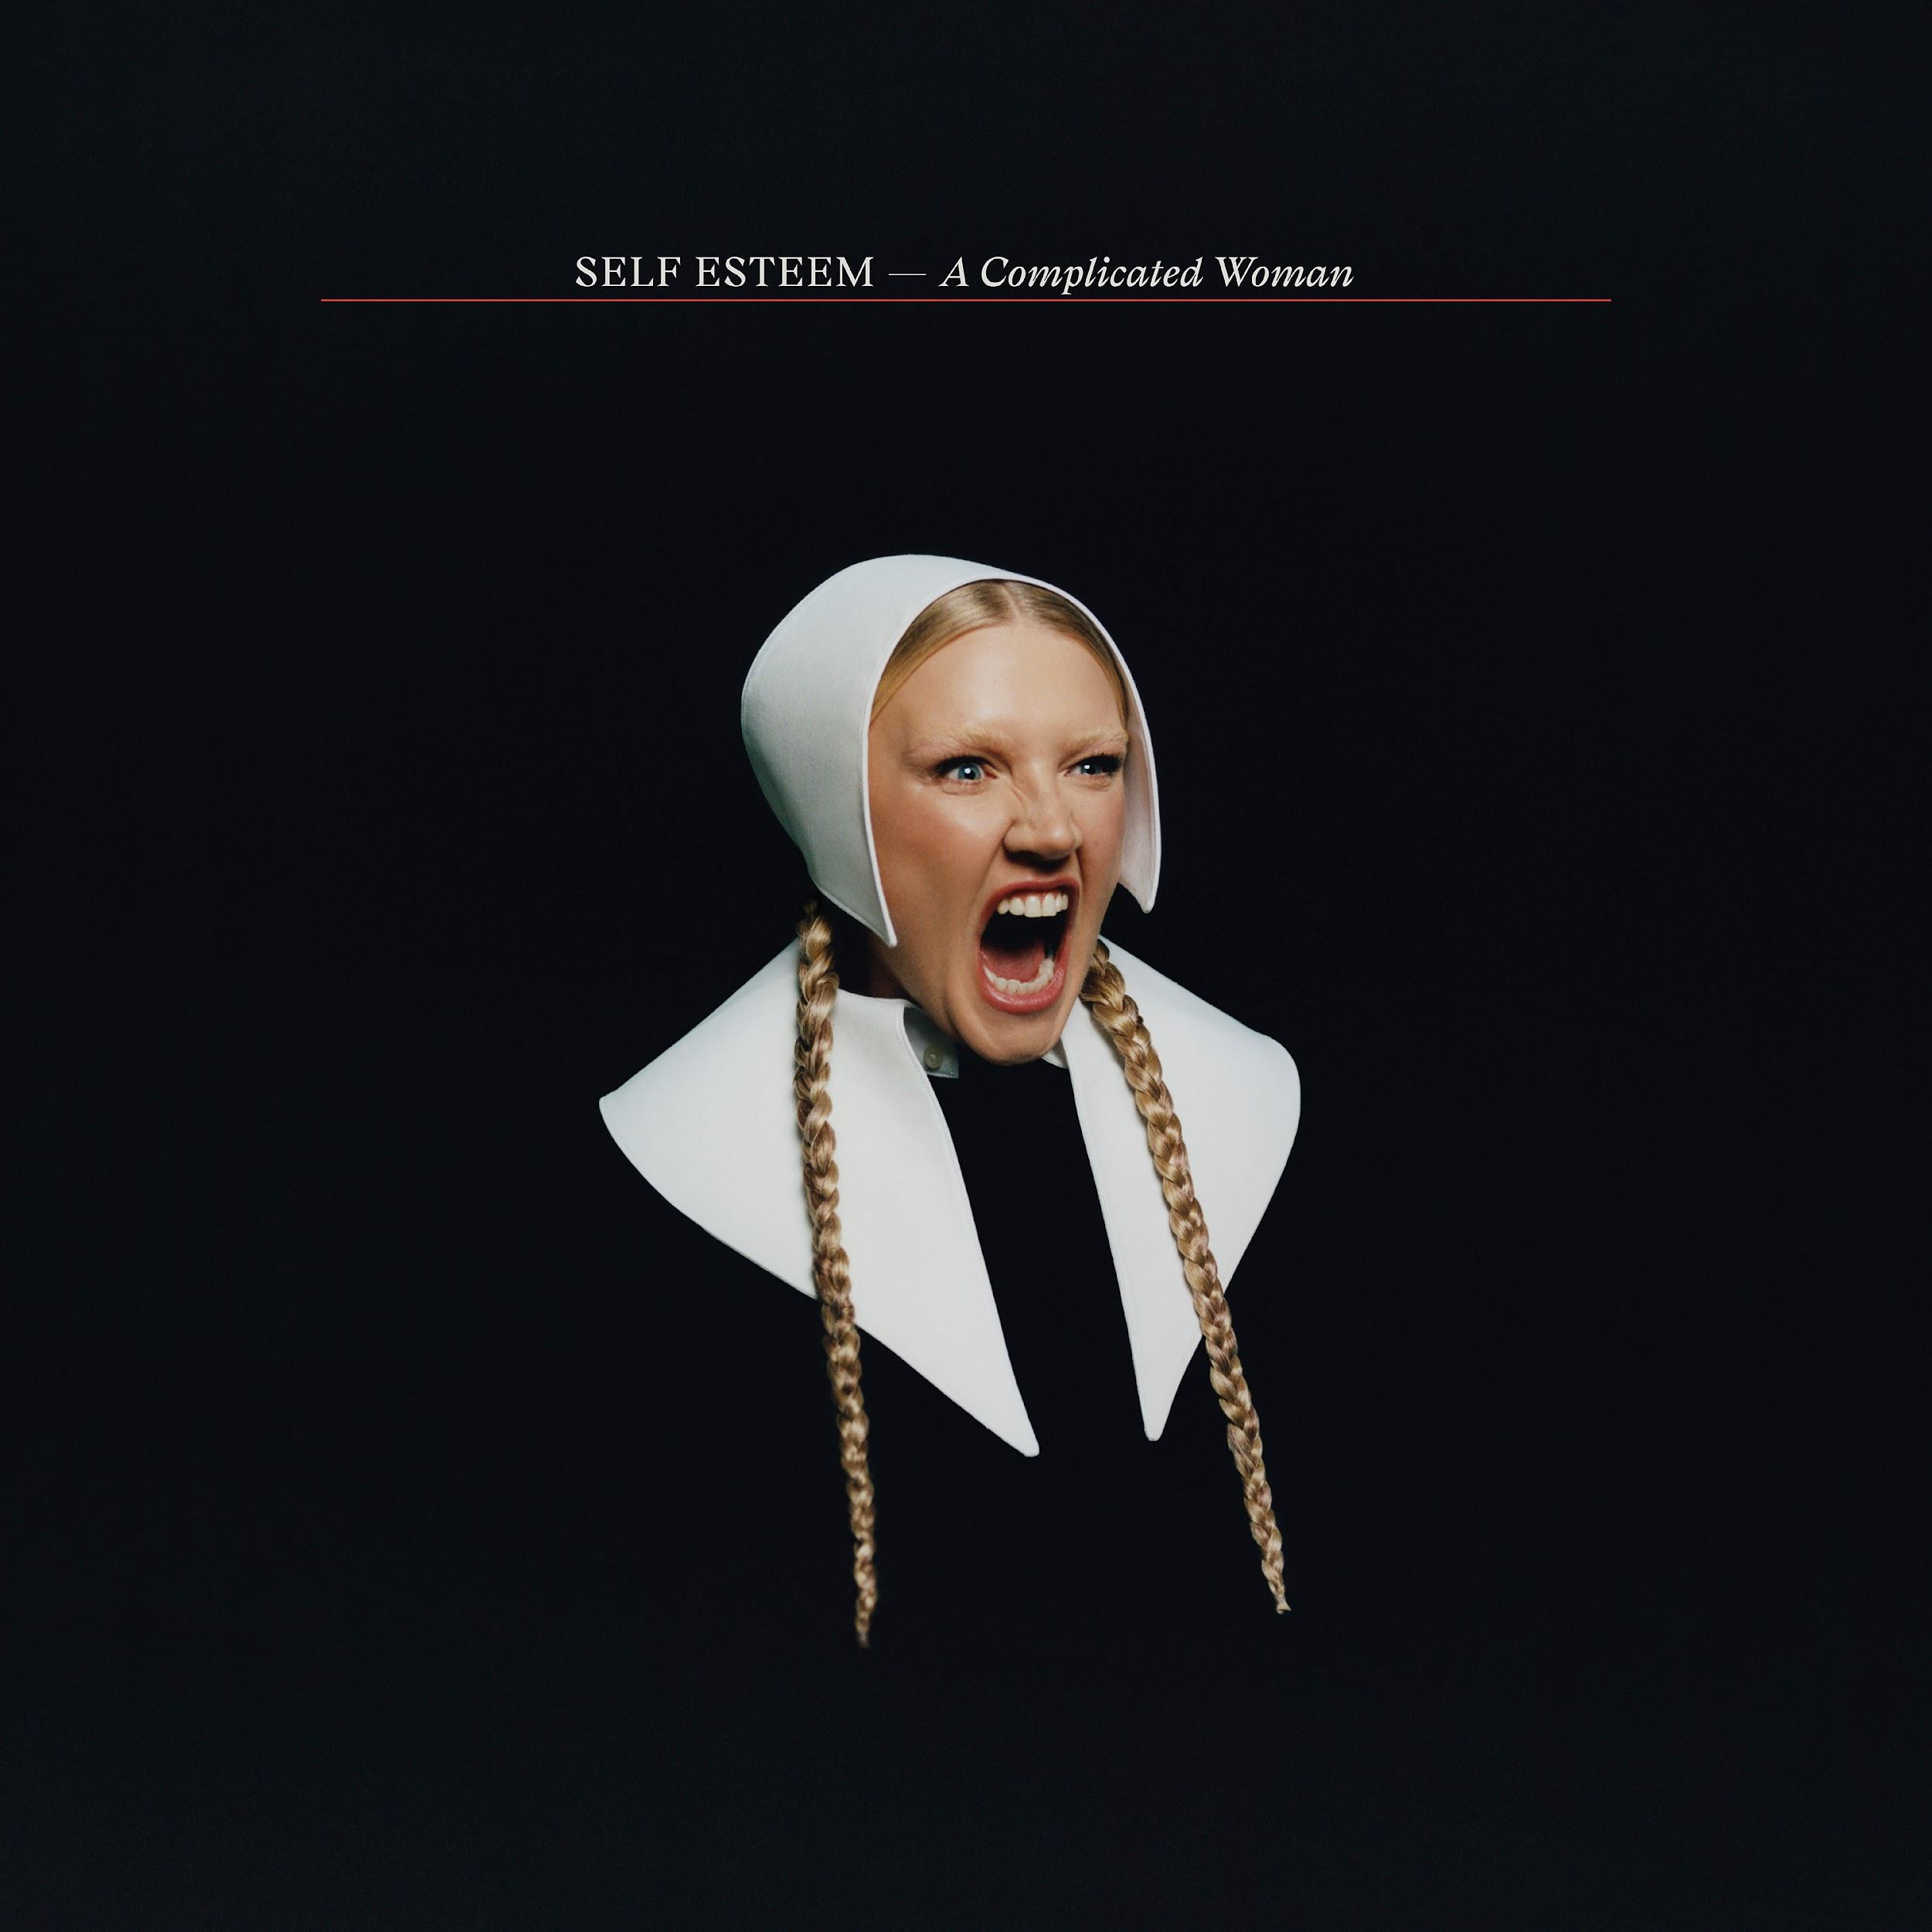

***A Complicated Woman* tracklisting**

1.⁠ ⁠I Do And I Don’t Care

2.⁠ ⁠Focus Is Power

3.⁠ ⁠Mother

4.⁠ ⁠The Curse

5.⁠ ⁠Logic, Bitch! ft Sue Tompkins

6.⁠ ⁠Cheers To Me

7.⁠ ⁠If Not Now, It’s Soon

8.⁠ ⁠In Plain Sight ft Moonchild Sanelly

9.⁠ ⁠Lies ft Nadine Shah

10.⁠ ⁠69

11.⁠ ⁠What Now

12.⁠ ⁠The Deep Blue Okay

Last week, Self Esteem announced *A Complicated Woman Live* - a unique and theatrical presentation of her forthcoming new album at the intimate Duke Of York’s Theatre in London for a strictly limited and unmissable season this April. The entire run of shows sold out within minutes of going on sale.

Created by Rebecca Lucy Taylor and Tony award-winning Designer Tom Scutt, who also directs here, *A Complicated Woman Live* is an ambitious quasi-theatrical experience that harnesses the power and energy of a gig but presents it through a theatrical format.

**A Complicated Woman Live performance dates**

Wednesday 16th April - 7.30pm - **SOLD OUT**

Thursday 17th April - 7.30pm - **SOLD OUT**

Friday 18th April - 7.30pm - **SOLD OUT**

Saturday 19th April - 3pm - **SOLD OUT**

Saturday 19th April - 7.30pm - **SOLD OUT**

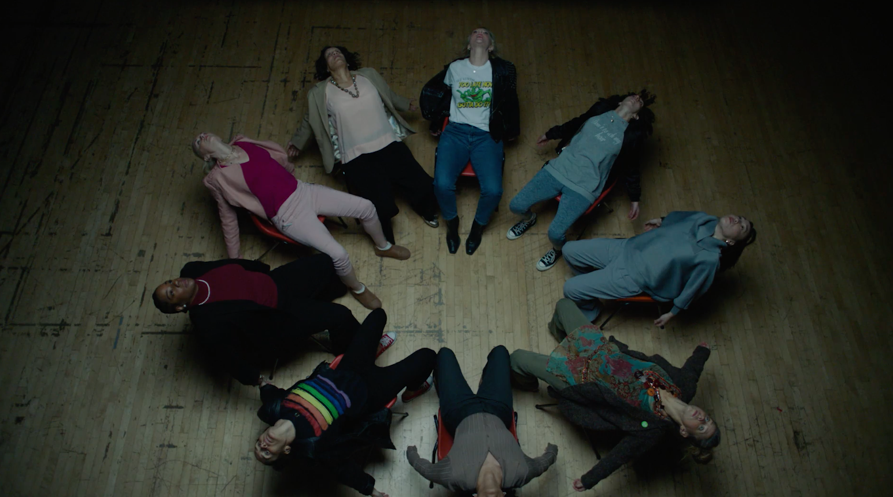

**`Self Esteem - ‘69’ video still (download assets** [**here**](https://drive.google.com/drive/folders/1PzHuReSTjuJiNgaqbggCcYvcYShnbD6l)**)**

**About Self Esteem**

One of the UK’s most exciting breakout stars of the past decade, Rebecca Lucy Taylor, AKA Self Esteem emerged from cult favourite status to mainstream hero following the huge success of her empowering, truth-telling 2021 single ‘I Do This All The Time’. The song resonated intensely as a perfect example of Taylor’s affectionately termed ‘trojan horse’ or ‘salad and chips’ approach, fearlessly packing important, emotive messages into witty, resonant pop music.

Self Esteem’s wildly acclaimed second album *Prioritise Pleasure* quickly followed, tackling the hypocrisies and joys found in her experiences of modern day womanhood across dating, friendship, comparison culture, self love, women’s safety and sexual assault and much more. *Prioritise Pleasure* received Mercury Prize, BRIT Award, Sky Arts and NME Award nominations, was crowned The Guardian and Sunday Times Culture’s Album of the Year, and ‘I Do This All The Time’ was also named The Guardian’s #1 song of 2021.

Quite the opposite of an overnight success, Taylor spent a decade as one half of indie duo Slow Club before adopting the pop star persona she’d always dreamed of. She released her first Self Esteem album *Compliments Please* in 2019, featuring fan favourite singles ‘The Best’, ‘Girl Crush’ and more.

Gathering a passionate and vast legion of fans ever since, Taylor has appeared on The Graham Norton Show, Celebrity Gogglebox, Friday Night Live, performed three times on Jools Holland including the NYE Hootenanny, graced the covers of magazines from Grazia to NME to Sunday Times Style, and is one of a handful of artists to have been playlisted across BBC Radio 1, 2 and 6 Music simultaneously.

Having reached new heights of acclaim, Taylor has continued to grow, diversify, and create in 2024. Branching out into the world of acting, Taylor starred in a regular role in the Sky series *Smothered*, before completing a run playing Sally Bowles in the multiple Olivier Award-winning production of 'Cabaret at the Kit Kat Club' in London's West End. Starring alongside Jake Shears (lead singer of Scissor Sisters) as Emcee, the pair’s time on stage was extended due to popular demand, and showcased the sheer range of talent in Taylor’s repertoire. A one-off collaborative single with Moonchild Sanelly, ‘Big Man’, was released in the summer of 2024.

**Connect with Self Esteem**

[**Website**](https://selfesteem.lnk.to/WE) **/** [**Instagram**](https://selfesteem.lnk.to/IN) **/** [**Facebook**](https://selfesteem.lnk.to/FB) **/** [**X**](https://selfesteem.lnk.to/TW) **/** [**TikTok**](https://www.tiktok.com/@selfesteemselfesteem69?)

**For more information please contact**

**jenny@chuffmedia.com**