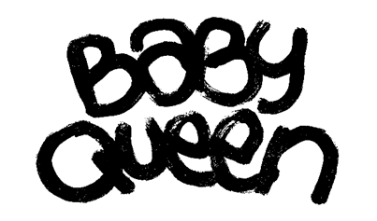

**SHARES BRAND NEW SONG ‘23’**

**FROM FORTHCOMING DEBUT ALBUM ‘QUARTER LIFE CRISIS’**

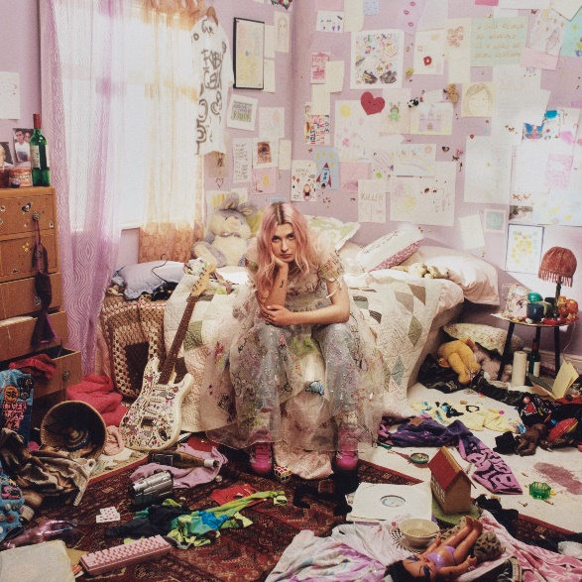

[LISTEN](https://eur02.safelinks.protection.outlook.com/?url=http%3A%2F%2Fbabyqueen.lnk.to%2FQLC&data=05%7C01%7CSusie.Ember%40umusic.com%7C3d74d18161f742a62d1d08dbc98c0c94%7Cbbcb6b2f8c7c4e2486e46c36fed00b78%7C1%7C0%7C638325375558391541%7CUnknown%7CTWFpbGZsb3d8eyJWIjoiMC4wLjAwMDAiLCJQIjoiV2luMzIiLCJBTiI6Ik1haWwiLCJXVCI6Mn0%3D%7C3000%7C%7C%7C&sdata=K1Mfum6itYYb3%2BPE4e04GkzvSOYL9oguETyS3LyYy4o%3D&reserved=0) / [WATCH](https://eur02.safelinks.protection.outlook.com/?url=http%3A%2F%2Fbabyqueen.lnk.to%2F23vid&data=05%7C01%7CSusie.Ember%40umusic.com%7C3d74d18161f742a62d1d08dbc98c0c94%7Cbbcb6b2f8c7c4e2486e46c36fed00b78%7C1%7C0%7C638325375558235303%7CUnknown%7CTWFpbGZsb3d8eyJWIjoiMC4wLjAwMDAiLCJQIjoiV2luMzIiLCJBTiI6Ik1haWwiLCJXVCI6Mn0%3D%7C3000%7C%7C%7C&sdata=iSeFGW074sKkDg5R2e9AgjCsZjFh7shXVh0W96gt%2Fh0%3D&reserved=0)

**BABY QUEEN** today (October 13th) shares new track **‘23’** alongside a [visualiser](https://eur02.safelinks.protection.outlook.com/?url=http%3A%2F%2Fbabyqueen.lnk.to%2F23vid&data=05%7C01%7CSusie.Ember%40umusic.com%7C3d74d18161f742a62d1d08dbc98c0c94%7Cbbcb6b2f8c7c4e2486e46c36fed00b78%7C1%7C0%7C638325375558235303%7CUnknown%7CTWFpbGZsb3d8eyJWIjoiMC4wLjAwMDAiLCJQIjoiV2luMzIiLCJBTiI6Ik1haWwiLCJXVCI6Mn0%3D%7C3000%7C%7C%7C&sdata=iSeFGW074sKkDg5R2e9AgjCsZjFh7shXVh0W96gt%2Fh0%3D&reserved=0). It arrives in the lead up to a major headline tour of the UK and the release of her eagerly awaited debut album **‘Quarter Life Crisis’** on **Nov 10th** via Polydor Records.

**‘23’** is one of Baby Queen’s favourite tracks from her forthcoming album and continues to explore themes of honesty and self-acceptance. It is, she says, “about a night out and the conflict I have within myself about my sexuality, and accepting certain truths about myself.”

**‘Quarter Life Crisis’** features 12 tracks, including previously released songs **‘Quarter Life Crisis’**, **‘Dream Girl’**, **‘We Can Be Anything’** and **‘All The Things’.** It was produced by long-time **Baby Queen** collaborator King Ed. **‘Quarter Life Crisis’** is available in multiple formats including CD, a deluxe CD featuring limited edition artwork from **Heartstopper** creator **Alice Oseman** and coloured vinyl.

The full tracklisting is:

|  |  |
| --- | --- |
| 1 | **We Can Be Anything** |
| 2 | **kid genius** |
| 3 | **Dream Girl** |
| 4 | **i can't get my shit together** |
| 5 | **Love Killer** |
| 6 | **Grow Up** |
| 7 | **Quarter Life Crisis** |
| 8 | **Die Alone** |
| 9 | **Obvious** |
| 10 | **23** |
| 11 | **every time i get high** |
| 12 | **a letter to myself at 17** |

Baby Queen contributed six songs to the soundtrack of the new series of the global smash Netflix show **Heartstopper**, which launched on August 3rd. The new series also features a cameo appearance from Baby Queen aka 25-year-old Bella Latham, who takes on the role of a performer at the school prom.

Having spent the best part of the 2020s taking over London’s anarchic anti-pop scene and writing songs for a generation falling out of love with social media that transformed her into her genre’s reigning star, **BABY QUEEN** is discovering the more grounded and introspective side of herself too, leading to the creation of some of the most pure, excellent and affecting music of her life so far.

**BABY QUEEN** recently announced the first leg of her forthcoming ***‘Quarter Life Crisis’*** tour. The dates are:

The dates are:

OCT 31ST BRIGHTON CONCORDE 2

NOV 1ST NORWICH THE WATERFRONT

NOV 3RD BIRMINGHAM 02 ACADEMY

NOV 4TH SHEFFIELD LEADMILL

NOV 5TH NEWCASTLE NEWCASTLE UNIVERSITY

NOV 7TH GLASGOW ST LUKE’S

NOV 9TH MANCHESTER ACADEMY 2

NOV 10TH LIVERPOOL 02 ACADEMY

NOV 11TH LEEDS LEEDS UNIVERSITY STYLUS

NOV 13TH NOTTINGHAM RESCUE ROOMS

NOV 14TH BRISTOL TRINITY CENTRE

NOV 15TH LONDON 02 FORUM KENTISH TOWN

NOV 27TH NEW YORK BOWERY BALLROOM

NOV 29TH LOS ANGELES THE ECHO

[LEAD PRESS PHOTO](https://umusic.box.com/s/v9nnxlkvfu4pgafl4641mf0uldsfbp4f) (CREDIT: NICOLE NGAI)

‘QUARTER LIFE CRISIS’ AVAILABLE TO PRE-ORDER HERE

**FOLLOW BABY QUEEN:**

[**INSTAGRAM**](https://eur02.safelinks.protection.outlook.com/?url=https%3A%2F%2Fplayerapi.plaympe.com%2Fclick%2FeyJ0eXAiOiJKV1QiLCJhbGciOiJIUzI1NiJ9.eyJ1cmwiOiJodHRwczovL3d3dy5pbnN0YWdyYW0uY29tL3F1ZWVub2Z0aGViYWJpZXMvIiwicmVjaXBpZW50aWQiOjEzMTY2OCwicmVsZWFzZWlkIjoiMTM1MDY1MyJ9.yfPhAQ4Xp5AQBqQTQdYqgUYN55wCv2Lqzma8BsN9ZFc&data=04%7C01%7Csusie.ember%40umusic.com%7C8106a90e73f24ff81f5708d91ebd5f40%7Cbbcb6b2f8c7c4e2486e46c36fed00b78%7C1%7C0%7C637574620959694451%7CUnknown%7CTWFpbGZsb3d8eyJWIjoiMC4wLjAwMDAiLCJQIjoiV2luMzIiLCJBTiI6Ik1haWwiLCJXVCI6Mn0%3D%7C1000&sdata=Drh7sHEhltphibkQb7NPBLFQ%2Bss%2Fkn5u4h7fnsSfpNM%3D&reserved=0)**//**[**TIKTOK**](https://eur02.safelinks.protection.outlook.com/?url=https%3A%2F%2Fplayerapi.plaympe.com%2Fclick%2FeyJ0eXAiOiJKV1QiLCJhbGciOiJIUzI1NiJ9.eyJ1cmwiOiJodHRwczovL3d3dy50aWt0b2suY29tL0BxdWVlbm9mdGhlYmFiaWVzIiwicmVjaXBpZW50aWQiOjEzMTY2OCwicmVsZWFzZWlkIjoiMTM1MDY1MyJ9.2MtOY8QwkdmQAKh-FbLa6X5Scu2CPkULuFDhzoaTJ3Y&data=04%7C01%7Csusie.ember%40umusic.com%7C8106a90e73f24ff81f5708d91ebd5f40%7Cbbcb6b2f8c7c4e2486e46c36fed00b78%7C1%7C0%7C637574620959699429%7CUnknown%7CTWFpbGZsb3d8eyJWIjoiMC4wLjAwMDAiLCJQIjoiV2luMzIiLCJBTiI6Ik1haWwiLCJXVCI6Mn0%3D%7C1000&sdata=rvPeSzxGrrYBBGHdE35xtpF7ukO9foS0e8FvjJNL7xo%3D&reserved=0)**//**[**FACEBOOK**](https://eur02.safelinks.protection.outlook.com/?url=https%3A%2F%2Fplayerapi.plaympe.com%2Fclick%2FeyJ0eXAiOiJKV1QiLCJhbGciOiJIUzI1NiJ9.eyJ1cmwiOiJodHRwczovL3d3dy5mYWNlYm9vay5jb20vcXVlZW5vZnRoZWJhYmllcy8iLCJyZWNpcGllbnRpZCI6MTMxNjY4LCJyZWxlYXNlaWQiOiIxMzUwNjUzIn0.CRFaz1fQT0qiY46QTgaF8Qh6YoYdV89j9ibfZv1vBV8&data=04%7C01%7Csusie.ember%40umusic.com%7C8106a90e73f24ff81f5708d91ebd5f40%7Cbbcb6b2f8c7c4e2486e46c36fed00b78%7C1%7C0%7C637574620959704407%7CUnknown%7CTWFpbGZsb3d8eyJWIjoiMC4wLjAwMDAiLCJQIjoiV2luMzIiLCJBTiI6Ik1haWwiLCJXVCI6Mn0%3D%7C1000&sdata=OR%2BdrhVzlhoyqwwdvGl6w8SMkUS8qfnjNAQnm8FPhrk%3D&reserved=0)**//**[**TWITTER**](https://eur02.safelinks.protection.outlook.com/?url=https%3A%2F%2Fplayerapi.plaympe.com%2Fclick%2FeyJ0eXAiOiJKV1QiLCJhbGciOiJIUzI1NiJ9.eyJ1cmwiOiJodHRwczovL3R3aXR0ZXIuY29tL2JhYnlvZnRoZXF1ZWVuIiwicmVjaXBpZW50aWQiOjEzMTY2OCwicmVsZWFzZWlkIjoiMTM1MDY1MyJ9.C9wD33MObjpV_WWvna0bgVtitnPnYOIk1eU60hh2amk&data=04%7C01%7Csusie.ember%40umusic.com%7C8106a90e73f24ff81f5708d91ebd5f40%7Cbbcb6b2f8c7c4e2486e46c36fed00b78%7C1%7C0%7C637574620959709390%7CUnknown%7CTWFpbGZsb3d8eyJWIjoiMC4wLjAwMDAiLCJQIjoiV2luMzIiLCJBTiI6Ik1haWwiLCJXVCI6Mn0%3D%7C1000&sdata=3dBR31cZkRpRqKnJ6wqMiSSZ3HwuCmA1gZmjtLarZik%3D&reserved=0) **//**[**YOUTUBE**](https://www.youtube.com/channel/UC9S9t9qA3hf0DqvOd3YdHqQ)

**For more information and press enquiries please contact**

**Jenny Entwistle**

[**Jenny@chuffmedia.com**](mailto:Jenny@chuffmedia.com)