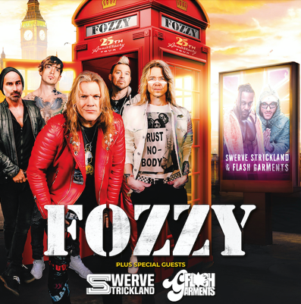

ALL IN ALL NIGHT LONDON AT O2 FORUM, KENTISH TOWN
FRIDAY 23RD AUGUST 2024

Pre-sale 10am, Wed 22nd May
On-sale 10am, Fri 24th May
Tickets £25

FOZZY have announced their hugely anticipated return to the UK capital with a date at London’s O2 Forum Kentish Town. Promising an explosive Friday evening of rock and rap, the show kickstarts a weekend that culminates in the return of AEW (All Elite Wrestling) to London’s Wembley Stadium on Sunday 25th August.

If it’s not enough for fans to have FOZZY, with their heavy melodic groove and fronted by 8 time World Champion Chris Jericho headlining the night, fans will go crazy knowing that direct support comes from current AEW World Champion: Swerve Strickland. Swerve Strickland & Flash Garments will be performing their first concert as a rap duo in the UK.

With the superstar showmanship of frontman Chris Jericho tag-teamed with guitar genius Rich Ward, FOZZY are a band that deliver a truly rock n roll experience - a sonic assault of headbanging riffs, energy and most importantly, amazing songs. The backbone of their sound comes from the killer combination of Grant Brooks on drums, bassist PF Farley and Billy Grey leading the charge on guitar shredding solos. It’s only good times and guaranteed electric performances no matter the crowd or country.

Coming off the back of their biggest UK Headlining tour in February and having shared the stage with a pantheon of rock icons such as Metallica, Avenged Sevenfold and Iron Maiden, it was the release of seventh LP JUDAS that elevated FOZZY into the rarified group of acts to cross over from the rock and metal world into mainstream consciousness. The title track from the album has been streamed over 72 million times on Spotify alone, earned a GOLD record in the US and was sung word for word by 81,000 fans when FOZZY performed at last years AEW Wembley Stadium sold out show in August 2023.

Pushing themselves both sonically and artistically over their twenty plus year career, the bands eighth and latest studio album, BOOMBOX contains ‘a swathe of catchy-as-hell tunes’ (Metal Hammer) and ‘sees the band doubling down on the stadium anthems’ (Classic Rock).

Swerve Strickland is the current AEW World Heavyweight Champion. As a performing artist, he has appeared on national cable television with rap superstars Rick Ross, Kevin Gates, Fabolous and others. Coming from the Bronx, the birthplace of hip hop, Flash Garments is a rapper, songwriter and dynamic performer whose legendary uncle Lovebug Starski happens to be recognized as the man who coined the phrase “hip hop”. Together these two artists form a rap duo that electrifies audiences and they have performed on major shows throughout the world including the renowned Rolling Loud music festival and The Jericho Cruise.

With FOZZY continually on the rise, expect an unmissable performance of groovy, energetic and hook-laden rock’n’roll supported by the electricity and magic of Swerve Strickland & Flash Garment at the O2 Forum.

Tickets available via FOZZYROCK.COM

*** FOZZY: Fan Owned, Band Operated Since 1999 ***

For all media enquiries contact warren@chuffmedia.com / 07762 130510

