FRANK TURNER

ANNOUNCES INTIMATE ALBUM LAUNCH PARTY AT THE CLAPHAM GRAND
THIS WEDNESDAY 16TH FEBRUARY – BUY TICKETS HERE

NEW ALBUM ‘FTHC’ OUT NOW AND IS IN THE RACE FOR THE NUMBER ONE SPOT IN THE UK ALBUM CHARTS

LISTEN TO THE ALBUM HERE

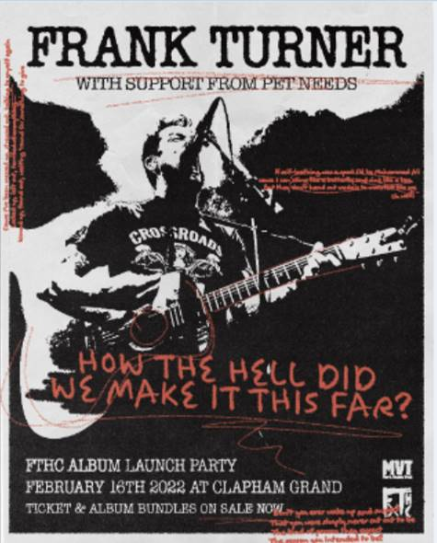

To celebrate the release of his critically acclaimed new album ‘FTHC’ (currently at number one in the UK midweek charts -stream the album HERE), Frank Turner has just announced a special intimate album launch party show at the Clapham Grand this Wednesday February 16th with support from Pet Needs – buy ticket and album bundles HERE.

Throughout ‘FTHC’, Frank moves through a barrage of sensitive subjects across fourteen uncompromising tracks, explored in the only way he knows how and that’s with unflinching honesty. Recent single ‘Miranda’ tackles a story that comes purely from Frank’s own life. With a country twang and clattering grunge dynamics, Frank Turner introduces the story as he sings, “My father is called Miranda these days / She’s a proud transgender woman and my resentment has started to fade.” The pair had been estranged for years following a difficult childhood and his parents’ separation. But when his father transitioned from male to female, they reconciled and now their relationship, although still fragile, is at least heading in the right direction.

‘Miranda’ represents one-half of the album’s emotive centrepiece alongside the immensely touching ‘A Wave Across A Bay’, a tribute to Scott Hutchison of Frightened Rabbit, who took his own life in 2018. Released with the permission of Scott’s younger brother Grant, it sees Frank coming to terms with Scott’s decision in a powerfully accepting manner. Today an animated video for ‘A Wave Across A Bay’ directed by Emily Crumby has been released, watch the video HERE.

Thematically, the album is a mini autobiography rooted in time and place. It ends with a rumination on leaving the capital after 7300 days for a new life on the Essex coast with the bittersweet ‘Farewell To My City’. As one chapter closes, a new journey begins to unfold.

‘FTHC’ was recorded at ARC – Abbey Recording Studios – just outside of Oxford, and was produced and mixed by Rich Costey (Foo Fighters, Muse, Biffy Clyro). The album is available to pre-order here on CD, deluxe CD, LP, picture disc and cassette, while signed bundles are available exclusively from Frank’s UK store.

The album represents a fresh landmark in a career that has already included four Top 5 albums and a total of almost 3000 shows played before a combined audience of over 2 million people, which has spanned everywhere from intimate grassroots venues to cavernous arenas including the O2 and Wembley. Frank Turner’s extensive support of the live music scene during the pandemic saw him play countless livestream benefit shows to raise money and awareness of the importance of small venues all across the country. After raising nearly £300,000, he was awarded the Music Venue Trust’s award for Outstanding Achievement for Grassroots Music Venues.

Following the release party this wek, Frank Turner will bee playing two runs of intimate launch shows, hosted in conjunction with a selection of independent record stores. The first wave of tickets for the launch shows sold-out immediately and Frank has now announced he will be doing an earlier evening performance at each of the dates. Tickets for the shows, listed below, are available HERE:

MARCH
16th - Southampton, The Brook (with Vinilo Records)
16th - Bournemouth, Old Fire Station (with Vinilo Records)
19th - Kingston, Pryzm (with Banquet Records)
21st - Nottingham, Metronome (with Rough Trade)

APRIL
12th - Leeds, The Wardrobe (with Crash Records)
13th - Liverpool, Arts Club (with Jacaranda Records)
14th - Sheffield, Foundry (with Bear Tree Records)
16th - Bristol, Fleece (with Rough Trade)

Due to covid, the forthcoming English, Welsh and Scottish dates of Frank’s Never Ending Tour of Everywhere will be rescheduled to later in the year - more info to follow shortly. Frank will also be taking his four-night Lost Evenings fan event to Berlin for the first time this September and will be participating in a special show at EartH on March 13th: Buswell & Nyberg’s Orchestra vs Xtra Mile Recordings.

Follow Frank Turner:
Website
Spotify
Apple Music
YouTube
Facebook
Instagram
Twitter

For more information, please contact jenny@chuffmedia.com

