**SELF ESTEEM**

**RETURNS WITH NEW SINGLE ‘BIG MAN’**

**WITH MOONCHILD SANELLY**

[**WATCH THE VIDEO NOW**](https://selfesteem.lnk.to/big)

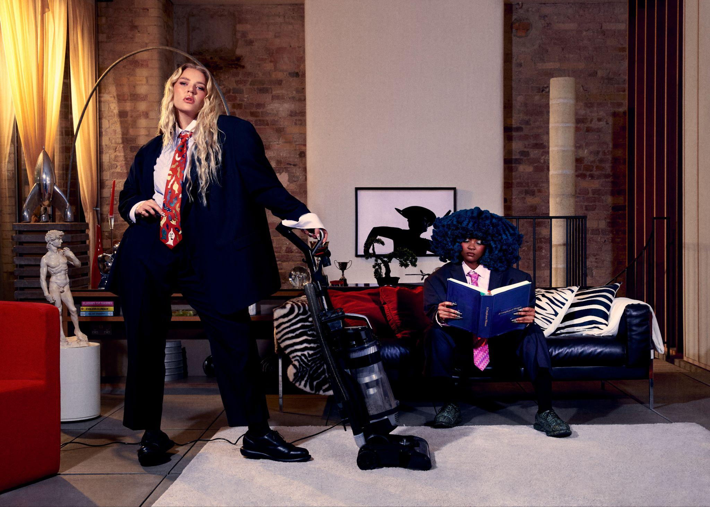

**Self Esteem & Moonchild Sanelly - photo credit: Yana Van Nuffel (Hi-res assets** [**here**](https://drive.google.com/drive/folders/1PzHuReSTjuJiNgaqbggCcYvcYShnbD6l)**)**

Self Esteem returns today with her first new music since the release of her wildly acclaimed BRIT and Mercury Prize-nominated 2021 album *Prioritise Pleasure*. Her new single ‘Big Man’ is a collaboration with South African trailblazer Moonchild Sanelly and explores the nuances of modern masculinity and gender roles.

‘Big Man’ was premiered as Hottest Record In The World on BBC Radio 1 and arrives with Self Esteem’s brightest and boldest music video yet; concept by Self Esteem, directed by Piers Dennis and produced by Ayomide Alli and Precious Mahaga. Opening with a nod to Queen’s iconic ‘I Want To Break Free’ visuals, it sees the duo take on household chores historically regarded as ‘women's work’ in style.

Self Esteem shares, *“Me and Moon wrote a song from the perspective of a good boyfriend. The ones that are just chill and secure so they just leave you to it. The ones that don’t want a medal for doing the bins. The ones that see that you’re working your tits off so they go and get yet another thing you’ve ordered and missed the delivery of from the post office. The ones that don’t take your success as a direct threat to their existence. To me this is real masculinity.*

*We have both collaborated with Johan Karlberg on our records and I'm so grateful to him for introducing us, it was a joy to make this song together. In my head the video always needed to be an inverse ‘I Want To Break Free’ - Piers Dennis executed this gorgeously cos he’s a fucking Big Man. Self Esteem 3 lez go.”*

Moonchild Sanelly adds, *“We were in the studio bonding HARD, having the deepest conversation about relationships and how it’s hard to be bold, loud female artists in a relationship. How you can be the baddest bitch on any stage, but if you have an insecure man he can't support your success as a woman. Instead of celebrating and supporting you, he sees your success as a personal attack and uses it to pull you down and make you feel bad. And we thought… what would it feel like... to be ourselves, doing what we do, and have a man who properly supported all that we are. So Rebecca and I wrote from the perspective of our ideal partner. The song is from the hypothetical perspective of a man who supports their partner and is happy for their woman. A man that is fully secure. A big man.”*

[**Watch the video for ‘Big Man’**](https://selfesteem.lnk.to/big)

‘Big Man’ follows a collaboration with Becky Hill on her recent song ‘True Colours’. Next week Self Esteem will be a special guest at Young Fathers’s huge outdoor hometown show in Stirling City Park, alongside Noname and Petite Noir.

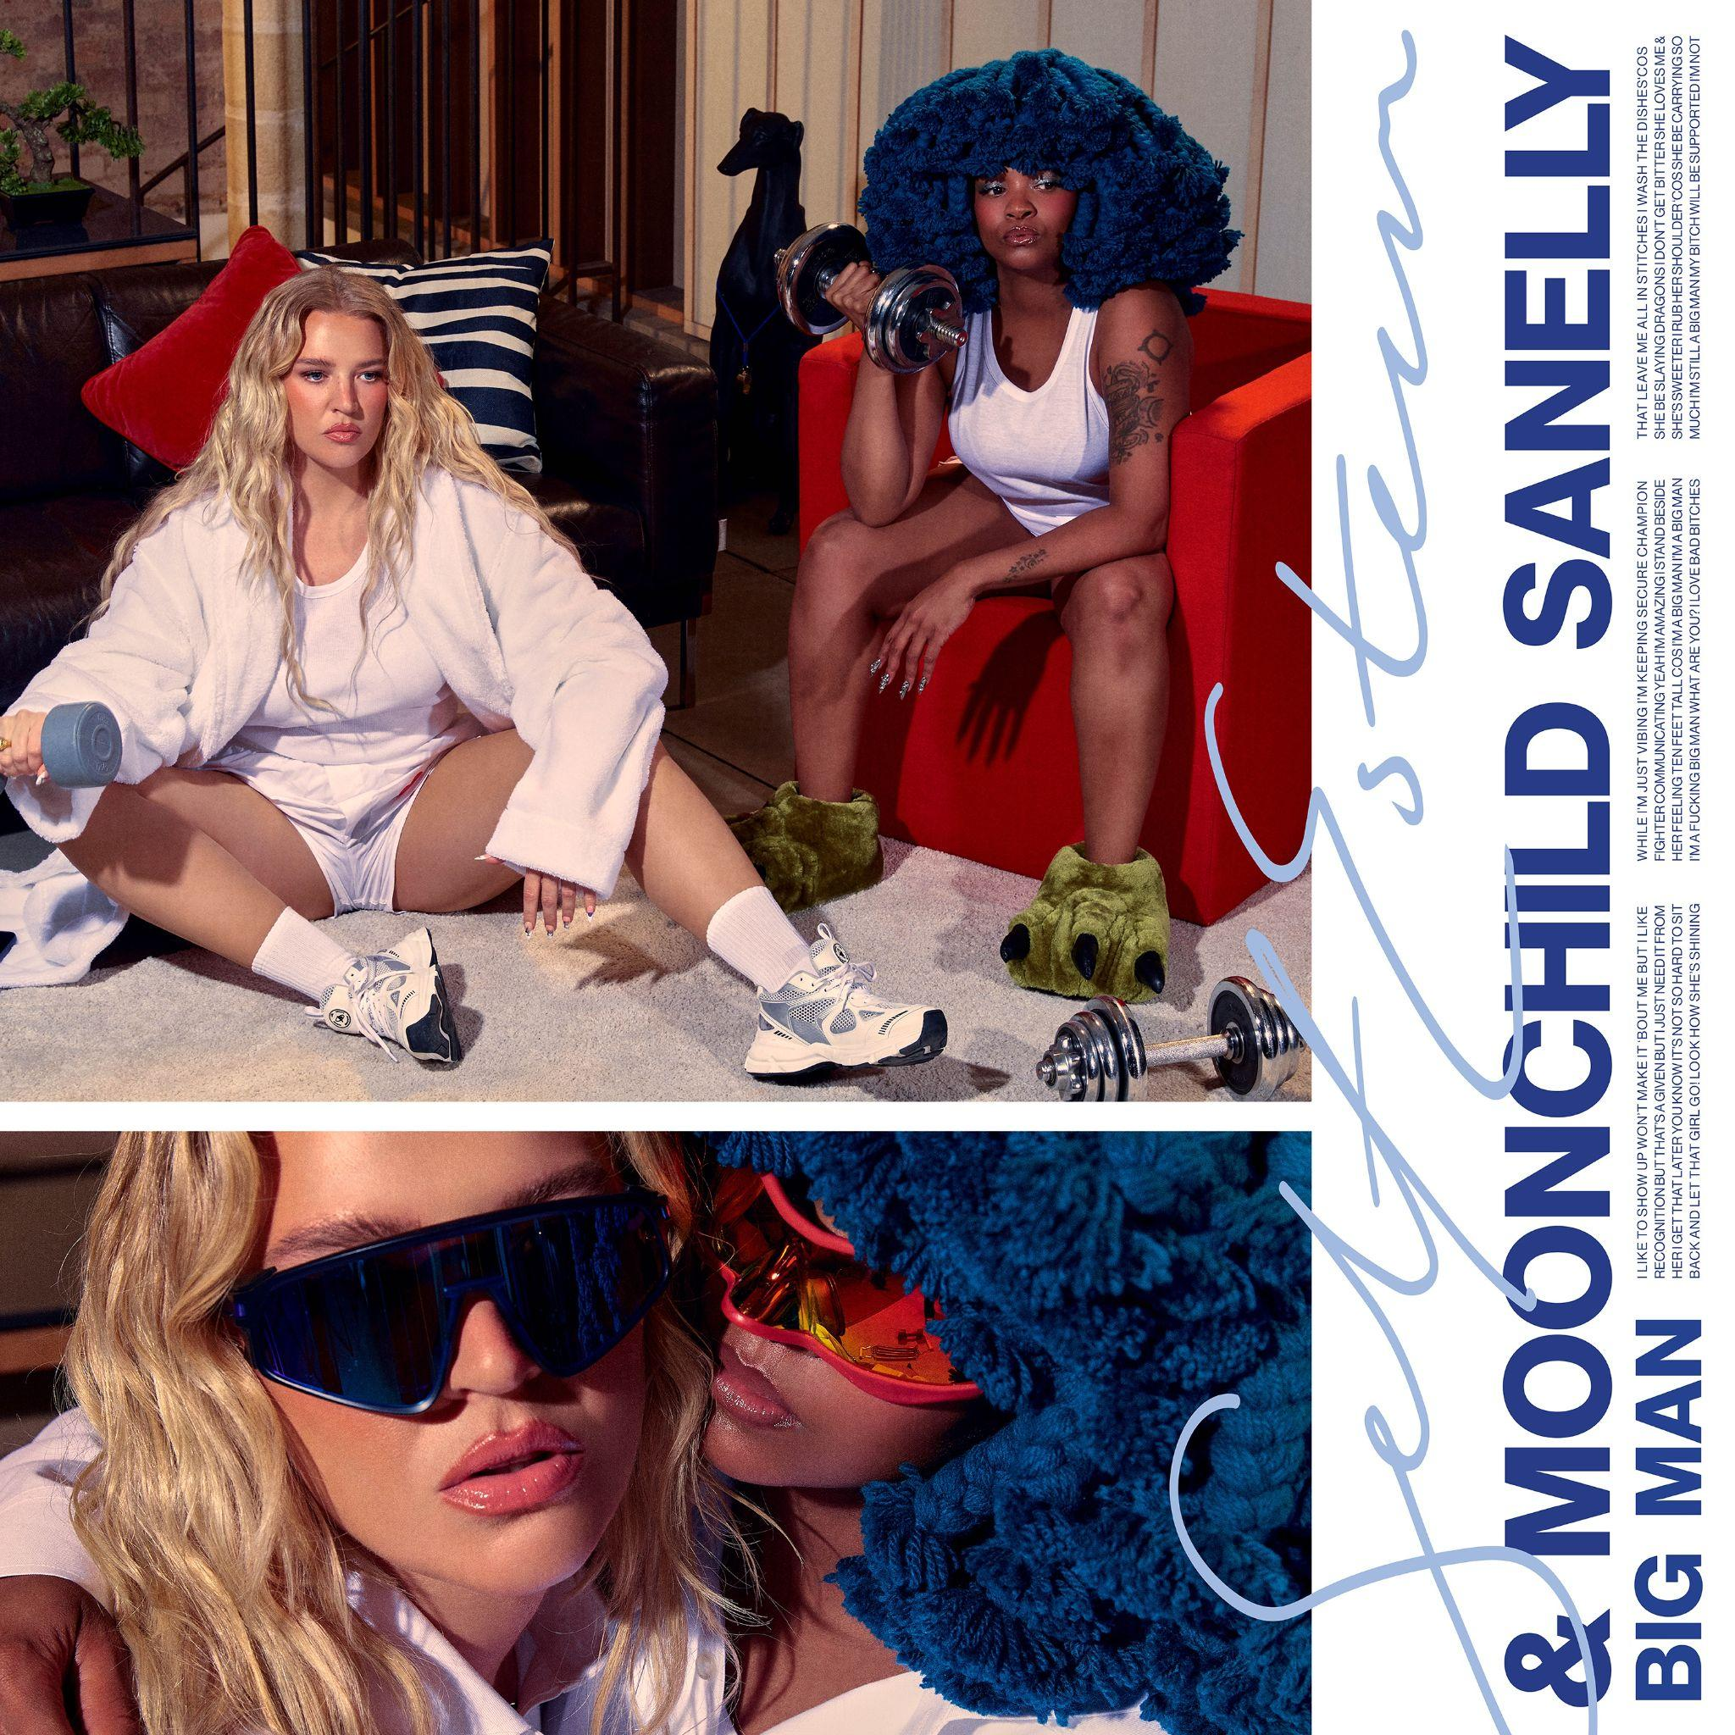

**‘Big Man’ artwork (Hi-res assets** [**here**](https://drive.google.com/drive/folders/1PzHuReSTjuJiNgaqbggCcYvcYShnbD6l)**)**

**About Self Esteem**

One of the UK’s most exciting breakout stars of the past decade, Rebecca Lucy Taylor, AKA Self Esteem emerged from cult favourite status to mainstream hero across a whirlwind year following the huge success of her empowering, truth-telling 2021 single ‘I Do This All The Time’. The song resonated intensely as a perfect example of Taylor’s affectionately termed ‘trojan horse’ or ‘salad and chips’ approach, fearlessly packing important, emotive messages into witty, resonant pop music.

Self Esteem’s wildly acclaimed second album *Prioritise Pleasure* quickly followed, tackling the hypocrisies and joys found in her experiences of modern day womanhood across dating, friendship, comparison culture, self love, women’s safety and sexual assault and much more. *Prioritise Pleasure* received Mercury Prize, BRIT Award, Sky Arts and NME Award nominations, was crowned The Guardian and Sunday Times Culture’s Album of the Year, and ‘I Do This All The Time’ was also named The Guardian’s #1 song of 2021.

Quite the opposite of an overnight success, Taylor spent a decade as one half of indie duo Slow Club before adopting the pop star persona she’d always dreamed of. She released her first Self Esteem album *Compliments Please* in 2019, featuring fan favourite singles ‘The Best’, ‘Girl Crush’ and more.

Gathering a passionate and vast legion of fans ever since, Taylor has appeared on The Graham Norton Show, Celebrity Gogglebox, Friday Night Live, performed three times on Jools Holland including the NYE Hootenanny, graced the covers of magazines from Grazia to NME to Sunday Times Style, and is one of a handful of artists to have been playlisted across BBC Radio 1, 2 and 6 Music simultaneously.

Having reached new heights of acclaim in 2023, Taylor has continued to grow, diversify, and create into the new year. Branching out into the world of acting, Taylor starred in a regular role in the recent Sky series SMOTHERED before completing a run playing Sally Bowles in the multiple Olivier Award-winning production of 'Cabaret at the Kit Kat Club' in London's West End. Starring alongside Jake Shears (lead singer of Scissor Sisters) as Emcee, the pair’s time on stage was extended due to popular demand, and showcased the sheer range of talent in Taylor’s repertoire.

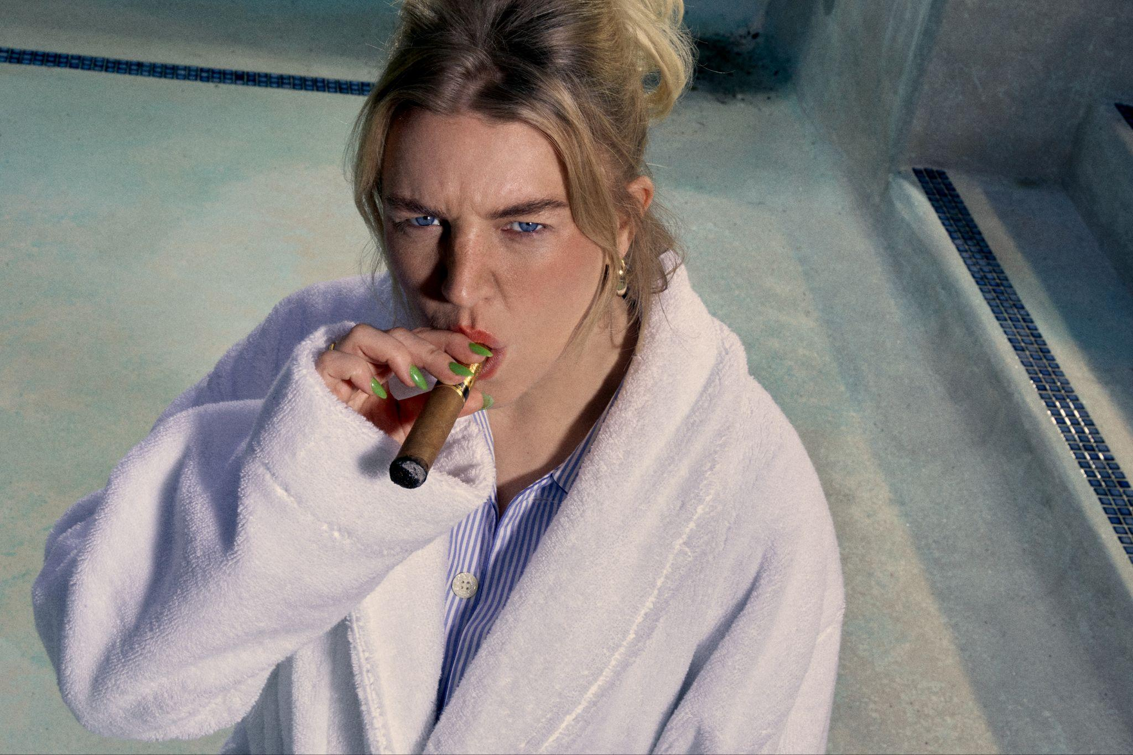

**Self Esteem - photo credit: Yana Van Nuffel (Hi-res assets** [**here**](https://drive.google.com/drive/folders/1PzHuReSTjuJiNgaqbggCcYvcYShnbD6l)**)**

**Connect with Self Esteem**

[**Website**](https://selfesteem.lnk.to/WE) **/** [**Instagram**](https://selfesteem.lnk.to/IN) **/** [**Facebook**](https://selfesteem.lnk.to/FB) **/** [**Twitter**](https://selfesteem.lnk.to/TW) **/** [**TikTok**](https://www.tiktok.com/@selfesteemselfesteem69?)

**About Moonchild Sanelly**

Trailblazing South African musician Moonchild Sanelly has always, since the very beginning, determinedly done things her own way. An artistic visionary, her drive to succeed is fuelled by an innate creativity, unique self-expression and extraordinary confidence, all underpinned by personal pain, trauma and a deep conviction and commitment to standing up for what she believes in.

Growing up in Port Elizabeth, Moonchild’s (born Sanelisiwe Twisha) music-filled childhood was one of creative exploration: whether it was self-choreographing dance routines to Spice Girls tracks, teaching herself to play the piano, singing at church with her family or writing poetry, artistic expression was always encouraged.

A move to Durban in 2005 to study fashion saw Sanelly become immersed in the local music scene, and later in Johannesburg, she would write for reggae bands and freestyle against other rappers, often overcoming misogynistic attitudes in the process. “*In my writing, I would pay homage to my hard times and the many years that I struggled, because it has shaped me,*” she says. She soon established her own signature sound: self-described as ‘future-ghetto-funk’, which would catapult Moonchild Sanelly to fame as South Africa’s most unique performer. With her electrifying live show - and self-designed flamboyant outfits - she became a superstar on her home turf. With an eye on audiences outside of South Africa, a commercialised approach to unapologetically spreading her message - one of female sexual empowerment - *“liberation for women, in the bedroom, in the boardroom, knowing your power… I needed to be heard by a lot of people”* - soon found a global audience which saw her invited to perform at festivals such as SXSW, Primavera, Glastonbury and Boardmasters.

A rarity as an uncompromising alternative artist who has found success in a commercial space, Moonchild Sanelly is a true fighter and unparalleled force of nature. *“I fought everything for me to exist as myself and to win as myself*,” she says, putting her ambition down to her mum’s passing when she was a teenager. *“I was constantly reminded about my magic and my power… that nothing is impossible.”*

Her award-winning first studio album *Rabulpha!* in 2015 signalled her arrival as an artist to watch and saw her collaborate with local favourites Maphorisa, Sho Madjozi and Thandiswa Mazwai. In the years that followed, she caught the attention of a host of international superstars, leading to high-profile collaborations with artists including Wizkid and Beyonce (featuring on ‘... MY POWER’, as part of ‘The Lion King: The Gift’ soundtrack, in 2019) and Gorillaz (on ‘With Love To An Ex’, in 2020).

Then, following her statement-making debut and a stream of South African hits, she signed to Transgressive records in 2020, kicking off with diverse mini-LP ‘Nüdes’. Her genre-crossing second studio album *Phases* was released in 2022, a highly collaborative record, with production and guest features from Sad Night Dynamite (on the hit track 'Demon') and Ghetts (‘Strip Club’), as well as Wesley Joseph, Xavier Thomas (Débruit), TOKiMONSTA, HOLLY and Aramboa.

Last month Moonchild Sanelly returned with ‘Scrambled Eggs’, the first single to be taken from her forthcoming new studio album, which will be announced later this year*.*

**Connect with Moonchild Sanelly**

[**Website**](http://www.moonchildsanelly.com) **|** [**Facebook**](http://r20.rs6.net/tn.jsp?f=001LZB5VqVwA5AOh0YBPmqTjE8-bVCh7XgPUUq2akP0ZDAhzQmORjwJQpTitwv4GyA-nMb2wy7RXNrepFGwcemvxe9tc8mHi1c4SDm4md1ZxH8xFcGVcGaXbVSKIwh1JsCHhDg71PCsJHbnjLGXMYokil1EHUsZq2A1lycrhkbZGetkbe0Tjo2IW_U7HYd5Rgtj&c=WKg7M7FDAX43TFRdFqlBioN7Krl4iEDJavlrO5kQqBqZFLAemsJtfg==&ch=KIqz9TqBTWrcT12zeAe4Xnn7WxJ_o9LmsQDj4kNQFj10JMIxWkAMrg==) **|** [**Instagram**](http://r20.rs6.net/tn.jsp?f=001LZB5VqVwA5AOh0YBPmqTjE8-bVCh7XgPUUq2akP0ZDAhzQmORjwJQpTitwv4GyA-aarEdL1wKri3t0eEv2b6P_QyBHg8-W-hj5P0GOXxiOwU2gSZuS8pmUqKSMMPG2R_gBTNBeGJEko8Mzuudo2ZqK5kKsMZvk7_xm8KsNWLptlr2uxQ6H2-qN4QTKSu7eLQ84Dhydm88J0=&c=WKg7M7FDAX43TFRdFqlBioN7Krl4iEDJavlrO5kQqBqZFLAemsJtfg==&ch=KIqz9TqBTWrcT12zeAe4Xnn7WxJ_o9LmsQDj4kNQFj10JMIxWkAMrg==) **|** [**Twitter**](http://r20.rs6.net/tn.jsp?f=001LZB5VqVwA5AOh0YBPmqTjE8-bVCh7XgPUUq2akP0ZDAhzQmORjwJQpTitwv4GyA-QciZ6vBJrIp3zjBl8-wkGF1MzxT8Jwm2eNAACK-TwES-msBbuKzid2UA_326R2Jg5ZctC3-i-tdbcdVutQtPeZjQ85kIK4KWXXJyH2v4hwczaoUMcMisjw==&c=WKg7M7FDAX43TFRdFqlBioN7Krl4iEDJavlrO5kQqBqZFLAemsJtfg==&ch=KIqz9TqBTWrcT12zeAe4Xnn7WxJ_o9LmsQDj4kNQFj10JMIxWkAMrg==) **|** [**Tik Tok**](https://www.tiktok.com/@moonchildsa?lang=en)

**For all media enquiries please contact** [**Warren@chuffmedia.com**](mailto:Warren@chuffmedia.com) **on 07762 130510**