**SELF ESTEEM**

**NEW SONG ‘LOVE SECOND MUSIC FIRST’ AVAILABLE DIGITALLY NOW**

**B-SIDE OF FORTHCOMING ‘BIG MAN’**

**7-INCH PICTURE DISC OUT 18 OCTOBER**

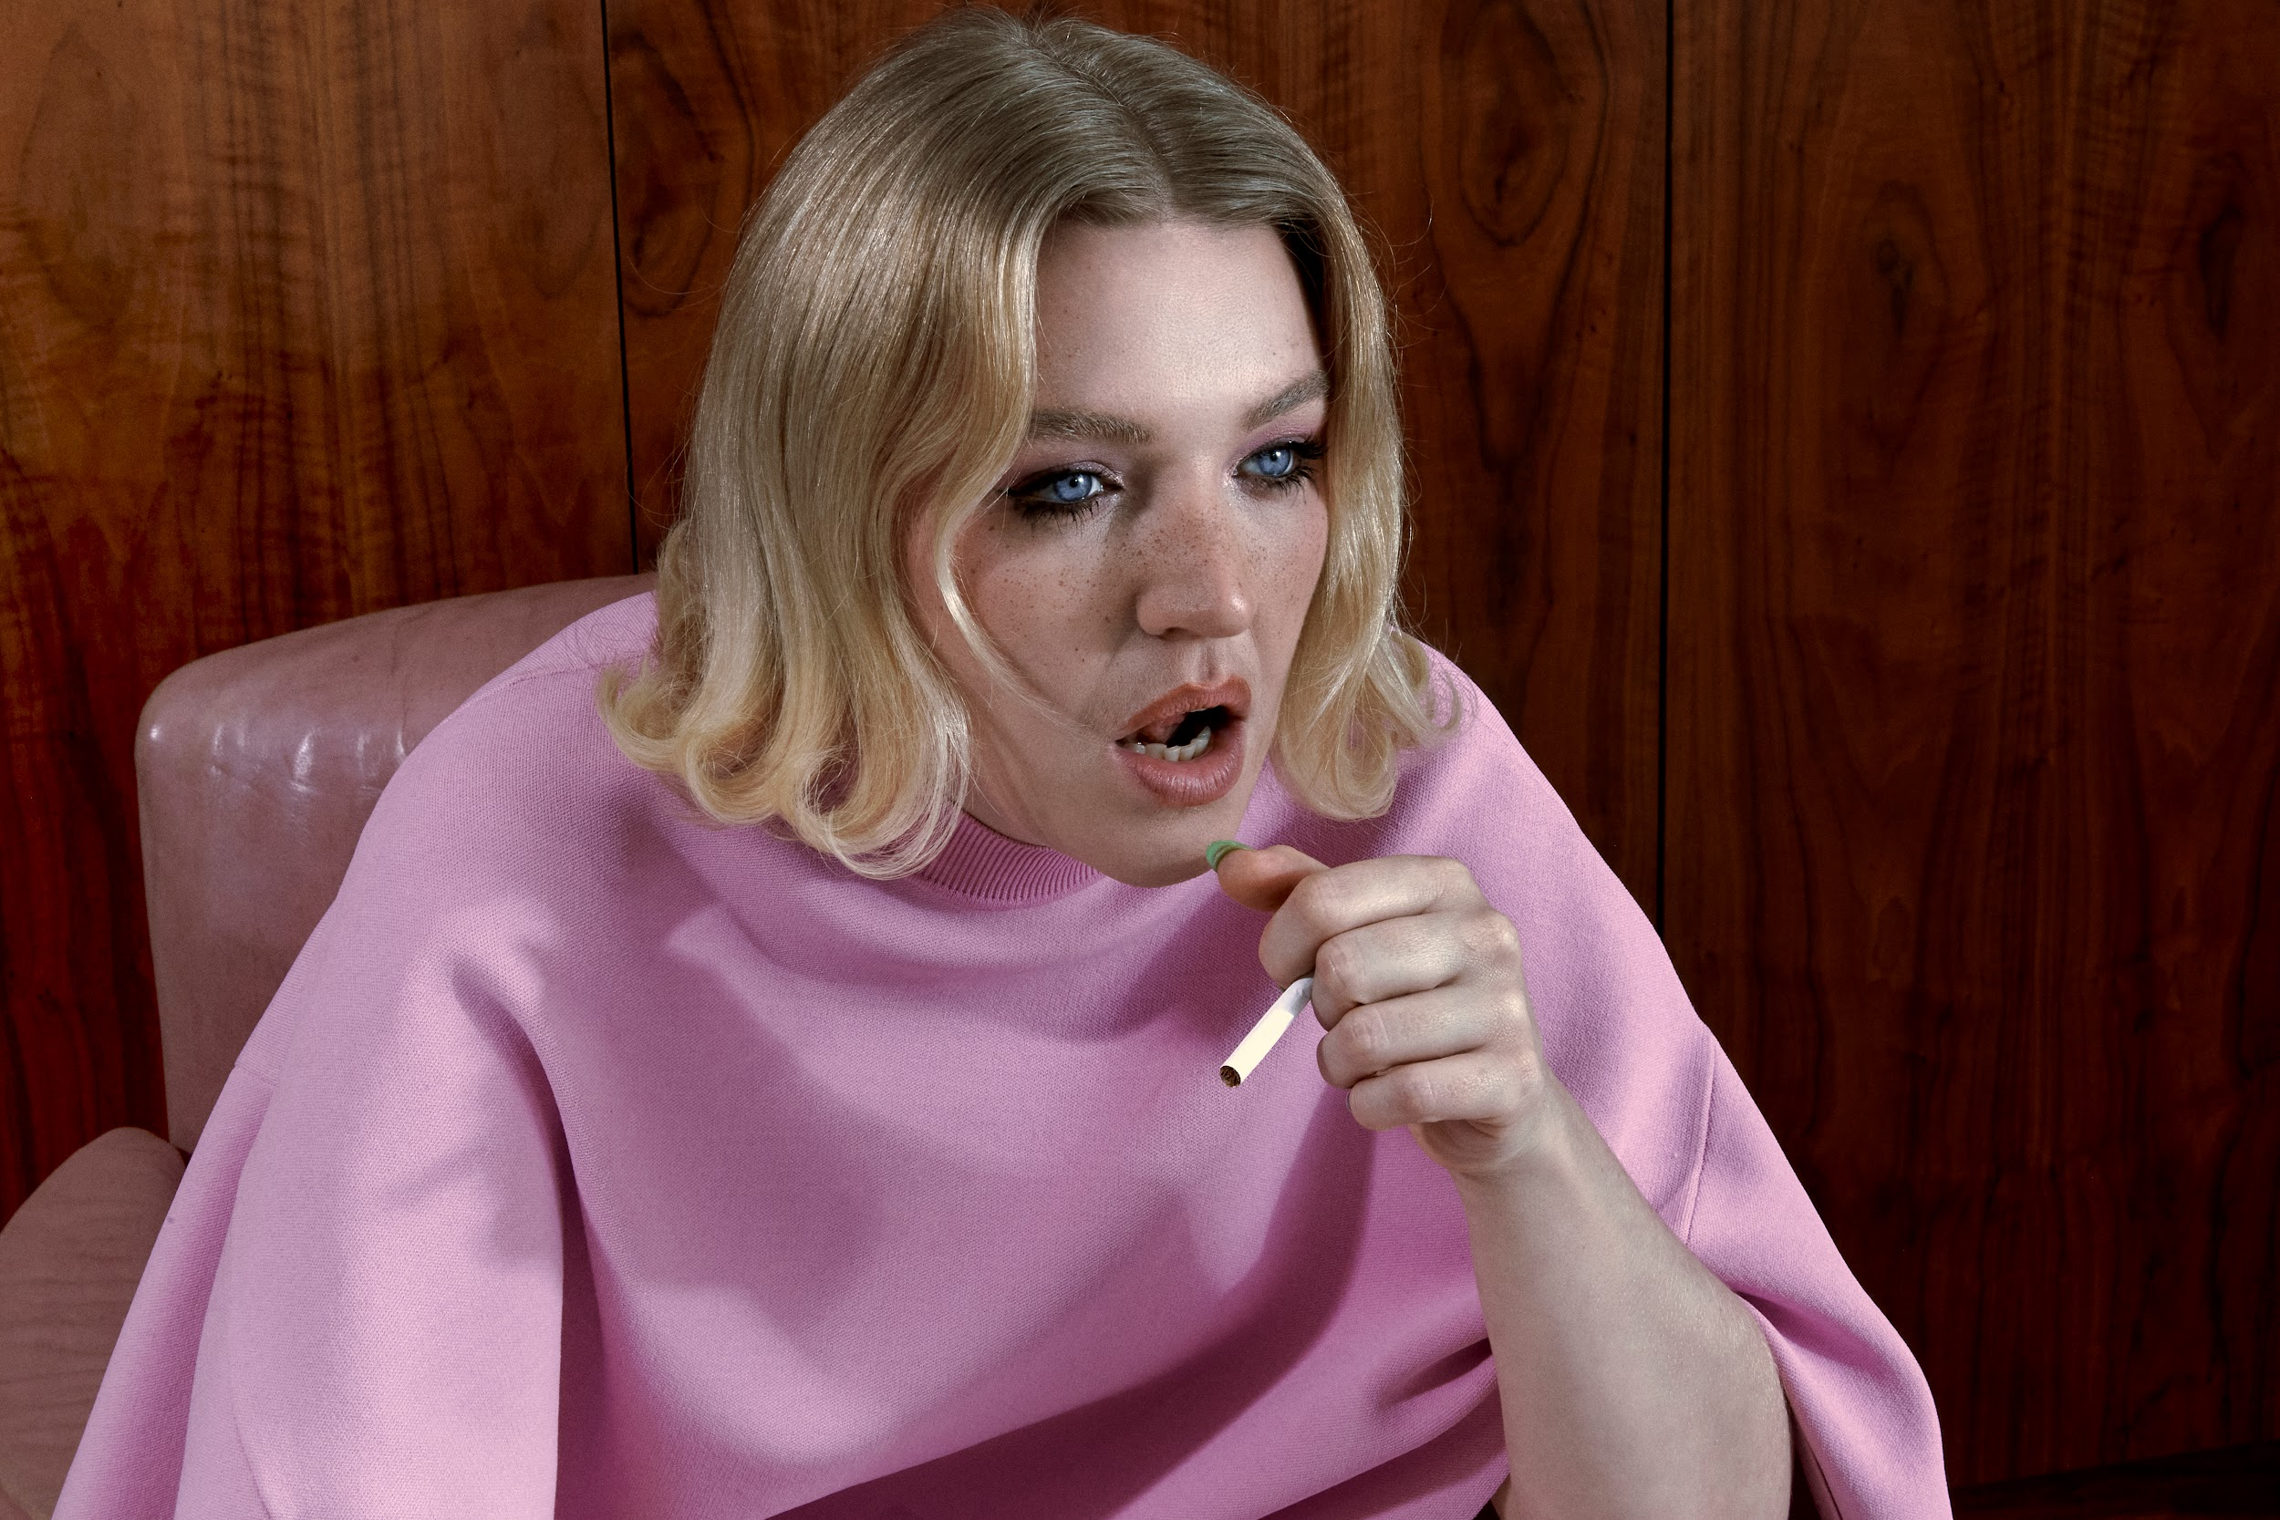

**Self Esteem - photo credit: Yana Van Nuffel (Hi-res assets** [**here**](https://drive.google.com/drive/folders/1PzHuReSTjuJiNgaqbggCcYvcYShnbD6l)**)**

Self Esteem today shares a new song ‘Love Second Music First,’ available to buy and stream digitally ahead of a physical release as the b-side of current single ‘Big Man’ on 7-inch picture disc vinyl on 18 October.

“This is a song I wrote about my long-term lover,” explains Rebecca Lucy Taylor AKA Self Esteem. “Music is a difficult lover. Controlling and toxic. I don’t recommend it. My heart aches but I can’t deny that nobody does it quite like them.”

[**Listen to ‘Love Second Music First’**](https://selfesteem.lnk.to/lovesecondmusicfirst)

[**Pre-order ‘Big Man’ / ‘Love Second Music First’ on 7-inch**](https://store.selfesteem.love/products/big-man-7-picture-disc)

‘Big Man’ / ‘Love Second Music First’ are Self Esteem’s first new songs since the release of her wildly acclaimed BRIT and Mercury Prize-nominated 2021 album *Prioritise Pleasure*.

‘Big Man’ is a collaboration with South African trailblazer Moonchild Sanelly and explores the nuances of modern masculinity and gender roles. It was premiered as Hottest Record In The World on BBC Radio 1 and has been playlisted across Radio 1 and 6 Music, named as one of the Guardian’s songs of the summer, and been streamed half a million times so far.

[**Watch / listen to ‘Big Man’**](https://selfesteem.lnk.to/big)



**‘Big Man’ artwork (Hi-res assets** [**here**](https://drive.google.com/drive/folders/1PzHuReSTjuJiNgaqbggCcYvcYShnbD6l)**)**

**About Self Esteem**

One of the UK’s most exciting breakout stars of the past decade, Rebecca Lucy Taylor, AKA Self Esteem emerged from cult favourite status to mainstream hero following the huge success of her empowering, truth-telling 2021 single ‘I Do This All The Time’. The song resonated intensely as a perfect example of Taylor’s affectionately termed ‘trojan horse’ or ‘salad and chips’ approach, fearlessly packing important, emotive messages into witty, resonant pop music.

Self Esteem’s wildly acclaimed second album *Prioritise Pleasure* quickly followed, tackling the hypocrisies and joys found in her experiences of modern day womanhood across dating, friendship, comparison culture, self love, women’s safety and sexual assault and much more. *Prioritise Pleasure* received Mercury Prize, BRIT Award, Sky Arts and NME Award nominations, was crowned The Guardian and Sunday Times Culture’s Album of the Year, and ‘I Do This All The Time’ was also named The Guardian’s #1 song of 2021.

Quite the opposite of an overnight success, Taylor spent a decade as one half of indie duo Slow Club before adopting the pop star persona she’d always dreamed of. She released her first Self Esteem album *Compliments Please* in 2019, featuring fan favourite singles ‘The Best’, ‘Girl Crush’ and more.

Gathering a passionate and vast legion of fans ever since, Taylor has appeared on The Graham Norton Show, Celebrity Gogglebox, Friday Night Live, performed three times on Jools Holland including the NYE Hootenanny, graced the covers of magazines from Grazia to NME to Sunday Times Style, and is one of a handful of artists to have been playlisted across BBC Radio 1, 2 and 6 Music simultaneously.

Having reached new heights of acclaim, Taylor has continued to grow, diversify, and create in 2024. Branching out into the world of acting, Taylor starred in a regular role in the recent Sky series SMOTHERED before completing a run playing Sally Bowles in the multiple Olivier Award-winning production of 'Cabaret at the Kit Kat Club' in London's West End. Starring alongside Jake Shears (lead singer of Scissor Sisters) as Emcee, the pair’s time on stage was extended due to popular demand, and showcased the sheer range of talent in Taylor’s repertoire. ‘Big Man’ / ‘Love Second Music First’ follows a collaboration with Becky Hill on her recent song ‘True Colours’.

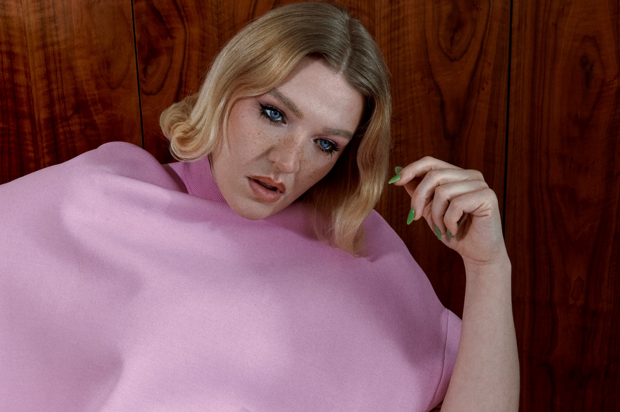

**Self Esteem - photo credit: Yana Van Nuffel (Hi-res assets** [**here**](https://drive.google.com/drive/folders/1PzHuReSTjuJiNgaqbggCcYvcYShnbD6l)**)**

**Connect with Self Esteem**

[**Website**](https://selfesteem.lnk.to/WE) **/** [**Instagram**](https://selfesteem.lnk.to/IN) **/** [**Facebook**](https://selfesteem.lnk.to/FB) **/** [**Twitter**](https://selfesteem.lnk.to/TW) **/** [**TikTok**](https://www.tiktok.com/@selfesteemselfesteem69?)

**For all media enquiries please contact** [**Warren@chuffmedia.com**](mailto:Warren@chuffmedia.com) **on 07762 130510**