MINISTRY OF SOUND CLASSICAL
FRIDAY 24TH JULY

BILLY OCEAN
WEDNESDAY 29TH JULY

HEADLINE SANDOWN PARK NIGHTS 2026

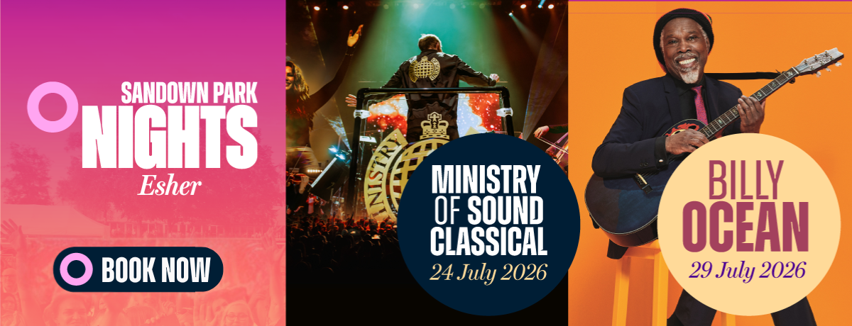
DOWNLOAD MEDIA ASSETS HERE

Sandown Park Nights will be welcoming two leading acts for its music nights this Summer - Ministry of Sound Classical and Billy Ocean.

Fresh from a racecourse debut in 2025, Ministry of Sound Classical will be bringing its unique experience to Sandown Park on Friday 24th July 2026.

A live concert-format production that takes iconic dance and club music and re-orchestrates them, Ministry of Sound Classical is a hugely influential name in dance music. Started in London in 1991, it has sold out shows at iconic venues such as the Royal Albert Hall, where it also returns in 2026 as part of its tour.
Celebrating more than 30 years of iconic dance anthems, the 2026 edition marks the show’s most exciting performance yet, with the power of an orchestra and sensational vocalists, all set to a stunning laser light production.
Nearly 50 years after his first big break, Billy Ocean will be heading to the Esher venue to perform live after racing on Wednesday 29th July 2026.

Billy is the biggest black recording star Britain has ever produced, with more than 30 million records sold to date. He has collected a pile of Gold and Platinum records across the world and hit the number one spot in multiple countries, with hits such as “There’ll be Sad Songs (To Make You Cry)” and “Get Outta My Dreams; Get Into My Car”.
Billy’s mix of soul and pop has been heard across the world for years now, from movie theme songs to number one albums. Having returned to touring in 2018, he continues to play sold-out shows in iconic venues like the Royal Albert Hall in London and Usher Hall in Edinburgh.
Sarah Drabwell, General Manager at Sandown Park Racecourse, said: “We’re so excited to be welcoming Billy Ocean and Ministry of Sound Classical to Sandown Park in 2026.
“Billy Ocean is sure to wow us with a show full of hits and fantastic vocals, while we know that customers will be ready for an unforgettable night with Ministry of Sound Classical and their exceptional show.
“We stage racing year-round at Sandown Park and these evenings where we combined thrilling sport on course with fantastic entertainment afterwards not only continue prove extremely popular but give people who might not ordinarily come racing the opportunity to experience it for themselves.”
The Sandown Park Nights series continues to set the standard for value-packed entertainment in Surrey, combining thrilling afternoon racing with full headline performances from some of the nation’s biggest music stars. With a single ticket granting access to both world-class racing and live music, fans enjoy an unforgettable afternoon (and night out) at exceptional value. The experience is further enhanced by a diverse range of food options, from vibrant street food offerings to Sandown Park’s renowned selection of outstanding restaurants.

Tickets for MINISTRY OF SOUND CLASSICAL on Friday 24th July and BILLY OCEAN on Wednesday 29th July are on sale now via thejockeyclub.co.uk/sandown

FOR MORE INFORMATION AND ALL MEDIA ENQUIRIES FOR
SANDOWN PARK NIGHTS, PLEASE CONTACT

Jenny Entwistle at Chuff Media
jenny@chuffmedia.com

About Sandown Park Racecourse
Founded in 1875, Sandown Park Racecourse has provided the backdrop to some of the greatest moments in horse racing history. A day at the races at Sandown Park has it all with top-level racing throughout the year including the bet365 Jump Finale, Coral-Eclipse Summer Festival and Betfair Tingle Creek Meeting, well as the popular Music Nights.

It is owned by The Jockey Club, the largest employer in British horseracing and one of the leading sports businesses operating in the UK today, with annual turnover in excess of £200 million. We run 15 of the UK’s racecourses – large and local – where we are charged with looking after some of the nation’s biggest events, including the Randox Grand National Festival at Aintree, The Cheltenham Festival, The Derby at Epsom Downs and the Guineas Festival in Newmarket.

We welcome thousands of racehorses a year to our training centres in Newmarket, Lambourn and Epsom. We run The National Stud in Newmarket and our charity, Racing Welfare, makes help available to all of racing’s people. We are governed by Royal Charter to act for the long-term benefit of British Racing, which is Britain’s second-biggest spectator sport.

For more information, please visit thejockeyclub.co.uk/sandown

