**SHARES NEW SONG “*WILD LONG LIE’* – SECOND TRACK TO BE LIFTED FROM FORTHCOMING NEW ALBUM -** [**LISTEN**](https://samfender.lnk.to/WildLongLiePR)

**SOLD OUT UK/IRELAND ARENA TOUR KICKS OFF TONIGHT IN DUBLIN + INCLUDES TWO NIGHTS AT LONDON’S O2 ARENA LATER THIS MONTH**

**4 UK STADIUM SHOWS FOR SUMMER 2025 – 3 X ST. JAMES’ PARK SHOWS SOLD OUT. REMAINING TICKETS ON SALE** [**NOW**](http://www.samfender.com/) **FOR LONDON STADIUM**

**“*PEOPLE WATCHING*” LP RELEASED 21ST FEBRUARY 2025**

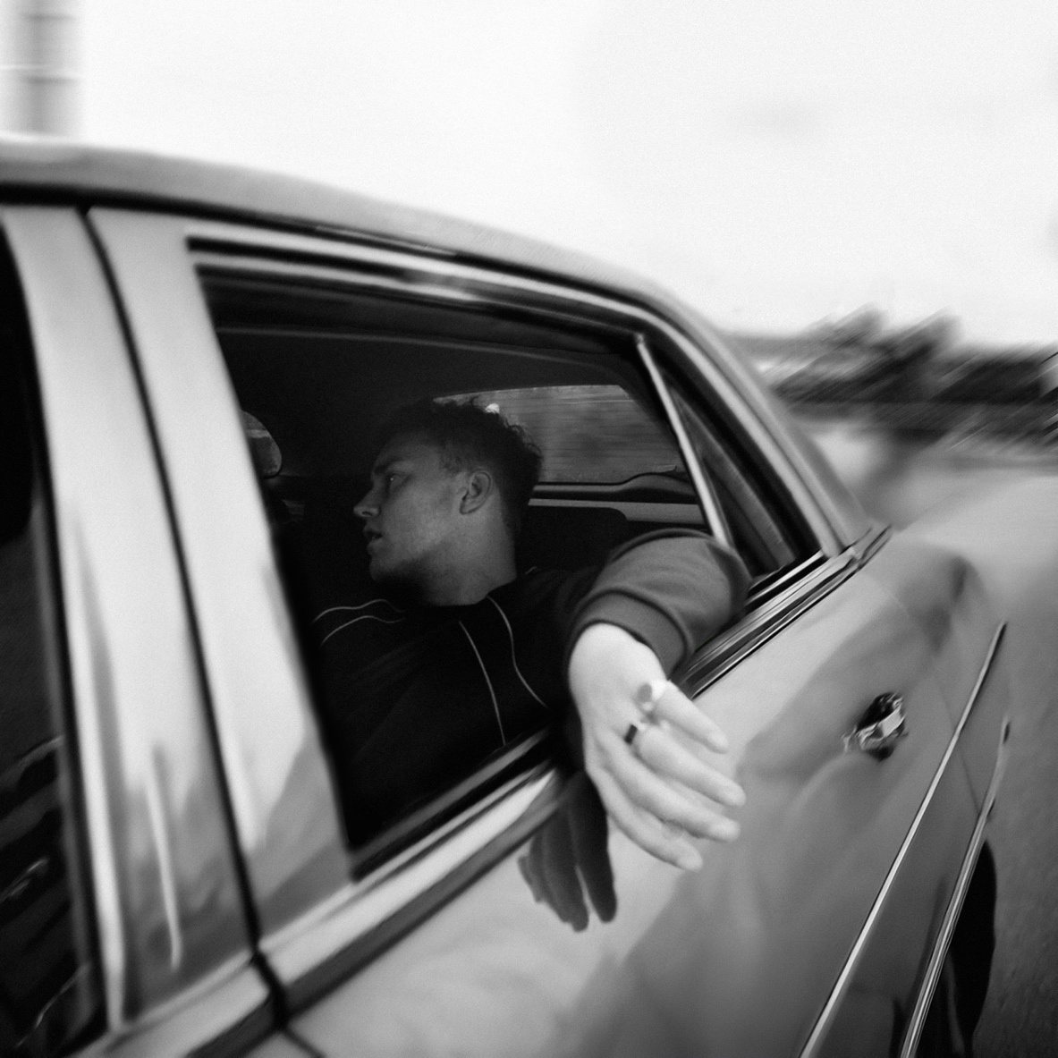

**Credit: Jack Whitefield**

Sam Fender is pleased to share the second track to be lifted from his forthcoming third album, *People Watching*. Listen to *Wild Long Lie* [**HERE**](https://samfender.lnk.to/WildLongLiePR)

Following his explosive re-introduction with last month’s soaring anthem in album title-track, *People Watching*, Sam follows it with the twisting folk rock of *Wild Long Lie*. The single will be backed with the bonus track, *Me & The Dog*.

*Wild Long Lie* takes a left turn from the euphoria of the returning single, and lands on something more reflective, subtle and understated - but no less impactful.

Just last week, four stadium dates went on sale for next June, with three nights at Newcastle’s St. James Park now all sold out, preceding Fender’s biggest show to date at the London Stadium. Remaining tickets for London are on sale now via [www.samfender.com](http://www.samfender.com). CMAT supports at all four shows, and The War on Drugs will play on 6th and 14th + 15th June.

£1 from every ticket sold will be donated to select cultural organisations such as Youth Music and Sunday For Sammy to support the arts in the North East of England.

Ahead of that, the North Shields musician kicks off his 10-date UK/Ireland arena People Watching Tour at Dublin’s 3Arena, calling at London’s O2 Arena on 10th and 12th December. Support for all UK arena dates comes from Wunderhorse.

**Listen to *People Watching*** [**HERE**](https://samfender.lnk.to/PWListen) **and pre-order the album** [**HERE**](https://samfender.lnk.to/peoplewatching)

Fender heads to Europe for the second leg of the tour in March 2025, and is also confirmed to headline next year’s Rock Werchter festival in July and perform at the Southside and Hurricane festivals in Germany.

Next February, Sam Fender releases his third album, *People Watching*. Now solidified as one of Britain’s most accomplished songwriters of his generation and the next, if *Seventeen Going Under* was Sam’s “coming of age” record, *People Watching* is his next step forward - colourful stories and observations of everyday characters living their everyday, but often extraordinary, lives

**Sam Fender Live – People Watching Tour**

**2024 (support from Wunderhorse):**

2nd December – 3Arena, Dublin SOLD OUT

4th December – First Direct Arena, Leeds SOLD OUT

6th December – Co-Op Live, Manchester SOLD OUT

7th December – Co-Op Live, Manchester SOLD OUT

10th December – The O2, London SOLD OUT

12th December – The O2, London SOLD OUT

13th December – Utilita Arena, Birmingham SOLD OUT

16th December – OVO Hydro, Glasgow SOLD OUT

17th December – OVO Hydro, Glasgow SOLD OUT

20th December – Utilita Arena, Newcastle SOLD OUT

**2025 (support from CMAT):**

4th March – Olympia, Paris SOLD OUT

5th March – 013 Poppodium, Tilburg SOLD OUT

8th March – Halle 622, Zurich SOLD OUT

10th March – Palladium, Cologne (SOLD OUT

12th March – Zenith, Munich SOLD OUT

13th March – ChorusLife Arena, Bergamo

16th March – Uber Eats Music Hall, Berlin SOLD OUT

18th March – Afas Live, Amsterdam SOLD OUT

19th March – Forest National, Brussels SOLD OUT

**US Tour 2025**

11th February – Webster Hall, New York SOLD OUT

5th April - Doug Mitchell Thunderbird Sports Centre - Vancouver, BC

7th April - The Paramount Theatre - Seattle, WA

9th April - Roseland Theater - Portland, OR

11th April - Fox Theater - Oakland, CA

13th April - Coachella Festival, CA

20th April - Coachella Festival, CA

21st April - Marquee Theatre - Tempe, AZ

23rd April - The Union Event Center - Salt Lake City, UT

24th April - The Fillmore - Denver, CO

**Summer 2025:**

6th June – London Stadium (w/ The War on Drugs + CMAT)

12th June – St. James’ Park, Newcastle (w/ CMAT) SOLD OUT

14th June – St. James’ Park, Newcastle (w/ The War on Drugs + CMAT) SOLD OUT

15th June - St. James’ Park, Newcastle (w/ The War on Drugs + CMAT) SOLD OUT

21st June – Hurricane, Germany

22nd June – Southside, Germany

4th July – Down The Rabbit Hole, Netherlands

 5th July – Rock Werchter, Belgium

[www.samfender.com](http://www.samfender.com)

**Wild Long Lie**

**For more information and press enquiries for SAM FENDER please contact**

**Jenny Entwistle**

[**Jenny@chuffmedia.com**](mailto:Jenny@chuffmedia.com)