STONE
Liverpool band STONE release new single ‘I Let Go’
Out now on Polydor Records

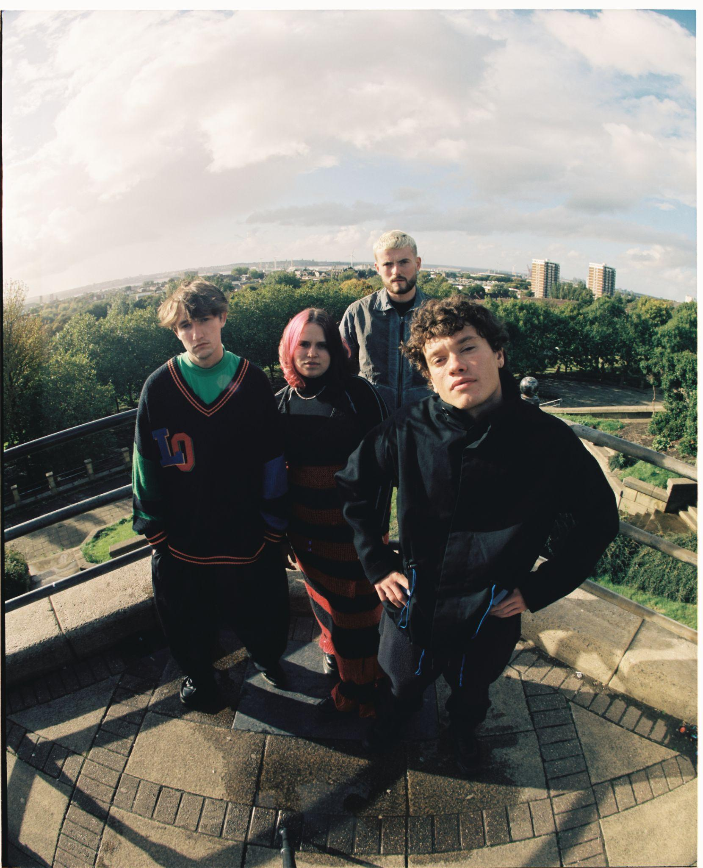
Photo Credit: Isaac Lamb

"Bruising post-punk full of Scouse spirit and soul"
NME

“STONE are the post-punks with a reputation for mosh-pit starting licks and the snarling delivery of frontman Fin Power”
Rolling Stone UK

“Full throttle and immediate but undeniably powerful – from a band that must be seen live to be truly believed. Expect venues around the country to be shaking in anticipation."
Dork

“A perfect post-pandemic band…raucous live shows and playfully rowdy indie bangers”
DIY

Liverpool four-piece STONE share new single ‘I Let Go’ today, a full-throttle rejoice of surrendering yourself to impulse and excess. The single follows the release of their debut EP Punkadonk late last year which featured stand out single and BBC Radio 1 ‘Tune of the Week’ ‘Money’ Hope Ain’t Gone’. Currently on an extensive European tour winning over massive crowds in support of The Kooks, the band will return to home soil for their own UK headline tour this April, with an extra show now added for London due to demand, full dates below and tickets here.

With ​​their formidable live reputation preceding them, STONE have stormed straight out of the new-era Liverpool scene. Their breakout 12 months was capped off by the release of debut offering Punkadonk, which fuses thrilling, frenetic rock with a more intimate exploration of the Gen-Z experience - as rewarding to mosh to as it is emotionally absorb. ‘I Let Go’ marks their first new music of 2023, and the band explain; "’I Let Go’ is a song about one of those nights where you promise yourself ‘I’m not going to drink’ then end up going straight out when your mates call you up. The song is about how out of control you can become when going out, and even though you know getting drunk and partying isn’t good for you - it’s so fun in the moment…”

Led by the instantly-discernable vocals of Fin Power, STONE are completed by Elliot Gill (lead guitar) Sarah Surrage (bass), and Alex Smith (drums). Their burgeoning fanbase already includes some of music’s biggest names, which has led to handpicked support slots from the likes of YungBlud, Inhaler, Sam Fender, as well as blistering festival sets at Reading and Leeds and Louis Tomlinson’s ‘Away from Home’ line up in Malaga. The band have been tipped as ones to watch by the likes of NME, Dork, Rolling Stone UK, MTV and more, and championed across BBC Radio1 and 6Music by the likes Jack Saunders, Clara Amfo and Steve Lamacq. ‘I Let Go’ anticipates another big year for STONE as they continue to cement their presence as one of the UK’s most exhilarating young acts.

Listen to ‘I Let Go’ on all platforms here:
https://stone.lnk.to/ILETGO

Listen to Punkadonk on all platforms here:
https://STONE.lnk.to/PUNKADONK

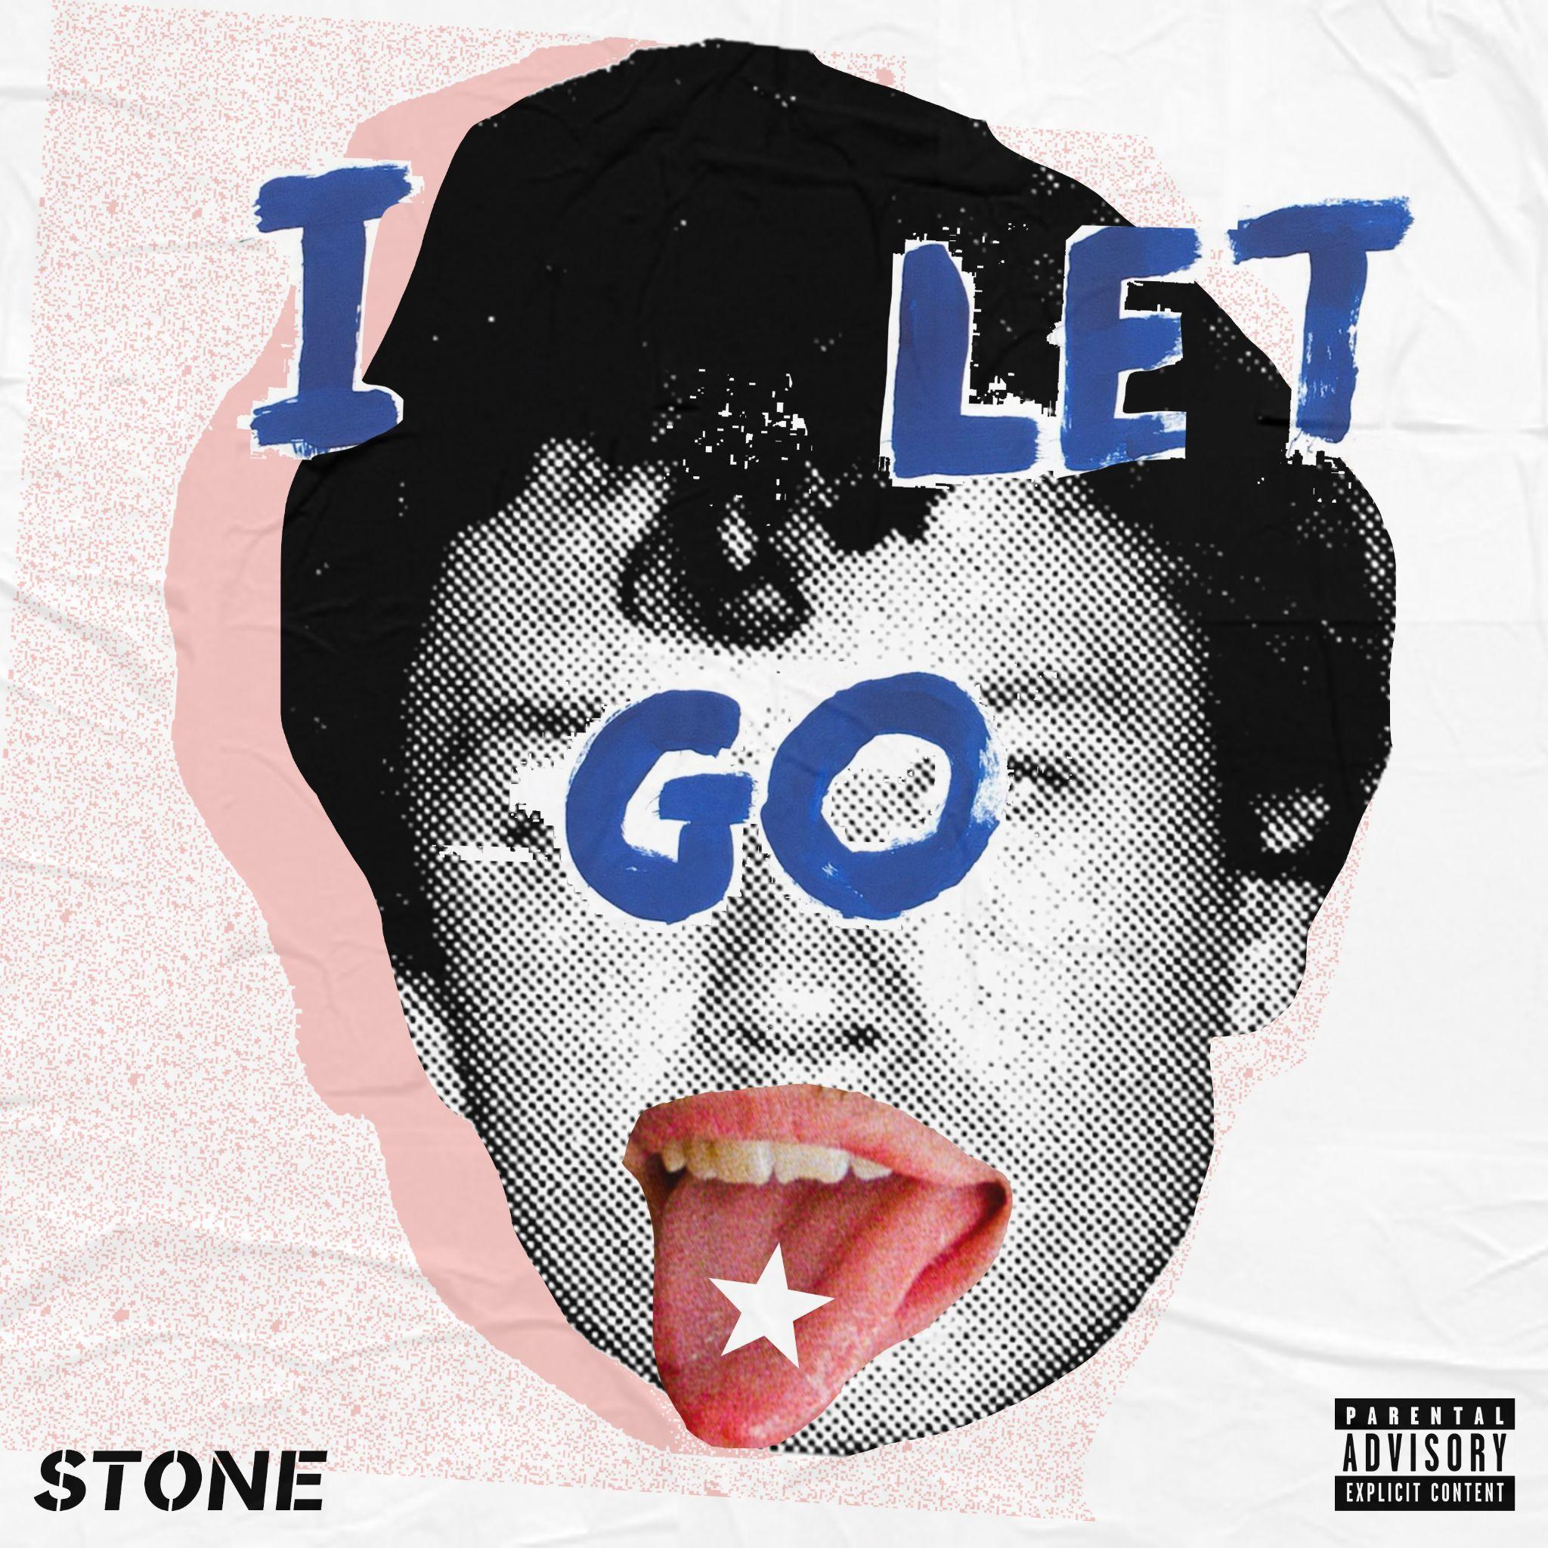
‘I Let Go’ single artwork

STONE supporting The Kooks:
*SOLD OUT*

24 Jan | Lisbon | Campo Pequeno Bullrings
25 Jan | Madrid | La Riviera
27 Jan | Barcelona | Sala Razzmatazz
28 Jan | Toulouse | Le Bikini
29 Jan | Bordeaux | Le Krakatoa
31 Jan | Lyon | Le Transbordeur
01 Feb | Milan | Fabrique
02 Feb | Zurich | X-Tra
04 Feb | Brussels | Forest National
05 Feb | Offenbach | Stadthalle
06 Feb | Ludwigsburg | MHP Arena
07 Feb | Cologne | Palladium
10 Feb | Stockholm | Annexet
11 Feb | Oslo | Sentrum Scene
12 Feb | Copenhagen | Store Vega
13 Feb | Hamburg | Sporthalle
14 Feb | Berlin | Columbiahalle
16 Feb | Munich | Zenith
17 Feb | Amsterdam | AFAS Live
18 Feb | Paris | L’Olympia

STONE 2023 UK Headline Tour:
Tickets here

10 April | London | Omeara *NEW SHOW ADDED*
11 April | London | Omeara *SOLD OUT*
13 April | Newcastle | Cluny *SOLD OUT*
14 April | Glasgow | SWG3 Warehouse
15 April | Cambridge | Junction 2
18 April | Birmingham | The Castle & The Falcon
19 April | Leeds | Wardrobe
21 April | Nottingham | Metronome
22 April | Liverpool | O2 Academy
23 April | Bristol | Thekla

STONE 2023 festivals:
27 May | Neighbourhood Weekender
03 Jun | Dauwpop
02 Jul | Barn On The Farm
21 Jul | Stanton Calling
28 Jul | Kendall Calling
1 Sept | Into The Great Wide Open

Follow STONE:
Instagram | Facebook | Youtube | TikTok | Spotify

For more information and press enquiries please contact

Warren Higgins
Warren@chuffmedia.com

