

**SHARE THE NEW SINGLE ‘QUEEN’**

**LISTEN** [**HERE**](http://stone.lnk.to/QUEEN_) **/ WATCH THE LYRIC VIDEO** [**HERE**](https://stone.lnk.to/QUEEN_)

**FROM THE DEBUT ALBUM ‘FEAR LIFE FOR A LIFETIME’, OUT JULY 12TH**

**PRE-ORDER / PRE-SAVE** [**HERE**](https://stone.lnk.to/FEARLIFEFORALIFETIME)

**UK AND EUROPEAN HEADLINE TOUR ALSO ANNOUNCED**

*“This is the step forward that they’ve been building in their heads… It’s safe to say that STONE are ready to establish themselves with ‘Fear Life’.”* - **DORK**

*“A musical mishmash of punk, garage rock and subtle electronica that you’ll be unable to peel your ears and, if you’ve seen them live, eyes away from.”* - **Rolling Stone**

*“The band explore their own identity while treading a path towards the big time.”* - **NME**

*“When STONE hit the stage, you simply can’t take your eyes off them.”* - **Kerrang!**

*“An uncanny ability to draw huge choruses out of thin air.”* - **DIY**

*“A force to be reckoned with.”* - **The Line of Best Fit**

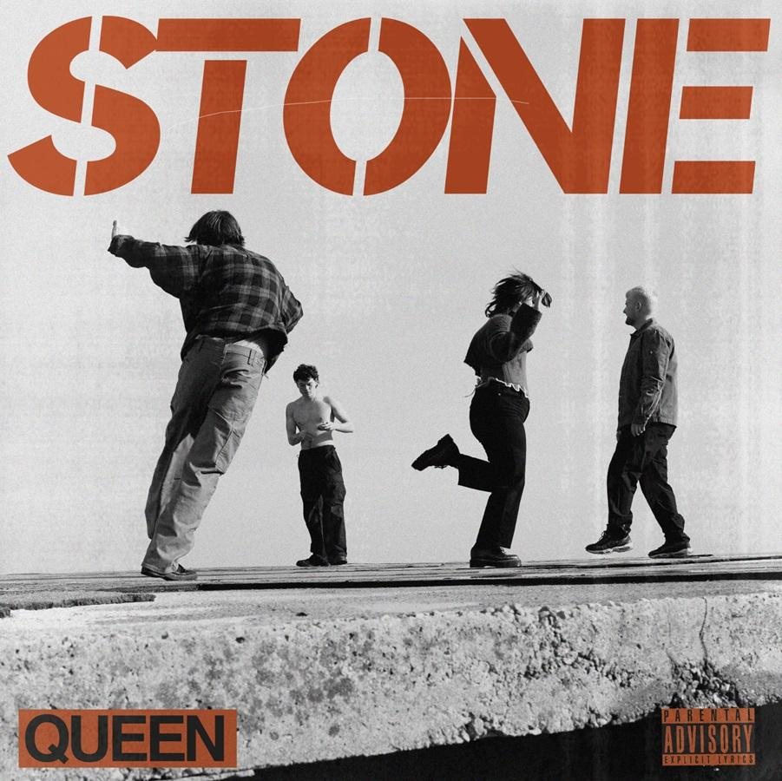

Download Artwork & New Press Shot [**HERE**](https://umusic.ent.box.com/s/0wvemtqsjyium7gqw7eb0h3p1ixz2fjk/file/1477632016268) – Credit Claudia Legge

**STONE** are firing on all fronts, their rise heralded with strong support at **Radio 1**, acclaim right across the board and all 500 copies of the **Blood Records** zoetrope vinyl edition of their debut album **‘Fear Life For A Lifetime’** selling out instantly. It’s easy to see their appeal. They’re a band who specialise in instantly addictive indie-rock anthems that speak to the experiences of their generation, and always strive to make a powerful connection with their growing fanbase. Frontman **Fin Power** is their not-so-secret weapon: a man with endless charisma and an electrifying stage presence.

Now **STONE** take another big step towards the **July 12th** release of **‘Fear Life For A Lifetime’** by sharing the new single **‘Queen’**. The track is accompanied by a lyric video, which edits together hundreds of black-and-white photos of the band’s adventures on the road.

**‘Queen’** has everything it takes to propel **STONE** to the next level. Every element is an earworm, from the soaring anthemic hook to its sweet, saturated synths and a sparkling riff so infectious it feels like you already know it. In short: it’s what you expect from a band with arena-filling aspirations. Opening with the attention-grabbing lyric *“I could drown in a bath of expensive wine”* it’s also a song with a twist - a love song, yes, but one powered by the anxiety that you might not deserve the love that comes your way.

**Fin** says, *“I wrote ‘Queen’ from the perspective of the person I was seeing at the time, and the words that they said to me. I remember someone saying to me, ‘You know, I don’t love myself, but I love the way you look at me.’ It’s a song about how falling in love is actually such a powerful thing that it makes you doubt yourself.”*

As with the rest of their upcoming album, **STONE** recorded **‘Queen’** during sessions in **Vermont** with producer **Rich Costey** (**Sam Fender**, **HAIM**, **Biffy Clyro**) in **Brattleboro**, **Vermont**. The young band - completed by **Elliot Gill** (guitar), **Sarah Surrage** (bass) and **Alex Smith** (drums), who have been together for years before their rise - have previewed the album with the singles **‘My Thoughts Go’** and **‘Save Me’**.

The album’s arresting cover image depicts **Fin** facing his deepest fear by jumping into the ocean from a 50-foot cliff: an apt metaphor for both the band’s conviction and the record’s theme of fighting your fears head-on.

**‘Fear Life For A Lifetime’** is available to pre-order or pre-save [**HERE**](https://stone.lnk.to/FEARLIFEFORALIFETIME) with physical formats including white vinyl, CD and cassette.

**STONE’s** famously incendiary live show will be back on the road later this year with select **European** headline dates and the **Come As You Are Festival** followed by an extensive **UK** headline tour. The news adds to a schedule that already includes a record store tour to celebrate the release of **‘Fear Life For A Lifetime’** as well as hitting much bigger venues in **November** as special guests to **Jake Bugg**. Tickets for the headline tour go on sale [**HERE**](https://www.stone.band/live) from **10am** on **Wednesday, June 19th**. The band’s upcoming tour dates are:

**JULY - RECORD STORE TOUR**

**12th - London, Rough Trade East**

**13th - Birmingham, hmv Vault**

**16th - Leeds, The Vinyl Whistle**

**17th - Liverpool, Jacaranda Baltic**

**SEPTEMBER - HEADLINE TOUR**

**30th - Berlin, Cassiopeia**

**OCTOBER - HEADLINE TOUR**

**2nd - Antwerp, Trix**

**3rd - Amsterdam, Melkweg**

**5th - Eindhoven, Come As You Are Festival**

**6th - Paris, La Boule Noire**

**18th - Hull, The Welly**

**19th - Stoke, Sugarmill**

**21st - Dundee, Caves**

**23rd - Nottingham, Rescue Rooms**

**24th - Norwich, The Waterfront**

**26th - Exeter, Cavern**

**27th - Portsmouth, Wedgewood Rooms**

**29th - Guildford, Boileroom**

**30th - Tunbridge Wells, Forum**

**NOVEMBER - GUESTS TO JAKE BUGG**

**18th – Leeds, O2 Academy**

**19th – London, Roundhouse**

**21st – Dublin, National Stadium**

**23rd – Glasgow, Barrowland Ballroom**

**24th - Edinburgh, O2 Academy**

**26th – Manchester, O2 Victoria Warehouse**

**Follow STONE:**

[**Spotify**](https://open.spotify.com/artist/1br1PqvafIUOis4rBUvv1H?si=S4RK_cY9TRiDPwDaCV8oiw) **|** [**Apple Music**](https://music.apple.com/gb/artist/stone/1504110389) **|** [**YouTube**](https://www.youtube.com/channel/UCy2UjknL3o-JILuB4h2KDCw) **|** [**Instagram**](https://www.instagram.com/stoneliverpool/) **|** [**TikTok**](https://www.tiktok.com/@stoneliverpool) **|** [**X**](https://twitter.com/STONELIVERPOOL/) **|** [**Website**](https://www.stone.band)

**For more information and press enquiries please contact**

**Warren Higgins**

[**Warren@chuffmedia.com**](mailto:Warren@chuffmedia.com)