SPORTS TEAM RELEASE NEW SINGLE

**‘BANG BANG BANG’**

A REFLECTION ON GUN CULTURE IN AMERICA

**LISTEN / WATCH**

PROPHETIC RELEASE FOLLOWS ARMED ROBBERY INCIDENT IN CALIFORNIA

*“I THINK WHAT WAS SHOCKING WAS HOW BLASE PEOPLE WERE. YOU’RE QUEUING FOR COFFEE AND THEN YOU’RE TRYING TO NEGOTIATE SOMEBODY WAVING A PISTOL AROUND. THE STAFF COME AND LOCK THE DOORS, TELL YOU TO STEP AWAY FROM THE WINDOWS. YOU’RE TRYING TO BARRICADE YOURSELF IN THE TOILET AND THEY’RE STILL DOING THE SQUIRTY CREAM ON THE DRINKS.”*

THIRD STUDIO LP, *BOYS THESE DAYS* PRODUCED BY MATIAS TELLEZ (GIRL IN RED, CMAT, GRACIE ABRAMS), OUT MAY 23rd, 2025

VIA DISTILLER RECORDS/BRIGHT ANTENNA

**SPORTS TEAM** today (Jan 10th) release new single **‘Bang Bang Bang’**, a blazing rock track with western inspired touches, originally written as a reflection on the gun culture of America. Long slated as their first release of 2025, in a strange twist of events, art became reality when the band were recently robbed at gunpoint on the first date of their US tour.

The incident took place on December 3rd and made headlines on both sides of the Atlantic after it was broken by [BBC News](https://www.bbc.co.uk/news/articles/cy09gkr08lpo) . Sports Team had just arrived in San Francisco and were grabbing a coffee in the Bay Area when someone alerted them that their tour van was being robbed. The band and crew attempted to intervene but were faced with an assailant brandishing a gun and ran for cover. Undeterred, they continued the tour and received hundreds of offers of support.

What was originally conceived as a view of gun culture from an outside perspective now has a deeper and darker significance.

“*We would tour America a lot, and you see the AR-15 logo used on coffee bags, hats, t shirts, bumper stickers,”* guitarist and lyricist Rob Knaggs explains. *“There’d be racks with tourist souvenirs, a Mickey Mouse hat, pet rocks, some local landmark postcard, then a AR-15 magnet and that’s where the seed of the lyrics came from. Then across the time we spent in America I was fleshing the lyrics out. There was a story I saw about NRA robocalls after the Newtown shooting, and it’s horrific. The immediate PR damage control machine. Then you go and drink in bars. Particularly in smaller towns, and people would hear the accent and ask you about guns. Bring them out and want you to hold them, or look at them. And it just seems like another weird part of the weird culture clash that touring America sometimes feels like. When I was writing the song I was a bit worried about how we would put it out. It’s not something that’s in your garden and you sort of think, however deeply you empathise with a problem, when it’s directly affecting other people you’re a bit nervous about clumsily trampling through it.*

*Imagining something like that happening and you always think it’ll feel dramatic. I think what was shocking was how blasé people were. You’re queuing for coffee. And then you’re trying to negotiate somebody waving a pistol around. The staff come and lock the doors, tell you to step away from the windows. You’re trying to barricade yourself in the toilet and they’re still doing the squirty cream on the drinks. Anyway now it all feels a bit ridiculous. You’re debating not putting the song out on the album, because it suddenly seems like some ridiculous stunt. Like it’s embarrassing. Everybody is so kind. Strangers offering help.  Some local mom has seen it on cable news and messages offering any help, or somewhere safe to wait and figure things out, and ultimately, you’re fine.”*

The track will feature on Sports Team’s upcoming studio album, *Boys These Days,* out May 23rd on Distiller Records/Bright Antenna. Alex Rice, Oli Dewdney, Al Greenwood, Rob Knaggs, Ben Mack, and Henry Young recorded *Boys These Days* with producer Matias Tellez (Girl In Red, CMAT, Gracie Abrams)in his Bergen Norwegian studio.

Sports Team marked their return last summer with the release of **“I’m In Love (Subaru)”** followed by second single **‘Condensation’**, revealinga dramatic shift in gears in their songwriting and showcasing the band at their brightest and most beguiling yet. **‘Bang Bang Bang’** is the third track to be unveiled from their forthcoming new album *Boys These Days* which boasts some of Sports Team's most dynamic musical performances to date and features hand painted artwork by Rob Knaggs. The album is Sports Team’s third and follows top 3 albums **Deep Down Happy** and **Gulp!**

*Boys These Days* is a witty and insightful examination of modern life, exploring the dissonance of our social media feeds that unleash an endless cycle upon us of porn, tragedy, war, violence, sex, money, inspirational quotes, no narrative. No unifying myth. Just “the churn” as Sports Team term it.

***Boys These Days*** is available to pre-order on CD, vinyl and cassette as well as a number of exclusive limited-edition formats including a box set, a signed test pressing and picture disc vinyl.

Pre-save [BOYS THESE DAYS ALBUM](https://ffm.to/BoysTheseDays)

*Sports Team are Alex Rice (vocals), Robert Knaggs (lyrics, backing vocals, rhythm guitar), Henry Young (lead guitar, lap steel), Oli Dewdney (bass), Al Greenwood (drums) and Ben Mack (synths, piano & percussion).*

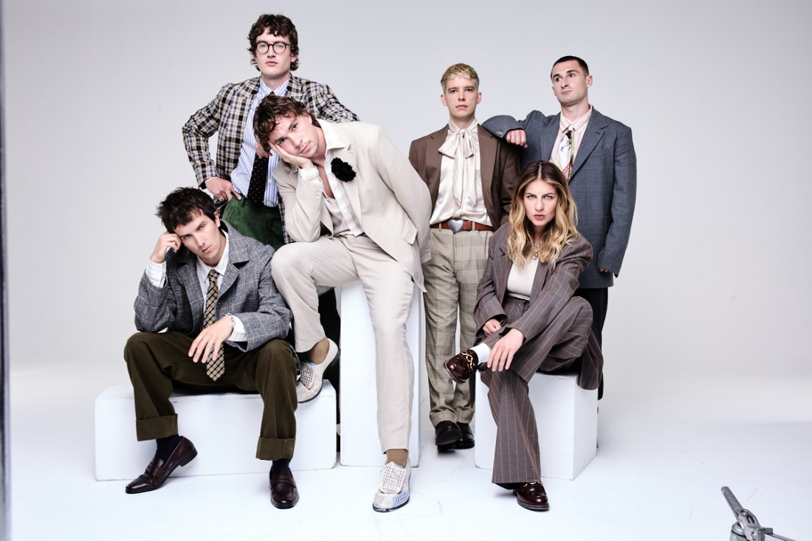

Photo Credit: Bartek Szmigulski - High res download [HERE](https://www.dropbox.com/scl/fi/bfli0ukkb3gz6ubp5h8og/CONDENSATION-PRESS-PIC.jpg?rlkey=mae2plc99cqvm864d8zz9pejo&e=1&st=12lesfvk&dl=0)

CONNECT WITH SPORTS TEAM

[Instagram](https://www.instagram.com/sportsteam/) | [tiktok](https://www.tiktok.com/@sportsteamband?lang=en) | [facebook](https://www.facebook.com/sportsteamband/?locale=en_GB) | [X](https://x.com/sportsteam_?lang=en) | [youtube](https://www.youtube.com/c/SportsTeam) | [website](https://www.sportsteamband.com/)

**For more info contact Warren** [**warren@chuffmedia.com**](mailto:warren@chuffmedia.com)