RELEASE NEW SINGLE **‘ALL’**

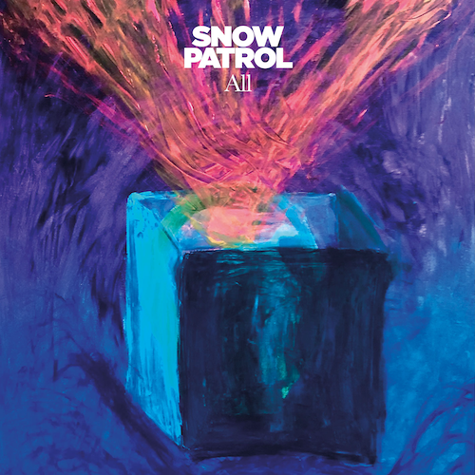

FROM FORTHCOMING NEW ALBUM ‘**THE FOREST IS THE PATH**’

SET FOR RELEASE **SEPTEMBER 13TH 2024**

BAND ANNOUNCE TWO UNDERPLAY SHOWS WEEK OF RELEASE

AT **KOKO** IN LONDON & **ULSTER HALL** IN BELFAST

[LISTEN](https://snowpatrol.lnk.to/All)

[Pre-order album](https://snowpatrol.lnk.to/TheForestIsThePathPR)

**SNOW PATROL** today (Aug 8th) release new single **‘All’** via Polydor Records. It is the third song to be shared from the Northern Irish band’s forthcoming new album **‘The Forest Is The Path’**, which is set for release on **September 13th** and marks their eagerly awaited return after six years, following 2018’s ‘Wildness’. The single release comes alongside news the band will play two underplay shows at KOKO in London on September 11th and Ulster Hall in Belfast on September 13th. Visit the [Snow Patrol Store](https://shopuk.snowpatrol.com/) for details of ticket on sale.

Speaking about the new single, Gary Lightbody says, “**All** was written by Fraser T Smith and myself in late November of 2022. This was almost exactly a year before we would ask Fraser to produce the album. The first time we recorded the album it didn’t work out and we would then ask Fraser to step into the producer’s chair in December of 2023 and he was a dream to work with.

The first day of writing with him I walked into the studio and he had already got some music going. It was all very much “hi, how are you, what about this?” and BAM we were off. I love when that happens. Not really a fan of the small talk. I like big talk. And when you’re writing a song with someone you have to get to the big talk (or what’s the point), so why wait?

My memory is that it all came together very quickly. I wrote a melody and some words while Fraser built the track and in a couple of hours we had a really great rough version of the song.

Then Johnny and Nathan put some extraordinary guitars, keys and piano on it, not to mention incredible backing vocals and so many things which lifted the song massively. Another example of the three of us being locked-in together on this record, it felt like something truly special was happening in the studio.”

‘All’ is already proving itself a firm fan favourite following its debut on Snow Patrol’s run of live dates this summer, with Gary Lightbody remarking he is “blown away by the reaction it’s been getting from crowds hearing it for the first time.”

**Snow Patrol** kicked off the series of headline shows with a stunning performance at Rock Werchter in Belgium before playing to over 35,000 fans at Thomond Park Stadium in Limerick. This month sees them headline a run of UK festivals, before the band return to play two intimate shows in London and Belfast in the week of album release. They will return to play an 8 date UK and Ireland Arena tour in February 2025.

**‘The Forest Is The Path’** is produced by **Fraser T Smith** (Adele/Dave/Stormzy) and the band. Now comprising of trio Nathan Connolly, Gary Lightbody and Johnny McDaid, Snow Patrol offered the first tastes of their extraordinary new album with single **‘The Beginning’** – which was A listed at Radio 2 **-** and recent track **‘This Is The Sound Of Your Voice’**.

**‘The Forest Is The Path’** was written by Nathan Connolly, Gary Lightbody and Johnny McDaid and features twelve tracks. Fraser T Smith, Will Reynolds, Roy Kerr and Troy Van Leeuwen (QOTSA) also contributed to the writing on some of the songs on the album. The album and single artwork features paintings by Gary Lightbody.

**‘The Forest is the Path’** is an album rooted in reflection, introspection and interrogation. One of its key building blocks, says Gary, was the idea of love from the distance of time. “I haven’t been in a relationship for a very long time, 10 years or more, so love from a distance to me meant the way a relationship sits in your memory from a distance of, say, 10 years. That’s not something I’d previously thought about as away to write about love. So it’s like, when you’re in love, you’re standing in the lobby of the Empire State Building. When you’ve broken up with that person, you’re out in the street. You can still see the building, but you’re not in there anymore. And when it’s 10 years later, now you’re standing in Brooklyn looking at the Manhattan skyline.”

‘The Forest Is The Path’ tracklisting:

1. All

2. The Beginning

3. Everything’s Here And Nothing’s Lost

4. Your Heart Home

5. This Is The Sound Of Your Voice

6. Hold Me In The Fire

7. Years That Fall

8. Never Really Tire

9. These Lies

10. What If Nothing Breaks?

11. Talking About Hope

12. The Forest Is The Path

**SNOW PATROL LIVE DATES**

**AUGUST**

16th – Hardwick Festival, Sedgefield

23rd – Victorious Festival, Portsmouth

25th – The Big Feastival

**SEPTEMBER**

11th London KOKO

13th Belfast Ulster Hall

**UK & Ireland Arena tour**

Feb 15th London O2

Feb 16th Birmingham Resorts World Arena

Feb 18th Cardiff Utilita Arena

Feb 19th Hull Connexin Live

Feb 21st Glasgow OVO Hydro

Feb 22nd Manchester Co-op Live Arena

Feb 25th Dublin 3Arena

Feb 27th Belfast SSE Arena

**-**

[LEAD PRESS PHOTO](https://www.dropbox.com/scl/fi/os7cobwdgc5oy7o4au4i3/APPROVED-TomB_010824_004.jpg?rlkey=30l5ob1e91msgbbtaj48knyca&st=gywm83po&dl=0)

(Credit Tom Beard)

Connect with Snow Patrol

[Facebook](https://www.facebook.com/SnowPatrol) [Instagram](https://www.instagram.com/snowpatrol) [Twitter](https://twitter.com/snowpatrol)

**For more on info contact** [**warren@chuffmedia.com**](mailto:warren@chuffmedia.com)