COLE LC RETURNS WITH NEW SINGLE “BUSY TONE” OUT NOW

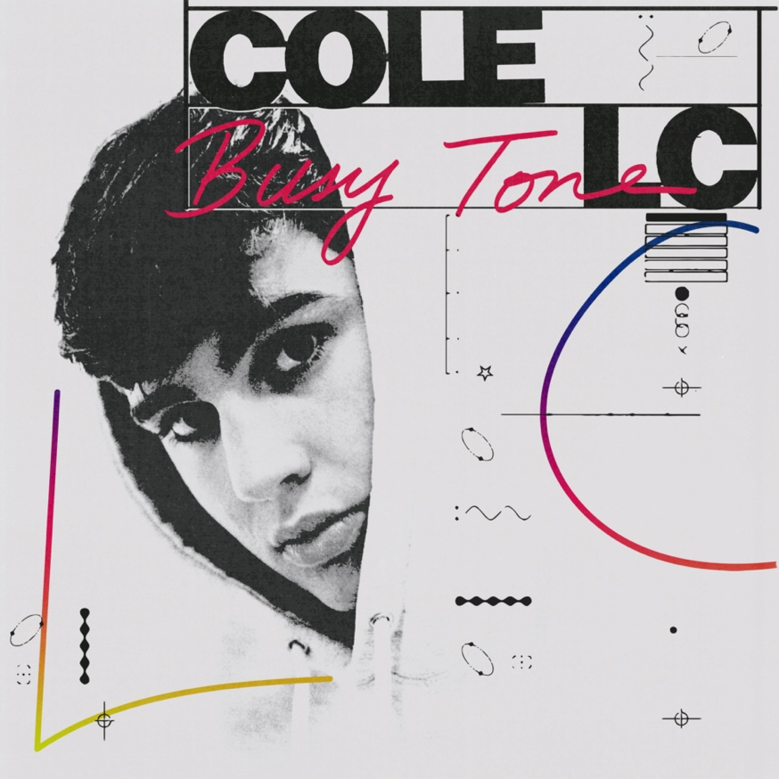

Listen here | Watch here

COLE LC is back with new single “Busy Tone”, listen here. The slick new single captures COLE LC in his element, as he flows over the Da Beatfreakz (D Block Europe, Dave) production. Watch COLE LC star in the accompanying visuals directed by Pip and Lib for “Busy Tone” here. Today COLE LC also announces his upcoming debut mixtape “Outside Looking in”, pre-order here.

Amassing over 300k views across his freestyle and debut single “Rollin’”, COLE LC gained support from the likes of Trench, GRM, Mixtape Madness, Capital Xtra, 1Xtra, Kiss Fresh and more. Subsequent releases “Westbrook” and “Grip ‘N’ Slide” saw Cole begin to solidify his own lane in the UK music scene, effortlessly bridging the sounds of Rap and R&B with his Leeds’ finesse. Garnering over a 1.5 million streams and views across his discography, COLE continues to gain new fans across peers and media.

Over the past 4 years COLE LC has steadily built himself a strong following in Leeds, from days spent busking and performing in local talent shows. Broadening his audience further with freestyles uploaded across social media, COLE LC quickly picked up recognition from fans for his effortless harmonies and his ability to switch to witty wordplay on raps.

Now ready to showcase his vocal delivery, range and rap ability, while fusing the worlds of R&B, rap and alternative pop across his own records. Listen back “Busy Tone” here, and catch COLE performing across the UK on the following dates:

Aug 27-29th: READING & LEEDS FESTIVAL
Sep 11th: MANCHESTER – PARKLIFE FESTIVAL
Nov 19th: LEEDS – THE KEY CLUB
Nov 22nd: LONDON – COLORS

Instagram | Twitter | TikTok

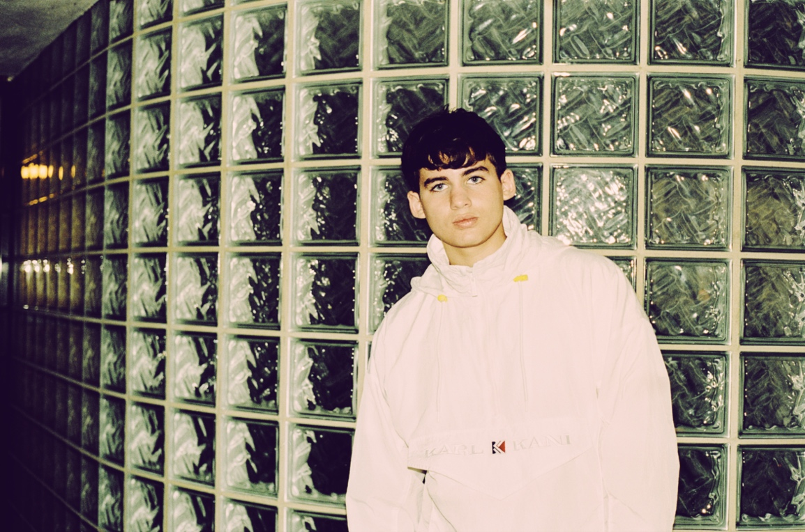

More About Cole LC

Emerging 17-year-old singer COLE LC has come a mighty long way — and he’s pulled it off in a staggeringly short space of time. With music piquing his interest at age 13, the young singer studied his craft and took singing lessons with local legend Cleve Freckleton. Busking around Leeds and uploading freestyles on social media quickly captured local attention.

Yorkshire-based YouTube channel First Media TV approaching COLE LC to perform as part of their Blue Room series, saw epic results. Swiftly booking him for a second performance, both videos quickly circulated far and wide. Fans of the freestyles flocking back to his Instagram account, to lap up the outpour of content from Cole. This demand and excitement steadily flowing outside of Leeds, it wasn’t long before the major labels started knocking at his door. A meeting with Columbia Records soon followed and, before long, the rest of the industry was sitting up and taking notice of the young artist merging soulful melodies with a rap and drill aesthetic.

Fusing the worlds of R&B, rap and alternative pop into a fluid, melodious sound, COLE LC’s influences and musical heroes are as eclectic as you might expect. Listing his biggest inspirations as Mike Skinner, Potter Payper, Mahalia, Lil Baby and Ed Sheeran. “I want to be unpredictable, but consistent,” he says, and it’s clear he’s working hard to learn as many lessons from his heroes as possible. He draws as much as he can from those figures, expressing his admiration for Lil Baby and Sheeran’s work-rate, Skinner’s presence on and off stage, and Mahalia’s humility, progression and lack of compromise.

Stay tuned for more music from COLE LC.

MORE INFO CONTACT JENNY@CHUFFMEDIA.COM

