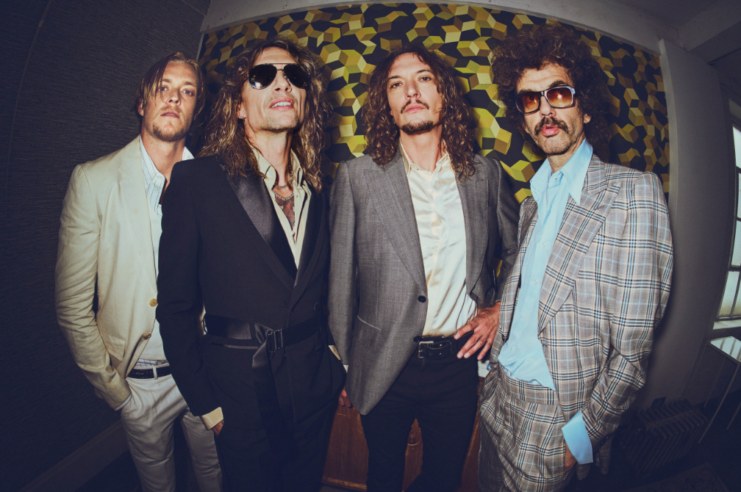

Photo Credit: Simon Emmett – [download here](https://we.tl/t-u0X1kHAxeI)

**‘ROCK AND ROLL PARTY COWBOY’**

**BRAND NEW SINGLE RELEASED**

[**LISTEN HERE**](https://thedarkness.lnk.to/rrpc) **/** [**WATCH THE VISUALISER HERE**](https://youtu.be/ACzJLhUarac)

***DREAMS ON TOAST***

**NEW ALBUM OUT MARCH 28TH 2025**

**VIA COOKING VINYL**

[PRE-ORDER HERE](https://thedarkness.lnk.to/dreamsontoastPR)

**TOURING UK IN MARCH 2025**

**WITH SUPPORT FROM ASH**

[TICKETS ON SALE NOW HERE](https://www.thedarknesslive.com/)

**TWO EXCLUSIVE FULL NEW ALBUM & GREATEST HITS**

**LIVE SHOWS ANNOUNCED FOR MAY 2025**

The Darkness have released their brand new single ‘Rock And Roll Party Cowboy’, the opening track of their forthcoming album *Dreams On Toast* out March 28th via Cooking Vinyl. Pre-order the album now [here](https://thedarkness.lnk.to/dreamsontoastPR).

The Darkness go hell for leather on the new single, channelling the sounds of hard rock legends such as ZZ Top, Motörhead and Judas Priest with searing solos, hell-raising vocals and a fist-pumpin’ rhythm section to create a tongue-in-cheek reflection on the hedonistic, macho music scene of the ‘70s and ‘80s.

Regarding the single, frontman Justin Hawkins says, *“People recognise me as astronaut pirate movie star cool and that’s obviously accurate. What they may have overlooked though, is that I am also ROCK AND ROLL PARTY COWBOY cool… which is a good 15 percent cooler!!! I think you’ll recognise that in the first listen."*

‘Rock And Roll Party Cowboy’ is the third single to be taken from the forthcoming magnum opus *Dreams On Toast* and features a [visualiser](https://youtu.be/ACzJLhUarac) full of imagery shot at their intimate shows at London’s Rough Trade store in December. The track follows the self-deprecating glam punk rock of ‘I Hate Myself’ and jaunty pop genius of ‘The Longest Kiss’, showcasing the diversity and brilliance of the band’s eighth studio album*.*

Produced by Dan Hawkins, *Dreams On Toast* flawlessly captures The Darkness at their peak, celebrating their influences and strengthening their sound, while also embarking on avenues never before heard from the band. It’s an indisputably grand display from the inspired and passionate quartet.

Destined to further cement The Darkness as one of Britain’s most important rock bands, *Dreams On Toast* finds Justin, Dan, Frankie and Rufus continuing to push boundaries. Over two decades deep into their multi-platinum, award-winning career, they offer up unexpected surprises to bedazzle and amaze fans once again in 2025.

The Darkness will be taking the album on the road with the *Dreams On Toast* UK headline tour seeing them play 18 shows across the country finishing at London’s OVO Wembley Arena on March 29th. This will be followed by a further 21 dates across Europe.

Full dates and tickets are available here [https://www.thedarknesslive.com/](https://wilfulpublicity.us9.list-manage.com/track/click?u=4ed22b50518a2d4aaa7dcb375&id=bee927c92f&e=77f4d10718).

Full UK dates are listed below:

**THE DARKNESS 2025 UK HEADLINE TOUR DATES**

06/03 - Ipswich, Regent’s Theatre (SOLD OUT)

07/03 - Ipswich, Regent’s Theatre (SOLD OUT)

08/03 - Oxford, New Theatre (SOLD OUT)

09/03 - Swansea, Arena

11/03 - Guildford, G Live (SOLD OUT)

12/03 - Hull, Connexin Arena

14/03 - Liverpool, Guild Of Students (SOLD OUT)

15/03 - Wolverhampton, Civic Hall (SOLD OUT)

17/03 - York, Barbican (SOLD OUT)

18/03 - Edinburgh, Usher Hall

20/03 - Glasgow, Royal Concert Hall (SOLD OUT)

21/03 - Newcastle, O2 City Hall (SOLD OUT)

22/03 - Manchester, O2 Apollo (SOLD OUT)

24/03 - Bristol, Beacon Theatre (SOLD OUT)

25/03 - Portsmouth, Guildhall

27/03 - Leicester, De Montford Hall

28/03 - Cambridge, Corn Exchange (SOLD OUT)

29/03 - London, OVO Arena Wembley

***DREAMS ON TOAST* TRACK LISTING**

1. Rock And Roll Party Cowboy
2. I Hate Myself
3. Hot On My Tail
4. Mortal Dread
5. Don’t Need Sunshine
6. The Longest Kiss
7. The Battle For Gadget Land
8. Cold Hearted Woman
9. Walking Through Fire
10. Weekend In Rome

*Dreams On Toast* album artwork designed by Grammy nominated artist [Perry Shall](https://www.perryshall.com/)

**For all media enquiries please contact** [**warren@chuffmedia.com**](mailto:warren@chuffmedia.com)