VIKINGS: THE IMMERSIVE EXPERIENCE NOW OPEN IN LONDON’S DOCK X
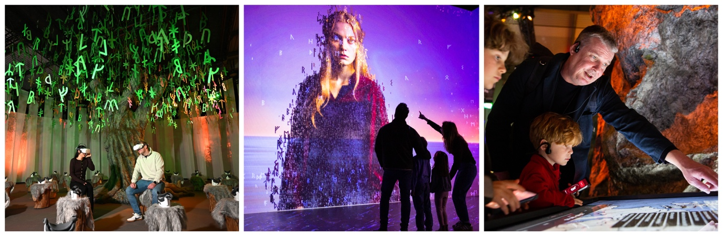

Vikings: The Immersive Experience, the largest of its kind ever in the UK, has officially opened in London at Dock X, Canada Water, beckoning adventurers to step into a realm of Norse legend, history, sagas and mythology.
Combining captivating storytelling with state-of-the-art technology and theatrical design, visitors are transported back in time to the 9th-century and the lands claimed by the Vikings. Featuring an ‘in world’ forest physical set, interactive maps and activities, as well as a mesmerising 360-degree cinematic projection room, guests can delve into the thrilling saga of the legendary Viking royalty, King Ragnar Lodbrok, Queen Kraka and their four extraordinary sons.
While Viking narratives and television series' typically focus on King Ragnar's raids, this immersive voyage shines a light on the powerful and enigmatic Queen Kraka, also known as Aslaug. Experience her incredible journey - from being the hidden daughter of the dragon-slayer Sigurd and the shield-maiden Brynhildr to a revered völva whose prophecies shaped the destiny of one of history's most renowned Viking dynasties.
Kickstart your adventure with an opening film set in 793 AD, the year that Viking warriors boldly raided the monastery of Lindisfarne on England’s northeast coast. From there, journey into the Forest of Time, a sprawling discovery space where towering trees whisper tales of Viking daily life, rituals, and beliefs.
Among the highlights is a recreation of the mythological World Tree, Yggdrasil symbolizing the connection between heaven, earth, and the underworld. In an immersive virtual reality experience under the tree, visitors will discover the beginnings of Kraka’s story and her fateful first meeting with Ragnar Lodbrok.
As you explore further into the forest, discover replica Viking artefacts, delve into history through interactive touchscreen maps, and engage with a ‘digital talking Kraka’ that answers your burning questions about Viking life in real-time. Test your skills by trying to tie a traditional Viking knot at the knotting station, all while a narrated audio guide enriches your understanding of Norse culture.
The adventure doesn't stop there! Journey through the Mist of Time, a fog-filled portal leading to the breathtaking cinematic finale with a 30-minute 360-degree cinematic projection, featuring cutting-edge video mapping and a sweeping musical score. At the heart of it all lies a magnificent full-size Viking longship that becomes part of the epic performance, pulling visitors into a riveting tale of love, power, conquest, and legacy, where the saga of Ragnar and Kraka unfolds in spectacular style.
Inspired by the global phenomenon of the Vikings television series yet deeply rooted in historical research and Norse mythology, this London experience dives deeper into Viking culture and way of life. Discover an engaging society built on agriculture, exploration, trade and unyielding beliefs.
Perfect for adventurers of all ages, the experience promises to be an entertaining and educational experience for families, school groups, history buffs, and fans of Norse mythology.
Tickets start from £23 for adults and £19 for children, with concession options available for seniors, students and NHS staff. VIP ‘Vikings Package’ tickets are also available from £50 which include a branded tote bag, souvenir brochure, activity quiz, a Vikings poster and more. Don’t miss your chance to embark on this thrilling journey into the Viking era!
For further information and tickets, visit www.vikings-immersive.co.uk.

ENDS
Notes to editors:
Link to assets, HERE.
Address: Dock X, Unit 1 Canada Water, Surrey Quays Rd, London SE16 2XU
Website: https://www.vikings-immersive.co.uk
Instagram: https://www.instagram.com/vikings.immersive/
Facebook: https://www.facebook.com/people/Vikings-Immersive/61577495646974/
Tiktok: https://www.tiktok.com/@vikings.immersiv?_t=ZN-8zO48uycIPm&_r=1
About FKP Scorpio Entertainment
FKP Scorpio Entertainment Ltd (FKPE) is the award-winning exhibition and special projects division of international promoter, FKP Scorpio GmbH, which has 10 offices throughout Europe as well as its own venue - OBEX in Oberhausen, Germany.
FKPE has promoted Jurassic World: The Exhibition and Disney100: The Exhibition at Excel London, alongside the Formula 1® The Exhibition at Excel’s entertainment district - Immerse LDN, winning two Access All Areas awards in 2022 and 2024 for 'Best Visitor Experience'. In 2025, FKPE also successfully launched Minecraft Experience: Villager Rescue and The Legend of The Titanic Exhibition, both in London’s Canada Water district as well as Tutankhamun: The Immersive Exhibition at Immerse LDN and SEC Glasgow. FKPE is currently promoting The Last Days of Pompeii: The Immersive Exhibition at Immerse LDN and in Brussels at Terminal One (Brussels Expo), Formula 1® The Exhibition in Oberhausen, Tutankhamun: The Immersive Exhibition in Stockholm and Minecraft Experience: Villager Rescue will open in Denmark at Herning MCH on 1st April 2026.
About Alegria Exhibition
As a producer and tour organizer, Alegria Exhibition stands for multimedia edutainment show concepts that invite visitors to enjoy art and culture in an easy and accessible, inspiring and entertaining way.
Since being founded in 2022, Alegria has made a name for itself with its own productions Monet’s Garden, Viva Frida Kahlo, Klimt’s Kiss, Vermeer: Master of Light, Vincent: Between Madness and Wonder and, most recently, Vikings: The Immersive Experience. With these productions, Alegria has already welcomed 3,5 million visitors across Continental Europe, Scandinavia and the United States (New York). With Vikings, Alegria Exhibition is now expanding for the first time into Great Britain. The exhibitions are holistic, all-round experiences that allow visitors to immerse themselves fully in the subject matter. The audience does not simply stand in front of a work of art or a historical exhibit; instead, the art, history or overarching theme unfolds around them, taking them on a distinctive journey. This approach makes the exhibitions suitable for all age groups and the entire family, offering children and young people in particular a completely new and engaging way to experience art and history. Vikings: The Immersive Experience is Alegria’s newest production, set to establish a new benchmark for narrative immersive exhibitions worldwide.
Learn more: www.alegria-exhibition.de
About flora&faunavisions
Founded in Berlin in 2005, flora&faunavisions is a multi-award-winning, interdisciplinary design studio that conceives, designs, and implements large-scale, narrative-driven immersive exhibitions, stage productions, brand experiences, and original IPs (intellectual properties) for international clients, partners, and audiences. For VIKINGS: The Immersive Experience, flora&faunavisions is responsible for the audiovisual design. Recent highlights include "The Ring Cycle," a 16-hour digital and kinetic opera for Opera Australia, as well as immersive experiences for the GermanPavilion at Expo Osaka 2025. The studio is responsible for the concept and design of immersive ticket formats such as "Genius da Vinci,“ ”Utopian Garden,“ and ”Eden," as well as creative concepts for collaborations with artists such as WhoMadeWho, Solomun, and British DJ Sasha. The work of flora&faunavisions has been recognized with awards including the Red Dot Award, the Cannes Lion, the Brand Ex Award, and the OPUS International Stage Award 2025. The studio recently joined forces with The Storytelling Company to expand its technical and operational capabilities and further strengthen its international experiences.
Learn more: https://www.florafaunavisions.de/
About Fever
Fever is the world’s leading tech platform for discovering culture and live entertainment, inspiring over 300 million people last year to discover the best experiences in over 40 countries. With a mission to democratise access to culture and entertainment in real life, Fever inspires users to enjoy unique experiences and events —from immersive exhibitions and sports to interactive theatrical performances, concerts, and festivals— while empowering its partners with data and technology to develop and expand new experiences worldwide.

For all media enquiries please contact Warren@chuffmedia.com on 07762 130510

