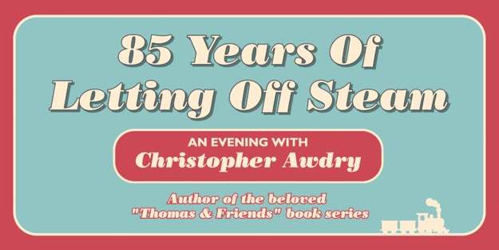
25 JUNE 2026 @ EVENTIM APOLLO, HAMMERSMITH, LONDON

Pre-sale: 10am, Thu 12th March
General sale: 10am, Fri 13th March
Tickets from £35 & limited VIP packages available

Available to purchase from https://linktr.ee/christopherawdry

One night. One stage. Eighty-five years of stories with plenty of steam still to come.

On 25 June, London’s iconic Hammersmith Apollo will host a truly special one-off evening. Promoted by Splot and Full Steam Ahead, “85 Years Of Letting Off Steam”, celebrates the life and legacy of Christopher Awdry, storyteller, railway historian, and custodian of one of the world’s most beloved literary worlds.

For over eight decades, Christopher Awdry has lived a life shaped by steam, story and tradition. Together with his father, Wilbert Awdry, the Reverend who first imagined the Island of Sodor, he helped create the 42 books that form The Railway Series, a cornerstone of children’s publishing that continues to delight new generations through Thomas & Friends.

Hosted by legendary record producer and lifelong rail enthusiast Pete Waterman, the evening promises warmth, insight and no shortage of steam-powered nostalgia. Through conversation, rare insights and untold stories, audiences will be taken on a journey across Christopher’s remarkable 85 years, from his early attempts at writing (including an abandoned detective series), to his career as a government-recruited tax officer and ultimately to his pivotal role as Railway Series author from 1983 to 2011.

It was Christopher who picked up the pen just one year before the debut of the first television adaptation in 1984, a moment that propelled Thomas The Tank Engine and the stories of Sodor into global phenomenon territory. Yet beyond the worldwide success lies a quieter, deeply personal commitment to continuity, detail and the enduring spirit of his father’s creation.

The evening will also reflect on Christopher’s continued writing in later life, including his most recent work: the expanded 20th anniversary edition of Sodor: Reading Between The Lines. This definitive volume explores the origins of each Railway Series story, enriched with intimate commentary, archival material and illuminating extracts from both Wilbert Awdry’s original notes and Christopher’s own reflections.

More than a retrospective, “85 Years Of Letting Off Steam” is a rare opportunity to celebrate a living literary legacy, the preservation of a world built on friendship, engineering, resilience and imagination.

Sodor: Reading Between The Lines is available now via Full Steam Ahead.

Media assets available here

For all media enquiries please contact Warren@chuffmedia.com on 07762 130510

