PLACEBO

New album Never Let Me Go out today

Hear the album in full including new focus track
‘Sad White Reggae’

UK / IE headline tour dates on sale now

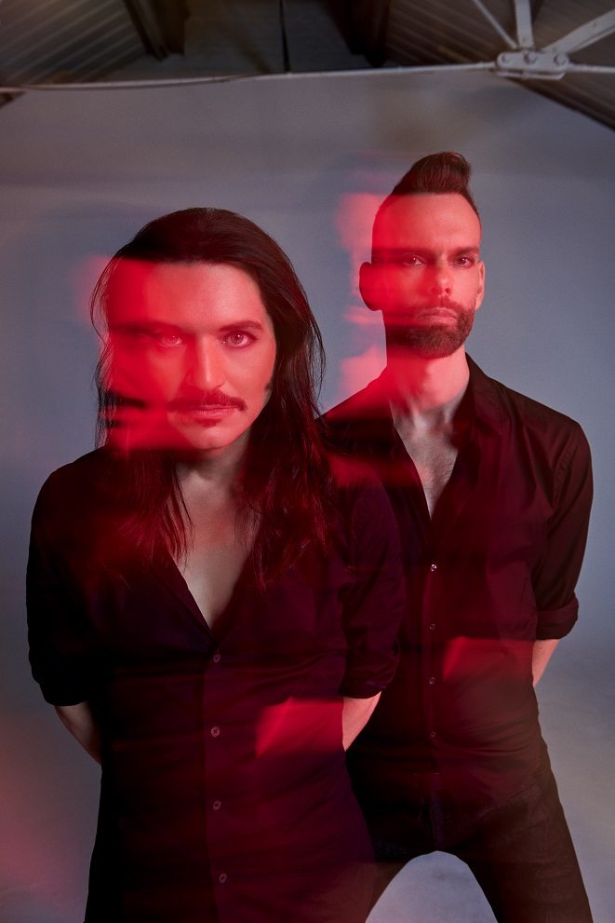

Placebo | Photo credit: Mads Perch | Download image here

////

Praise for new album Never Let Me Go and its singles

“Never Let Me Go rocks and rages yet is melodic and thoughtful” - The Arts Desk

"Never Let Me Go is a reminder of how thrilling, and genuinely intoxicating Placebo can be." – Clash

“Hugz is menacing and Twin Demons is pummelling” – Classic Pop

“Sounding as timely and relevant to future rock trends as at any point since Nancy Boy” – Classic Rock ****

“The punky rants are still great fun, with Try Better Next Time recalling their classic Nancy Boy.” – Daily Star

“Placebo are as vital as they’ve ever been” – DIY ****

"Captivating" - Gigwise

“Giant synth-rock riffs” – The Guardian on ‘Beautiful James’

“A stirring statement of intent” – Hot Press

"When the world feels increasingly unpredictable, it’s kind of comforting to know that Placebo are still here, singing about the end of it." - The Independent ****

"An enduring talent, and crown princes of the People’s Republic of Rock’n’Roll." – Kerrang! ****

“The first Placebo album in almost a decade is one that perfectly captures the pain of our dying world.” Louder Than War (Album Of The Week) ****

"Never Let Me Go is a true renaissance record" – NME ****

“Instantly catchy” – The Observer on ‘Try Better Next Time’

“A perfectly crafted slab of fuzzy alt-rock joyfulness” - Rock Sound on ‘Try Better Next Time’

“Never Let Me Go feels like Placebo’s strongest album in years” - Rolling Stone

“Their dark electro pop still sounds relevant and fresh.” – The Sun

“Outstanding” – Upset ****

“Never Let Me Go is a synthesiser-led soundtrack to the end of the world” - VICE

////

Placebo today release their highly-anticipated, and universally-acclaimed, new album, Never Let Me Go. The near decade-long wait for a new full-length from the band is over.

Excitement for the new album reached a fever pitch in recent months as the band teased its early singles, ‘Beautiful James’, ‘Surrounded By Spies’, ‘Try Better Next Time’ and ‘Happy Birthday In The Sky’. Each single offered its own unique glimpse into what has been weighing on the minds of the band in the years since their last release. Considering themes of personal accountability, tech-saturation, mortality, and humanity’s true place in the world, Brian Molko and Stefan Olsdal conjure a world that stares harsh realities in the face.

Listen to / buy the album here.

View the visualizer for ‘Sad White Reggae’ here.

////

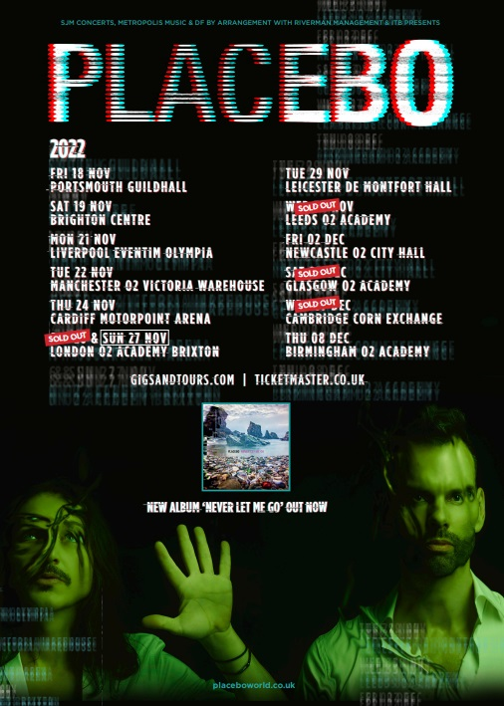

Placebo | 2022 UK headline tour poster | Download image here

Placebo play a sold-out intimate show at London’s Islington Assembly Hall this Thursday 31st March before touring internationally. A run of headline UK / IE tour dates commences in November 2022. Tickets are available here.

PLACEBO UK + IE 2022 HEADLINE TOUR DATES

NOVEMBER 2022
Fri 18 - Portsmouth - Guildhall
Sat 19 - Brighton - Brighton Centre
Mon 21 - Liverpool - Eventim Olympia
Tue 22 - Manchester - O2 Victoria Warehouse
Thu 24 - Cardiff - Motorpoint Arena
Sat 26 - London - O2 Brixton Academy
Sun 27 - London - O2 Brixton Academy – SOLD OUT
Tue 29 - Leicester - De Montfort Hall
Wed 30 - Leeds - O2 Academy Leeds – SOLD OUT

DECEMBER 2022
Fri 2 - Newcastle – O2 City Hall
Sat 3 - Glasgow - O2 Academy Glasgow – SOLD OUT
Mon 5 - Dublin - 3 Arena
Wed 7 - Cambridge - Corn Exchange – SOLD OUT
Thu 8 - Birmingham - O2 Academy 1

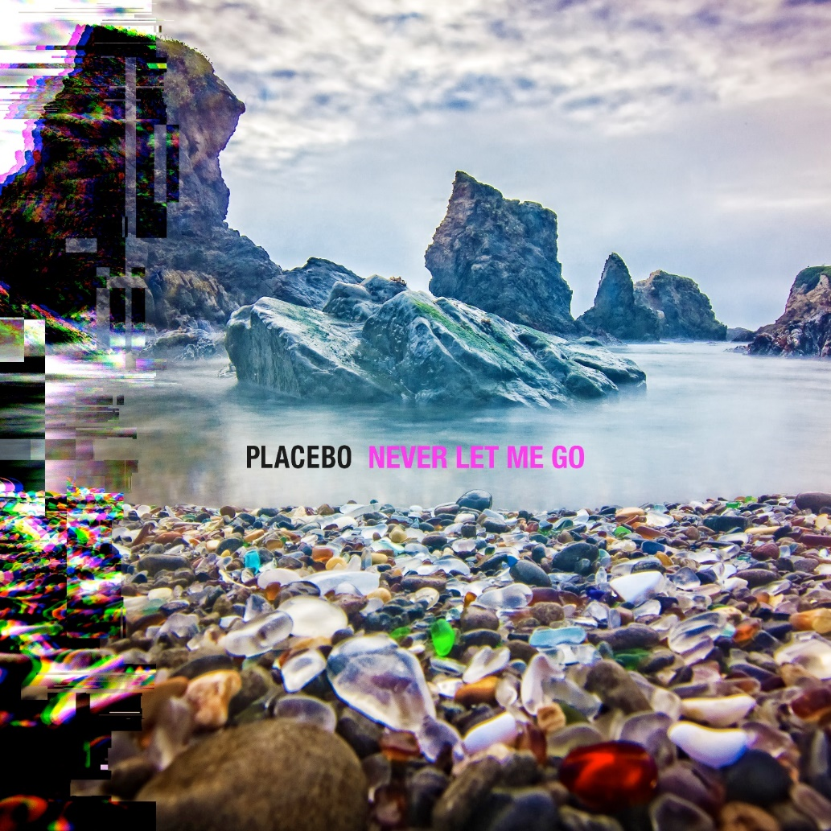

Placebo | Never Let Me Go album artwork | Download image here

Placebo – Never Let Me Go album track listing

- Forever Chemicals
- Beautiful James
- Hugz
- Happy Birthday In The Sky
- The Prodigal
- Surrounded By Spies
- Try Better Next Time
- Sad White Reggae
- Twin Demons
- Chemtrails
- This Is What You Wanted
- Went Missing
- Fix Yourself

For press only: Download the latest biography here.

Placebo: Website | Instagram | Facebook | Twitter

