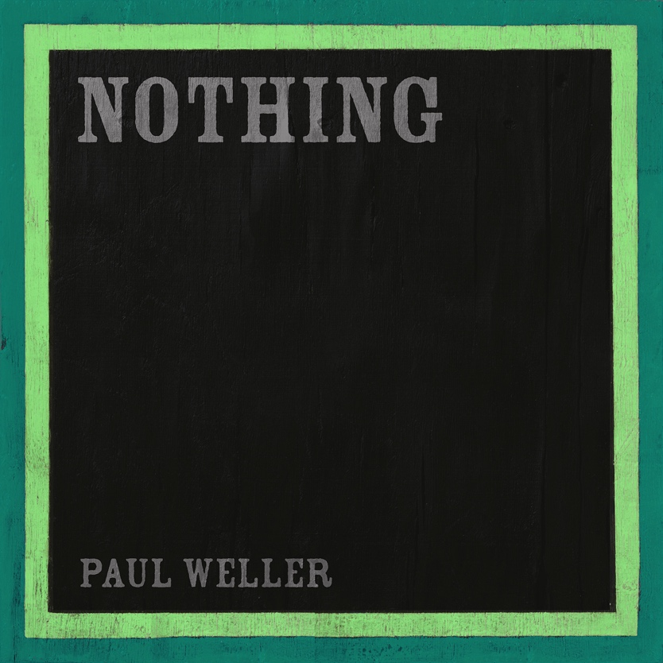

PAUL WELLER
New single - NOTHING – out now
From his forthcoming new album “66” released on May 24th
On Polydor Records

Press shot here

Us & we
We had nothing
We came together by
Having nothing

Paul Weller unveils another treat from his hotly anticipated new album “66”.
Entitled “Nothing”, you can hear this new track on all streaming platforms now, while the release of “66” gets ever closer when it becomes available on May 24th.

Paul co-wrote “Nothing” with Madness frontman Suggs and Andrew Chalk – a mutual friend of the two. This beautiful atmospheric track paints a scene of introspection and longing and features a flugehorns’s warm, mellow tones weaving their way sublimely through the song.
With the sleeve of the new album “66” designed by none other than Sir Peter Blake (his first for Weller since 1995’s Stanley Road), Paul Weller’s forthcoming long player marks the completion of his 66th journey around the sun and is released on May 24th – the day before his 66th birthday.
Paul and his band have just completed a hugely successful sold out tour – so if you missed that, try and catch him in the Autumn….
Oct 17 – CHELTENHAM Centaur
Oct 18 – PORTSMOUTH Guildhall
Oct 19 – BRIGHTON Centre
Oct 21 – NOTTINGHAM Royal Concert Hall
Oct 22 – WOLVERHAMPTON Halls
Oct 24 – NEWCASTLE 02 City Hall
Oct 25 – NEWCASTLE 02 City Hall
Oct 27 – DUNDEE Caird Hall
Oct 28 – GLASGOW Barrowland
Oct 29 – GLASGOW Barrowland
Oct 31 – HULL Bonus Arena
Nov 01 – MANCHESTER 02 Apollo
Nov 02 – LLANDUDNO Venue Cymru
Nov 04 – LIVERPOOL Olympia
Nov 05 – BRADFORD St George’s Hall
Nov 07 – OXFORD New Theatre
Nov 08 – LONDON Eventim Apollo
Nov 09 – LONDON Eventim Apollo
www.ticketmaster.co.uk; www.seetickets.com;
www.paulweller.com

For more info please contact Warren@chuffmedia.com on 07762 130510

