PALACE
Return With Deeply Personal New Album Ultrasound Out April 5th, 2024
First Single ‘Bleach’ Out Now
Special Intimate London Show @ EartH - February 23rd, 2024
Playing Ultrasound In Full

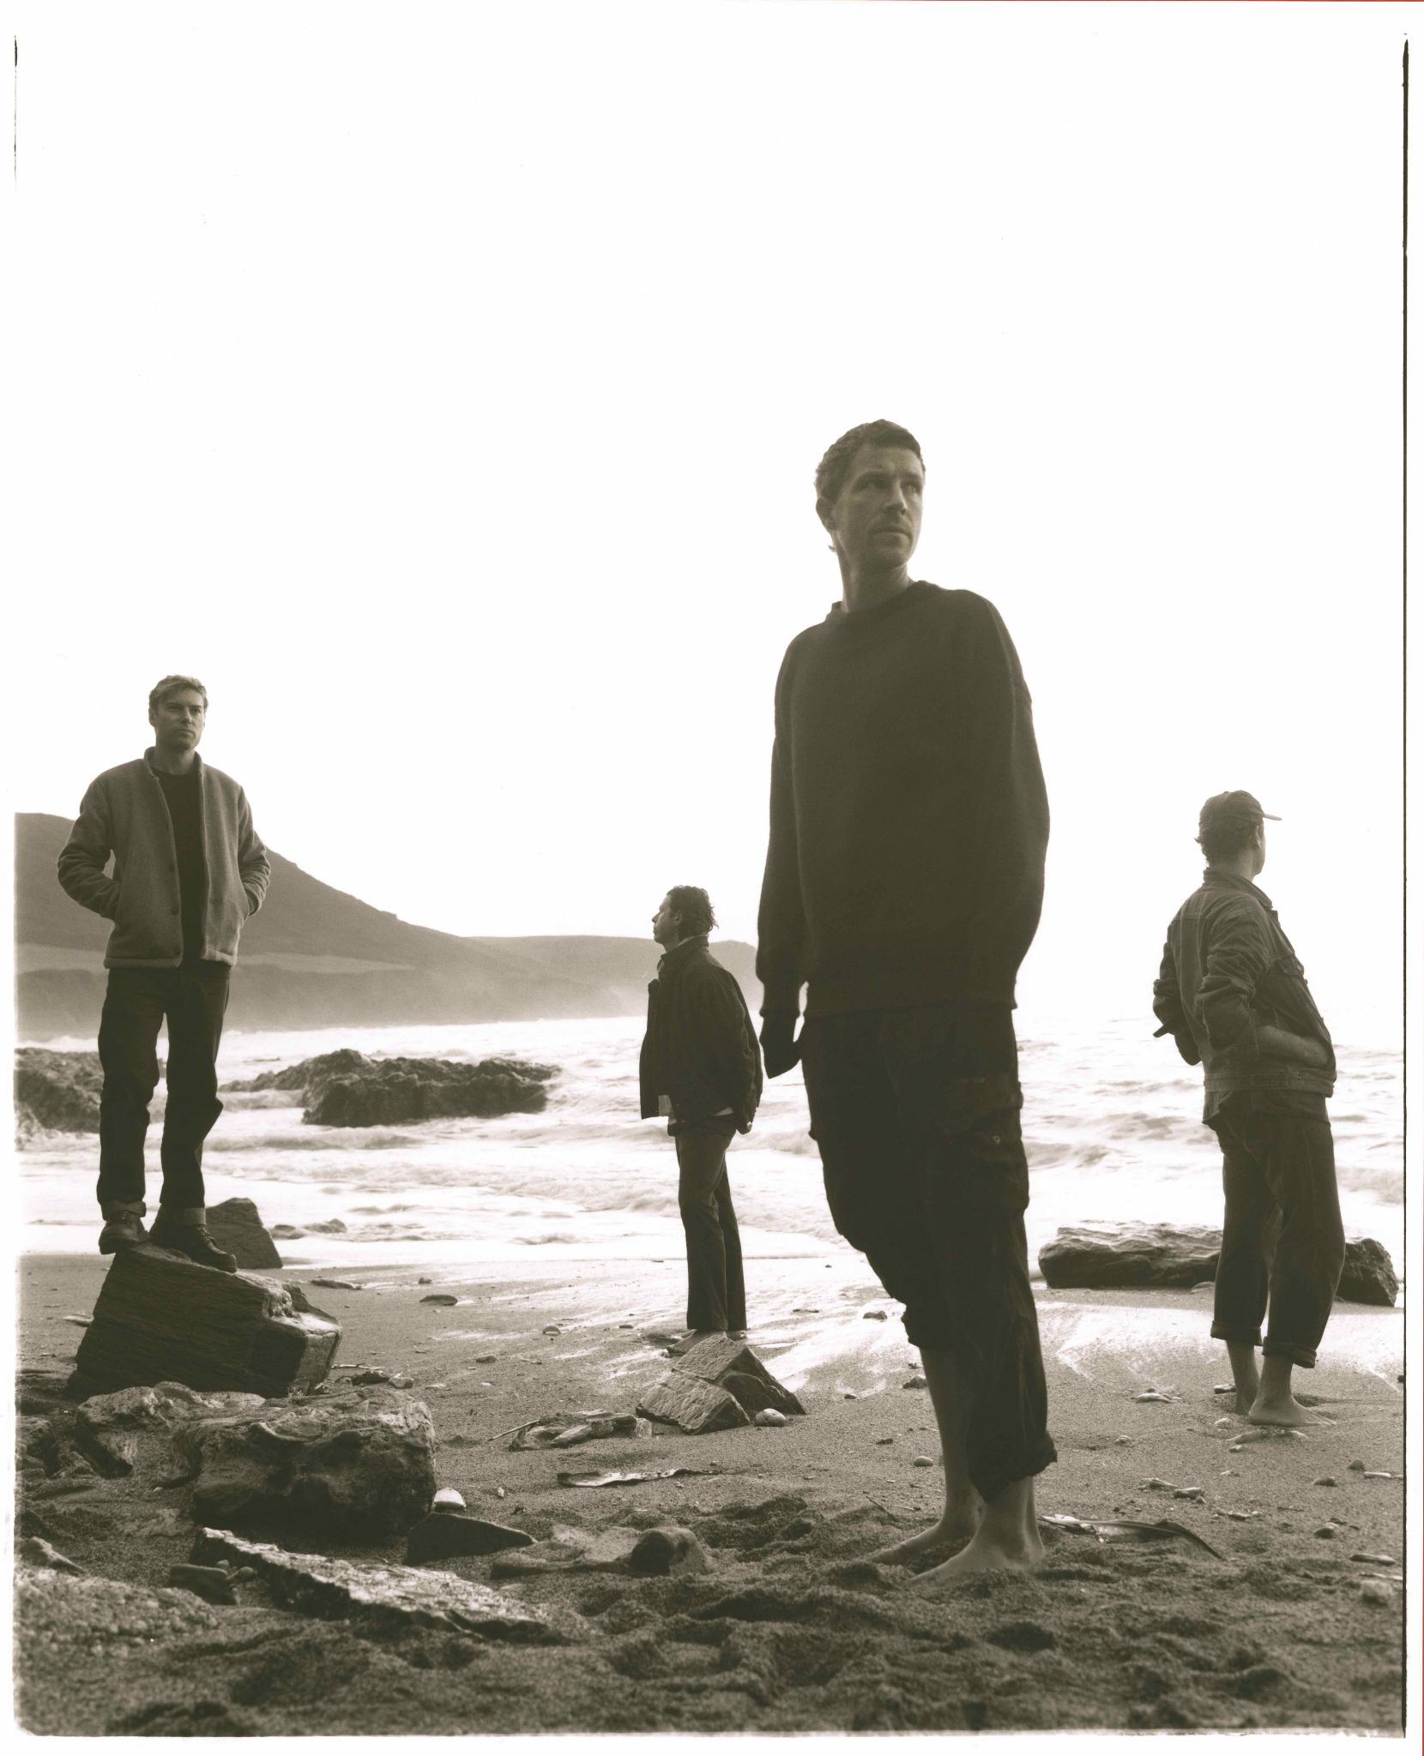
Photo Credit: Keerthana Kunnath

Armed with an already extensive back-catalogue of stunning music, Palace return with the announcement of their brand new, deeply personal, fourth studio album, Ultrasound - out April 5th, 2024. Its new offering, ‘Bleach’ is available today - listen HERE.
The record’s production sees the band reunited with Adam Jaffrey, 8 years after working together on their debut album, and arrives off the back of ‘Part I - When Everything Was Lost’ and ‘Part II - Nightmares & Ice Cream’, the band’s 2023 companion EPs.
While writing the first batch of songs for the album, frontman Leo Wyndham’s partner suffered a late miscarriage. Ultrasound naturally became an open diary of a year-long struggle from devastation to deliverance. “It was incredibly hard to comprehend what had happened, how to deal with it and how to move forward,” Leo says. “The album is the journey of that experience - starting with a loss, then a period of processing, and then finally acceptance, release and growth. And being in awe of women within that. Their dignity, strength and courage in how they can deal with these things that feel beyond a man.”
Album opener ‘When Everything Was Lost’, is chilling ozone rock with a hint of Bon Iver, capturing what Leo calls “that initial bombshell feeling”. From there, Ultrasound picks its way through the wreckage, seeking light, with the languid and lustrous pop-gaze trio of ‘Bleach’, ‘Nightmares & Ice Cream’ and ‘Rabid Dog’. The hallucinogenic ‘Nightmares…’ was based on a dream Leo had about seeing his partner in the afterlife: “It was a very beautiful abstract thing that we were together and there was this total acceptance of what had happened and it was euphoric,” he says.

At the album’s core sit three songs of support and consolidation. ‘Make You Proud’ is about wanting to be the best version of yourself out of love for another. There’s the soulful ‘Inside My Chest’, and ‘Love Is A Precious Thing’, the album’s melodic centrepiece.
The final stretch signifies a more reflective period. ‘Say The Words’ acknowledges the societal pressures on women to raise families and their resilience in the struggles of motherhood, ‘How Far We’ve Come’ confronts ageing and mortality. ‘All We’ve Ever Wanted’ revisits the rawness of Leo’s anguish in its images of forest fires and quicksand, his desire for fatherhood still burning.

Leo, guitarist Rupert Turner and drummer Matt Hodges began playing together in 2012 after fate had brought them all separately to London. The childhood friends released their acclaimed debut EP Lost In The Night in 2014, followed by the Chase The Light EP the year after. With three albums under their belt, So Long Forever, Life After and 2022’s Shoals, the band have acquired a mass of adoring fans across the world.

Palace will perform Ultrasound in full at an exclusive one-off show at London’s EartH on February 23rd. There will be an exclusive ticket pre-sale from Wednesday, January 31st for those who have pre-ordered the new album from wearepalace.com.
Epic album closer ‘Goodnight Farewell’ sums up the future. Sonically corroded, beaten, but standing proud, it finds Leo finally attaining a sense of peace.“That’s about transitioning to a new phase. It’s saying goodbye to this life-changing year, saying goodbye to former versions of ourselves and what would have been a child as well. It's that transcendence of suddenly discovering that we can move forward into something that feels lighter and optimistic.”
And with that, Palace sail into 2024, fired up for one of the biggest years of their careers.
Palace - Ultrasound Tracklisting
- When Everything Was Lost
- Son
- Bleach
- Nightmares & Ice Cream
- Rabid Dog
- Make you Proud
- Inside My Chest
- Love Is A Precious Thing
- Cocoon
- Say The Words
- How Far We’ve Come
- All We’ve Ever Wanted
- Goodnight Farewell

Instagram | Facebook | Twitter | Website | YouTube

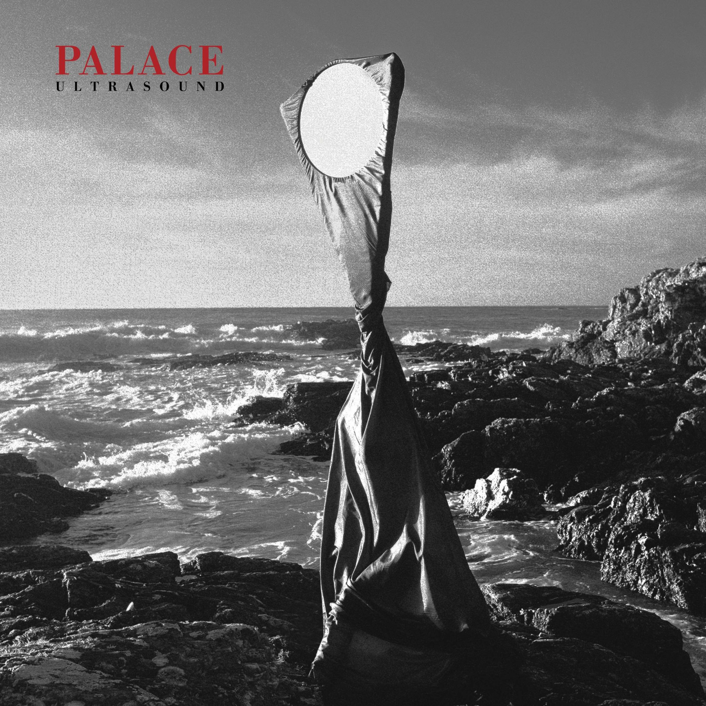

For more on info contact warren@chuffmedia.com

