PALACE
Announce Oct/Nov UK & EU Headline Tour
Including Biggest Ever London Show @ Eventim Apollo - Sat, Nov 30th
Pre-Sale – Wed, February 28th @ 10.00am
General On Sale - Fri, March 1st @ 10.00am
Tickets HERE
Deeply Personal New Album Ultrasound - Out April 5th
First Single ‘Bleach’

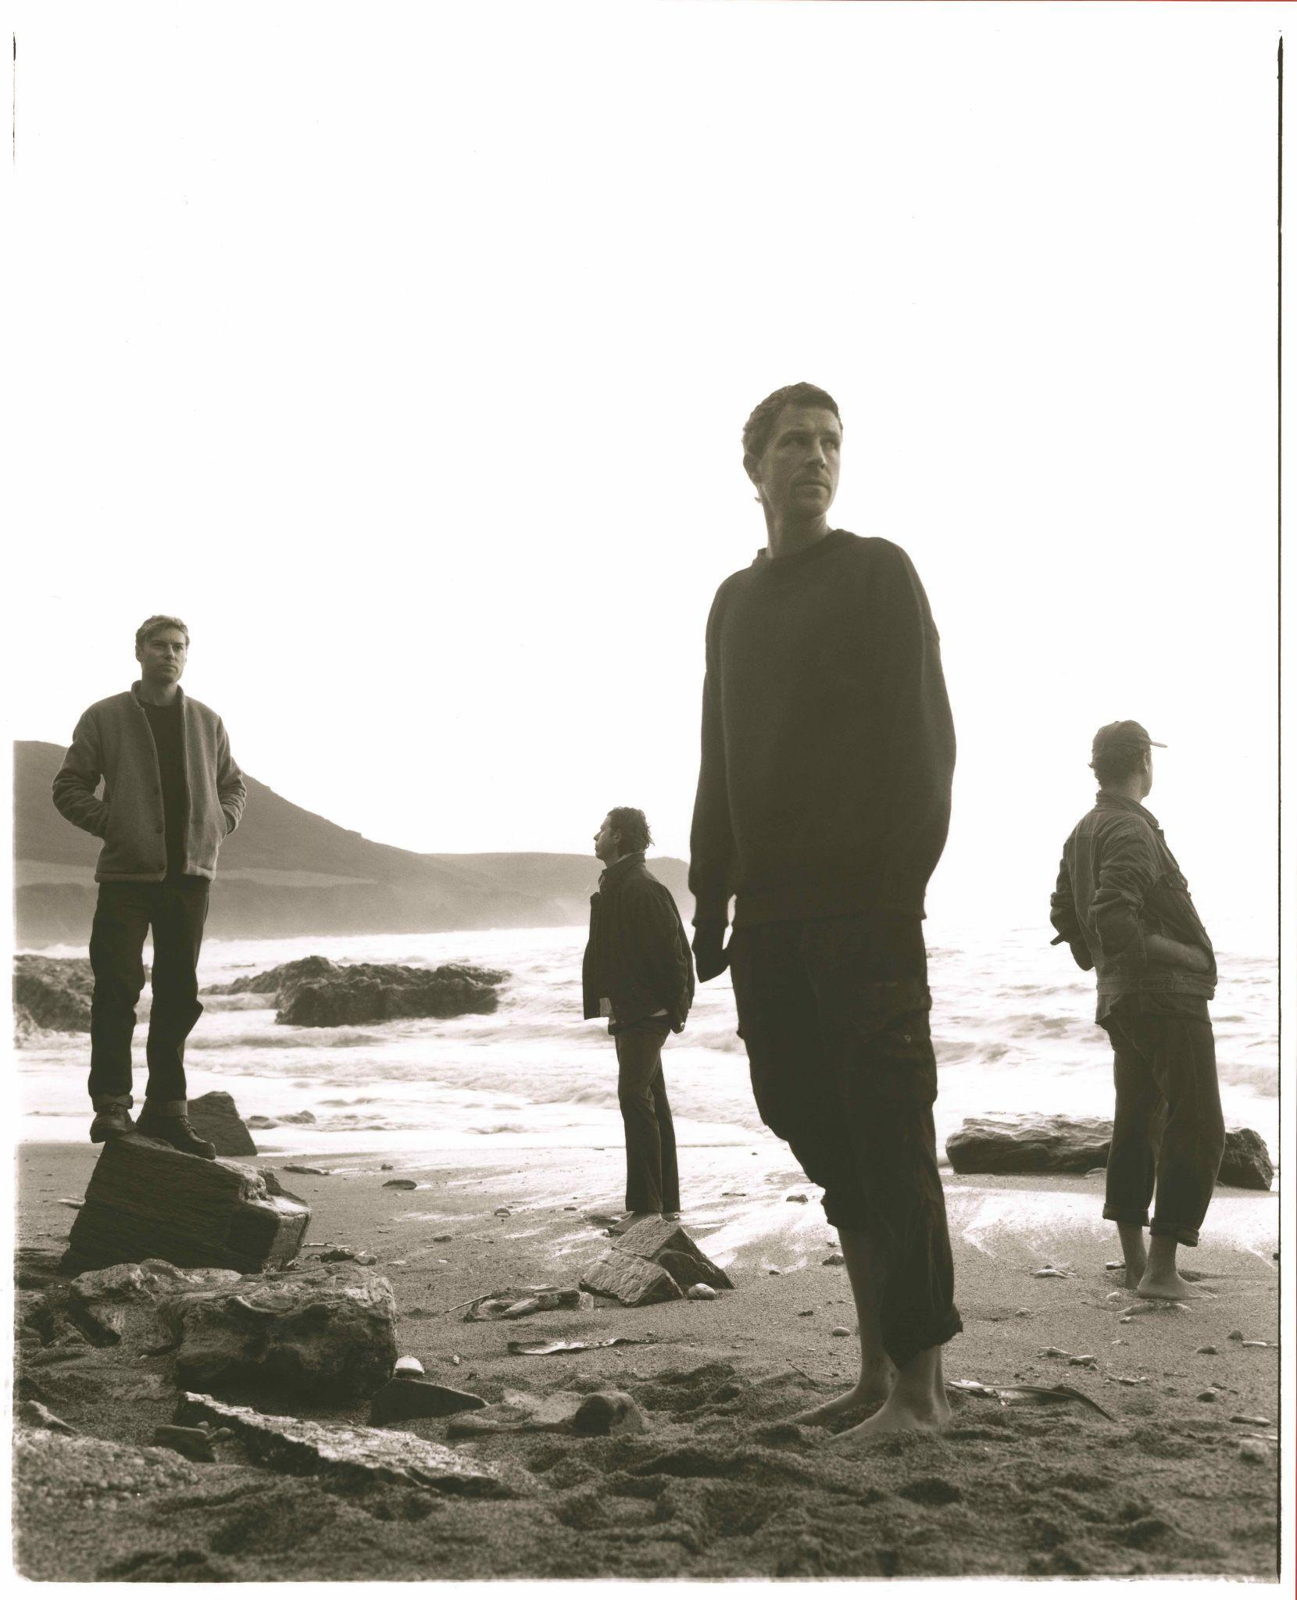
Photo Credit: Keerthana Kunnath

Off the back of a simply extraordinary, intimate performance at London’s EartH last week which saw the band play their entire forthcoming new album in full, Palace today announce a full Oct/Nov UK & European tour. The UK run will include their biggest ever headline show, at London’s Eventim Apollo. Pre-Sale & General Sale tickets will be available HERE.

The band recently returned with the announcement of their brand new, deeply personal, fourth studio album, Ultrasound - out April 5th, 2024. Its first offering is the stunning ‘Bleach’ - listen HERE.
NOVEMBER UK DATES
Thu 21st GLASGOW, SWG3 Galvanizers
Fri 22nd LEEDS, Project House
Sat 23rd MANCHESTER, Albert Hall
Wed 27th BRISTOL, O2 Academy
Fri 29th BIRMINGHAM, Birmingham Town Hall
Sat 30th LONDON, Eventim Apollo
The new record’s production sees the band reunited with Adam Jaffrey, 8 years after working together on their debut album, So Long Forever, and arrives off the back of ‘Part I - When Everything Was Lost’ and ‘Part II - Nightmares & Ice Cream’, the band’s 2023 companion EPs.
While writing the first batch of songs for the album, frontman Leo Wyndham’s partner suffered a late miscarriage. Ultrasound naturally became an open diary of a year-long struggle from devastation to deliverance. “It was incredibly hard to comprehend what had happened, how to deal with it and how to move forward,” Leo says. “The album is the journey of that experience - starting with a loss, then a period of processing, and then finally acceptance, release and growth. And being in awe of women within that. Their dignity, strength and courage in how they can deal with these things that feel beyond a man.”

Leo, guitarist Rupert Turner and drummer Matt Hodges began playing together in 2012 after fate had brought them all separately to London. The childhood friends released their acclaimed debut EP Lost In The Night in 2014, followed by the Chase The Light EP the year after. With three albums under their belt, So Long Forever, Life After and 2022’s Shoals, the band have acquired a mass of adoring fans across the world.
Palace gear up for one of the biggest years of their careers.
OCT/NOV EU & UK DATES

October
Tue 29th PARIS, FR, Alhambra
Wed 30th BRUSSELS, BE, Ancienne Belgique
Thu 31st UTRECHT, NL, TivoliVredenburg

November
Fri 1st COLOGNE, DE, Live Music Hall
Sun 3rd HAMBURG, DE, Docks
Mon 4th COPENHAGEN, DK, DR Studie 2
Tue 5th BERLIN, DE, Astra Kulturhaus
Wed 6th WARSAW, PL, Niebo
Fri 8th VIENNA, AT, Flucc
Sat 9th PRAGUE, CZ, MeetFactory
Sun 10th MUNICH, DE, Backstage Werk
Mon 11th LAUSANNE, CH, Les Docks
Thu 21st GLASGOW, SWG3 Galvanizers
Fri 22nd LEEDS, Project House
Sat 23rd MANCHESTER, Albert Hall
Wed 27th BRISTOL, O2 Academy
Fri 29th BIRMINGHAM, Birmingham Town Hall
Sat 30th LONDON, Eventim Apollo

Instagram | Facebook | Twitter | Website | YouTube

For more on info contact warren@chuffmedia.com

