PALACE
Release New Single ‘Make You Proud’
New EP Part II - Nightmares & Ice Cream
Out December 5th
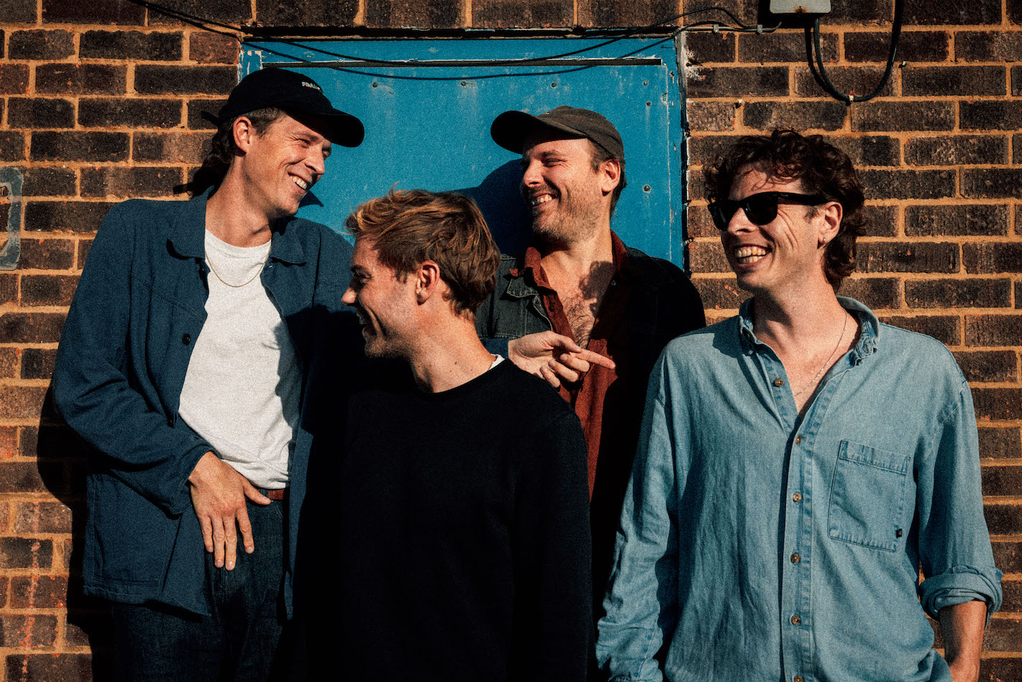
(Photo credit: Adrian Lee)

Following the release of stunning EP opener ‘Rabid Dog’ last month, London four-piece Palace return with brand new single ‘Make You Proud’. The track is the second cut from their forthcoming EP Part II - Nightmares & Ice Cream, which is out December 5th on Fiction Records.

A beautifully bewitching single, the guitar driven ‘Make Your Proud’ showcases lead singer Leo’s captivating ability with words. “‘Make You Proud’ is about insecurity in new love,” Leo said of the single. “Questioning oneself constantly and overthinking at every turn - but still having this incredible patience and support from a partner.” Listen to ‘Make You Proud’ HERE.

Produced by Adam Jaffrey (Loyle Carner, Tom Misch, Yussef Dayes) at Unwound Studios, Nightmares & Ice Cream EP sees the band with a sharp new focus. Beautifully hypnotic, mesmerising and full of raw emotion, the EP is the band at their very best. “‘Nightmares & Ice Cream’ is another snapshot of life and moments of the past year,” Leo said of the EP. “It’s Part II of the journey, and one that’s felt very significant. It’s a hazy chapter of intense reflection to past events, but also a sort of purgatory where we stumble forward, stunned, trying to find some kind of grip on reality.”

Childhood friends Palace released their acclaimed debut EP Lost In The Night in 2014, followed by the Chase The Light EP the year after. Now with three albums under their belt, So Long Forever, Life After and 2022’s Shoals and a mass of adoring fans across the world, the band look set to close 2023 on a high.

Palace are Leo Wyndham, Matt Hodges and Rupert Turner.

Instagram | Facebook | Twitter | Website

For more information & media enquiries, please contact
Warren Higgins warren@chuffmedia.com

