**PAUL WELLER**

**SUPPLEMENT: 66 EP**

**Released October 18th on Polydor Records**

**Listen to ‘Change What You Can’** [**HERE**](paulweller.lnk.to/ChangeWhatYouCan) **| Pre-order the EP** [**HERE**](PaulWeller.lnk.to/Supplement66)

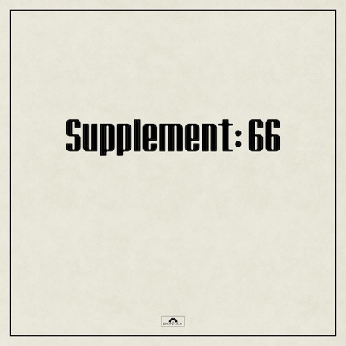

After the success of his recent album *66*, **Paul Weller** releases 4 sublime new songs for the “Supplement: 66” EP on October 18th, available to pre-order from September 27th with instant grat single “Change What You Can.”

The tracks on “Supplement: 66” were recorded at Paul’s own Black Barn Studios especially for an EP and serve as a loving nod to his past while also embracing his continued growth as an artist.

Opener “That’s What She Said” tips a hat to Paul’s Style Council days capturing the warmth and lively energy of those times. “Change What You Can” drives vibrantly along amidst soaring backing vocals from Jake Fletcher and irresistible flute from Jacko Peake.  Track 3 “Earth In Our Feet”, co-written with Steve Pilgrim, has a laid back waltzy feel with a joyful horn section weaving its way throughout. Esteemed folk singer/songwriter Kathryn Williams takes lead vocals on the haunting closer “So Quietly” which she also co-wrote.

All tracks were produced by Paul Weller and feature most of the Weller band plus a few additions such as Max Beesley on vibraphone, folk legend Danny Thompson on double bass and original Jam member Steve Brookes on guitar.

Tracklisting:

That’s What She Said

Change What You Can

Earth In Our Feet

So Quietly

Paul heads off on a UK tour in October and November – all dates now sold out.

[**https://www.paulweller.com**](https://www.paulweller.com)

**For more info please contact** [**Warren@chuffmedia.com**](mailto:Warren@chuffmedia.com) **on 07762 130510**