FRANK TURNER

ANNOUNCES INTIMATE INDIE STORE TOUR
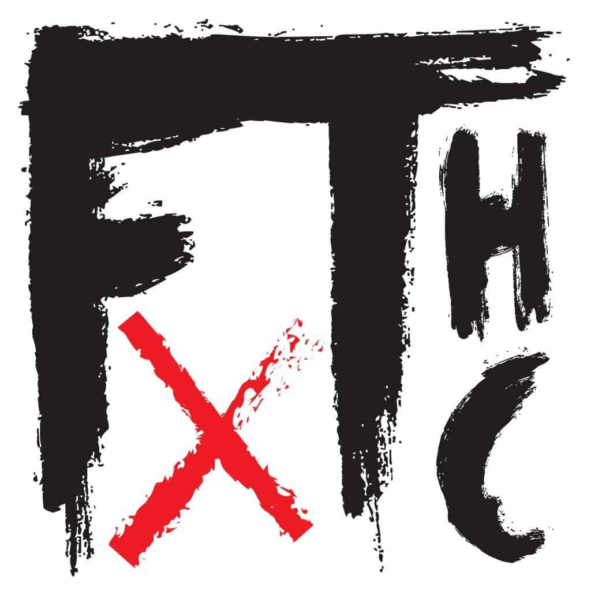

NEW ALBUM ‘FTHC’ TO BE RELEASED ON FEBRUARY 11TH
VIA XTRA MILE RECORDINGS / POLYDOR – PRE-ORDER HERE & WATCH THE ALBUM TRAILER HERE

FRANK TURNER has announced a run of intimate independent record store shows to celebrate the release of his ninth studio album, ‘FTHC’. Released on February 11th via Xtra Mile Recordings / Polydor, ‘FTHC’ is his first album since 2019’s ‘No Man’s Land’. It marks a new chapter in a career that has already spawned four Top 5 albums; nearing an impressive 3000 shows to over 2 million people worldwide and stretching from grassroots venues to Wembley Arena, and the O2.

‘FTHC’ was recorded at ARC – Abbey Recording Studios – just outside of Oxford and produced/mixed by Rich Costey (Foo Fighters, Muse, Biffy Clyro). The album darts between punk, folk, hard rock and singer-songwriter confessionals, starting with the recent single ‘The Gathering’ featuring Jason Isbell and Muse’s Dom Howard. ‘Fatherless’ is particularly revealing as Turner reflects on childhood trauma. ‘A Wave Across A Bay’ is a tribute to his friend, the late Scott Hutchison of Frightened Rabbit. The album ends with a rumination on leaving the capital after 7300 days for a new life on the Essex coast with the bittersweet ‘Farewell To My City’. It’s a mini autobiography rooted in time and place, but one that ultimately accepts that it’s time to move on.

‘FTHC’ is now available to pre-order here on CD, deluxe CD, LP, picture disc and cassette, with signed bundles exclusively available from Frank’s UK store.

Frank Turner’s extensive support of the live music scene during the pandemic saw him play countless livestream benefit shows to raise money and awareness of the importance of small venues all across the country. After raising nearly £300,000 he was recently awarded the Music Venue Trust’s award for Outstanding Achievement for Grassroots Music Venues.

Ticket bundles for Frank’s intimate record store shows are available now via the independent stores direct.

INTIMATE RECORD STORE SHOWS

16th March - Southampton Brook - Vinilo Records
18th March - Bournemouth Old Fire Station - Vinilo Records
19th March - Kingston Pryzm - Banquet Records
21st March - Nottingham Metronome - Rough Trade
12th April - Leeds Wardrobe - Crash Records
13th April - Liverpool Arts Club - Jacaranda Records
14th April - Sheffield Foundry - Bear Tree Records
16th April - Bristol Fleece - Rough Trade

Follow Frank Turner:
Website
Spotify
Apple Music
YouTube
Facebook
Instagram
Twitter

For more information please contact jenny@chuffmedia.com

