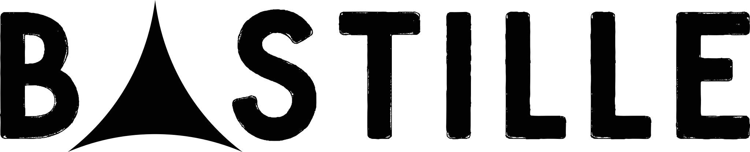

ANNOUNCE INTIMATE INDIE RECORD STORE TOUR
NEW ALBUM ‘GIVE ME THE FUTURE’
OUT 4TH FEB 2022

BASTILLE have announced a run of intimate indie record store sessions to celebrate the release of their hugely anticipated fourth album, Give Me The Future, out 4th February 2022.

The dates, which will see lead singer Dan Smith perform a rare solo stripped back set, are partnered with indie record stores across the UK. Ticket bundles are on sale at 10am Wednesday 8th December via https://Bastille.lnk.to/outstores

Give Me The Future explores both the opportunities of new technology and the dark side of lives lived online, it’s as playful and fun as it is thought-provoking, as dystopian as it is dancefloor-friendly, and as electronic as Bastille have ever been.

The album takes us into a sci-fi wonderland free from restrictions – each song a different danceable dreamscape, a place where you can travel back and forward in time to be anyone, do anything and embrace a new wave of technology which enables us to get lost inside our imagination

The Brit winning four-piece have built their reputation as one of the world’s most captivating live bands. Over the summer the band headlined not one but two UK festivals - Latitude and Standon Calling - and played a further two sold-out shows at Hampton Court Palace Festival. With over 11 million records sold, 6 U.K. Top 40 singles, and 1.5 billion video views, Bastille continue to be one of the world’s most streamed bands.

The run of indie store album shows come ahead of the band’s arena tour, which will give fans the opportunity to hear the new album for the first time fully live. Tickets are on sale now.

Intimate Indie Store Album Shows

Saturday 05 February – Edinburgh Queens Hall – Assai Records
Sunday 06 February – Dundee Fat Sams – Assai Records
Monday 07 February – Preston Blitz – Action Records
Tuesday 08 February – Leeds Wardrobe – Crash Records
Wednesday 09 February – Nottingham The Level – Rough Trade
Friday 11 February – Bristol Marble Factory – Rough Trade
Saturday 12 February – Brighton Chalk – Resident
Sunday 13 February - Southampton The Brook – Vinilo Records
Monday 14 February – Kingston Pryzm – Banquet Records

Give Me The Future Tour 2022 UK dates

Thursday 31 March – Bournemouth International Centre

Friday 01 April – Hull Bonus Arena
Thursday 07 April – London, The O2
Friday 08 April – Manchester, AO Arena
Sunday 10 April – Glasgow, O2 Academy SOLD OUT
Monday 11 April – Glasgow, O2 Academy
Wednesday 13 April – Cardiff, Motorpoint Arena
Thursday 14 April – Birmingham, O2 Academy SOLD OUT
Friday 15 April – Birmingham, O2 Academy SOLD OUT
Sunday 17 April – Plymouth Pavilions
Monday 18 April – Brighton Centre

BASTILLE: INSTAGRAM | TWITTER | WEBSITE

For more information and press enquiries please contact

Jenny Entwistle
Jenny@chuffmedia.com

