RUPERT GAVIN for INCIDENTAL COLMAN PRESENTS

ARTHUR SMITH AND PHIL NICE: “OOF!”

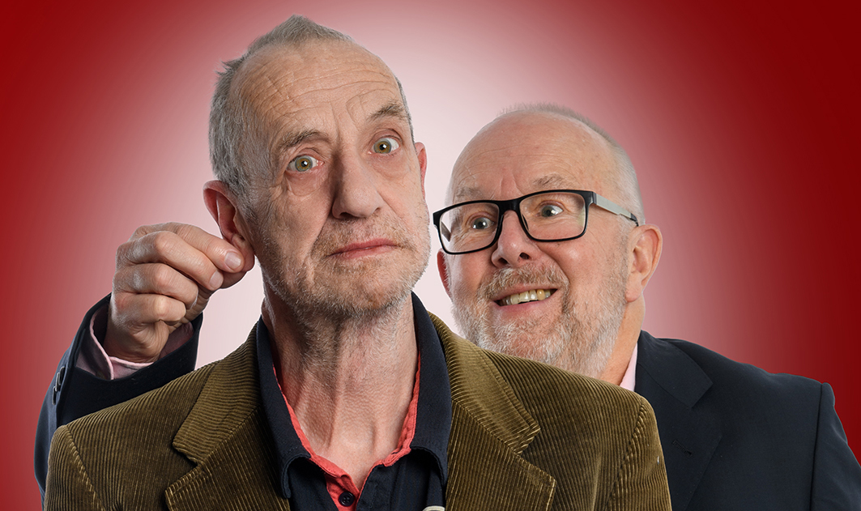

A hilarious double act drama about age, friendship, grief, regret, love and showbiz.

Thursday 3rd – Saturday 5th April 2025
Soho Theatre Downstairs

‘Tear-inducingly tender and disarmingly silly.’ **** Times

‘The more I think about it the more I realise just how bloody clever and moving it is. The fact that it’s also bloody funny just makes it better. Don’t miss it.’ **** Entertainment Now

Following their sold-out performances at the Edinburgh Fringe 2024, this critically acclaimed theatrical gem reunites the legendary Arthur Smith and Phil Nice—marking the fortieth anniversary of their iconic double act, Fiasco Job Job. Now set to take the stage at London’s Soho Theatre, OOF! is a masterful blend of comedy and drama, delivering both hilarity and profound insight into the complexities of human connection."

Set on a solitary bench, two men, weathered by time, reflect on their lives, their friendship, and the world around them. What begins as a playful, bittersweet dialogue soon reveals a deeper, hidden narrative, as old wounds resurface and secrets unfold. With its sharp wit and tender vulnerability, OOF! transcends traditional comedy, delving into themes of grief, love, regret, and the endurance of companionship.

This is no ordinary reunion. It’s a celebration of survival, a toast to decades of showbiz madness, and a reminder that true friendship is always worth the chaos. This limited run of three performances is an unmissable opportunity to witness a one of life’s classic comedic collaborations.
- Arthur Smith: The legendary “Grumpy Old Man,” award-winning comedian, playwright, and author, whose hit shows (An Evening with Gary Lineker, 100 Things I Meant to Tell You) and countless radio appearances (Loose Ends, The Comedy Club) have cemented his place as a national treasure.
- Phil Nice: The versatile actor-comedian beloved for his scene-stealing roles in The Inbetweeners, Hebburn, Citizen Khan, and more. Together with Arthur, he was one-half of the cult comedy duo Fiasco Job Job.
- Directed by Kevin Day: BAFTA-nominated comedy powerhouse and writer for Have I Got News For You, Dave Allen, Jo Brand, and Jon Richardson.
SOHO THEATRE DOWNSTAIRS – DEAN STREET
21 Dean Street, London W1D 3NE
7.15pm, Running time: 60 minutes
Age 16+
Tickets from £25

Box office: 020 7478 0100
Email: tickets@sohotheatre.com
Book online: https://sohotheatre.com/book-online/1230003/

www.arthursmith.co.uk X: @ArfurSmith Facebook: @ArthurSmithComedy

For all media enquiries please contact Warren@chuffmedia.com on 07762 130510

