**ONLY THE POETS**

**SHARE NEW SINGLE ‘MINDSET’**

**LISTEN** [**HERE**](https://onlythepoets.lnk.to/mindset)

**UK TOUR + READING & LEEDS NEXT MONTH**

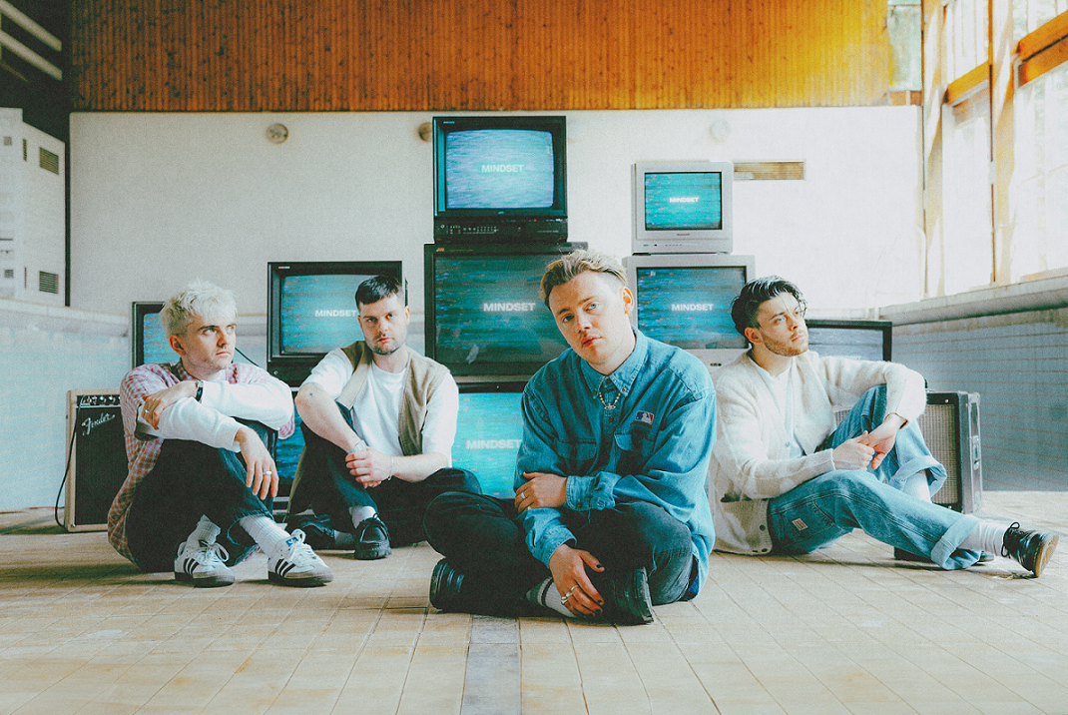

[**HI-RES IMAGE / ARTWORK**](https://umusic.box.com/s/x2e67e4vw7vsr7yt35x26ob0463m2kg7)

*"The soul of Only The Poets is deeply, intimately rooted in empathy above all else****"* – Boys By Girls**

*“The synth-pop styling of these rising stars are unlike anything we are hearing from anyone else at the moment.”* ***–*CLASH**

**Only The Poets** continue their momentum in the alt-pop realm following their international chart success with their ['One More Night'](https://onlythepoets.lnk.to/OMN-EP) EP, releasing new track ‘Mindset’ – Listen [HERE](https://onlythepoets.lnk.to/mindset).

*“I was, lost in my vices / But you changed my mindset / Now my minds set on you,”* yearns frontman Tommy Longhurst over heavy synths and soaring guitars. ‘Mindset’ arrives off the back of a hectic touring schedule which include a string of support slots for **Tom Grennan** and **YUNGBLUD** on dates across Europe, plus they’ll be taking the stage at **Reading & Leeds** festival in August.

Last month saw the four-piece put forward their addictive ‘One More Night’ EP, scoring top 5 placements in Belgium, Austria and the Netherlands plus a top 20 release in Germany. Celebrating the EP’s release, they performed 2 sold out shows at London’s KOKO, and next month will be contunuing their tour across the UK, full dates below and tickets [HERE](https://onlythepoets.os.fan).

*“We’ve taken a lot of our influences from stuff we’re listening to now intertwined with Brit-pop and experimented with vocal layers and harmonies,”* says Tommy on the EP. *“At the back of our minds we’re constantly thinking about how these songs will sound live. We really wanted to go for that big, expansive stadium filler sound.”*

Working on the ‘One More Night’ EP with Mark Ralph (**RAYE**, **Years & Years**) for ‘[Gone By Now](https://onlythepoets.lnk.to/GoneByNow)’ and co-writing alongside The Nocturns (**Tom Grennan**, **Cian Ducrot**) for ‘[All This Time](https://onlythepoets.lnk.to/ATT)’, the EP also includes the self-co-written and produced ‘[I Don’t Wanna Be Your Friend](https://onlythepoets.lnk.to/IDWBYF)’ and the euphoric title track ‘[One More Night](https://onlythepoets.lnk.to/OMN)’.

Only The Poets, comprising of **Tommy** **Longhurst**, bassist **Andy “Roo” Burge**, guitarist **Clem Cherry** and drummer **Marcus Yates,**have established themselves in just a few short years as one of the UK’s biggest emerging live acts. Unsigned until the start of 2023, the band’s DIY ethos saw them build things from the ground up, from playing student house parties, pub circuits and small venues to selling out 1,600-capacity venues in the UK and across Europe last year. Continuously building their fanbase with each release and performance, all signs point to a bright 2024 for the band.

**UK Dates**

Thurs 22 August 2024 – Glasgow, Saint Lukes

Mon 26 Aug 2024 – Manchester, Gorilla

Wed 28 Aug 2024 – Bristol, The Fleece

Thurs 29 Aug 2024 – Southampton, Engine Rooms

**LISTEN TO ‘MINDSET’** [**HERE**](https://onlythepoets.lnk.to/mindset)



**FOLLOW ONLY THE POETS:**

[**OTP**](https://eur02.safelinks.protection.outlook.com/?url=https%3A%2F%2Fonlythepoetsofficial.com%2F&data=05%7C01%7CKaterina.Marka%40umusic.com%7Cb3e4f8db640447edf73808db61c717a7%7Cbbcb6b2f8c7c4e2486e46c36fed00b78%7C1%7C0%7C638211279939469280%7CUnknown%7CTWFpbGZsb3d8eyJWIjoiMC4wLjAwMDAiLCJQIjoiV2luMzIiLCJBTiI6Ik1haWwiLCJXVCI6Mn0%3D%7C3000%7C%7C%7C&sdata=MPuCSsmAm803bkOA2tuWrFTJMCc1AGmOAsyqDVIi3GU%3D&reserved=0)**//**[**INSTA**](https://eur02.safelinks.protection.outlook.com/?url=https%3A%2F%2Fwww.instagram.com%2Fonlythepoets%2F%3Fhl%3Den&data=05%7C01%7CKaterina.Marka%40umusic.com%7Cb3e4f8db640447edf73808db61c717a7%7Cbbcb6b2f8c7c4e2486e46c36fed00b78%7C1%7C0%7C638211279939469280%7CUnknown%7CTWFpbGZsb3d8eyJWIjoiMC4wLjAwMDAiLCJQIjoiV2luMzIiLCJBTiI6Ik1haWwiLCJXVCI6Mn0%3D%7C3000%7C%7C%7C&sdata=68uNHSn8LrUUuQKZDX6NucvWEKpPAAFZi3MP7hTNNE0%3D&reserved=0)**//**[**TWITTER**](https://eur02.safelinks.protection.outlook.com/?url=https%3A%2F%2Ftwitter.com%2Fonlythepoetsuk&data=05%7C01%7CKaterina.Marka%40umusic.com%7Cb3e4f8db640447edf73808db61c717a7%7Cbbcb6b2f8c7c4e2486e46c36fed00b78%7C1%7C0%7C638211279939625508%7CUnknown%7CTWFpbGZsb3d8eyJWIjoiMC4wLjAwMDAiLCJQIjoiV2luMzIiLCJBTiI6Ik1haWwiLCJXVCI6Mn0%3D%7C3000%7C%7C%7C&sdata=UanI1gXEXMcSCxZK6XuqMWCsMkqsSd4WmiMKcT2l5lc%3D&reserved=0)**//**[**FB**](https://eur02.safelinks.protection.outlook.com/?url=https%3A%2F%2Fwww.facebook.com%2Fonlythepoets&data=05%7C01%7CKaterina.Marka%40umusic.com%7Cb3e4f8db640447edf73808db61c717a7%7Cbbcb6b2f8c7c4e2486e46c36fed00b78%7C1%7C0%7C638211279939625508%7CUnknown%7CTWFpbGZsb3d8eyJWIjoiMC4wLjAwMDAiLCJQIjoiV2luMzIiLCJBTiI6Ik1haWwiLCJXVCI6Mn0%3D%7C3000%7C%7C%7C&sdata=zOPbXYxuYGUygw%2FIj66IdyHS%2BH6rxHSxRCcpD4Y2rQc%3D&reserved=0)

**For more information and press enquiries please contact**

**Jenny Entwistle**

[**Jenny@chuffmedia.com**](mailto:Jenny@chuffmedia.com)