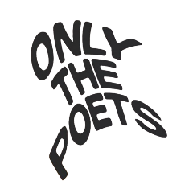
ONLY THE POETS SHARE NEW SINGLE ‘GONE BY NOW’
ANNOUNCE ‘ONE MORE NIGHT’ EP OUT 7TH JUNE
LISTEN HERE / PRE-ORDER HERE
UK TOUR IN JUNE
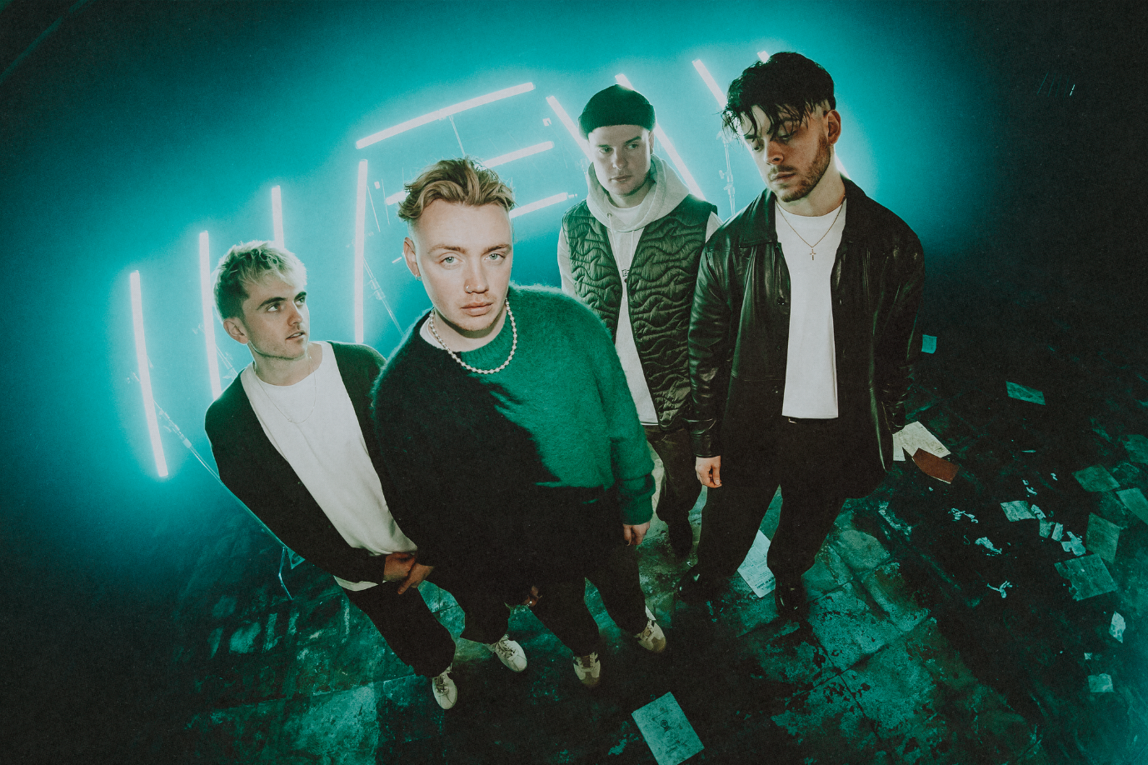
HI-RES IMAGE / ARTWORK
Today, alt-pop four-piece Only The Poets announce their much anticipated, ‘One More Night’ EP out June 7th, plus share fan favourite track, ‘Gone By Now’ – Listen HERE / Pre-Order EP HERE.
Featuring the euphoric ‘One More Night’ plus six new rip-roaring songs, the ‘One More Night’ EP sees the band at their most captivating, consolidating their electrifying synch-pop sound and illuminating the heartfelt emotion in their lyrics.
“We’ve taken a lot of our influences from current pop intertwined with Brit-pop and experimented with vocal layers and harmonies,” says frontman Tommy Longhurst. “At the back of our minds we’re constantly thinking about how these songs will sound live. We really wanted to go for that big, expansive stadium filler sound.”
Currently embarking on a massive 30-date tour across Europe + UK, the band kick off the tour with the release of new single ‘Gone By Now’ – a song that has long been a firm fan favourite. Produced and mixed by Mark Ralph (RAYE, Years & Years), ‘Gone By Now’ soars with pulsating synths and choppy guitars, wrapped around Tommy’s aching vocals.
Travelling from country to country, the new EP was recorded on the road, the band setting up recording equipment and cutting vocals whilst touring “We’re excited that so much of this EP was done just the four of us, and a lot of the production was done by Marcus (drums) and Clem (guitar). Feeling inspired and recording whilst playing shows was a cool way of working, we’d not done that before.”
Only The Poets, comprising of Tommy Longhurst, bassist Andy “Roo” Burge, guitarist Clem Cherry and drummer Marcus Yates, have established themselves in just a few short years as one of the UK’s biggest emerging live acts. Unsigned until the start of 2023, the band’s DIY ethos saw them build things from the ground up, from playing student house parties, pub circuits and small venues to selling out 1,600-capacity venues in the UK and across Europe last year.
2024 has already seen the band kick off a massive run of 22 European shows taking in venues across the continent including Milan, Krakow, Berlin, Prague, Oslo and Krakow, ending in Lille on the 11th April. The band embark on a UK tour in June - full list of dates below.

UK Tour dates
Wed 5 June 2024 – London, KOKO
Fri 7 June 2024 – Birmingham, O2 Academy 2
Sat 8 June 2024 – Oxford, O2 Academy 2
Mon 10 June 2024 – Glasgow, Saint Lukes
Tues 11 June 2024 – Manchester, Gorilla
Wed 12 June 2024 – Bristol, Thekla
Thurs 13 June 2024 – Southampton, Engine Rooms

PRE-ORDER THE ‘ONE MORE NIGHT’ EP HERE
ONE MORE NIGHT EP TRACKLIST
Digital EP:
One More Night
Gone By Now
I Don't Wanna Be Your Friend (explicit)
All This Time
It's Okay (Not to Be Okay)
Change
One More Night (alt version)
One More Night (live version)

Physical EP:
One More Night
Gone By Now
I Don't Wanna Be Your Friend (explicit)
All This Time
It's Okay (Not to Be Okay)
Change
Black and Blue (demo)
One More Night (alt version)
One More Night (live version)

‘One More Night’ EU Tour 2024
Sun 24 Mar 2024 – Frankfurt, Zoom
Mon 25 Mar 2024 – Prague, MEETFACTORY
Tue 26 Mar 2024 – Munich, Technikum
Wed 27 Mar 2024 – Strasbourg, La Laiterie (Club)
Fri 29 Mar 2024 - Heerlen, Nieuwe Nor SOLD OUT
Mon 1 Apr 2024 – Copenhagen, DR Koncerthuset, Studio 2
Wed 3 Apr 2024 – Stockholm, Fryshuset (Klubben)
Thu 4 Apr 2024 - Oslo, Vulkan Arena
Sat 6 Apr 2024 - Hamburg, Gruenspan SOLD OUT
Mon 8 Apr 2024 – Leipzig, Taubchenthal
Tue 9 Apr 2024 - Cologne, Kantine SOLD OUT
Wed 9 April - Cologne, Kantine
Thu 11 Apr 2024 – Lille, The Black Lab

FOLLOW ONLY THE POETS: OTP // INSTA // TWITTER // FB
For more information and press enquiries please contact
Jenny Entwistle
Jenny@chuffmedia.com

