ONLY THE POETS SHARE NEW SINGLE ‘EVERY GOD I PRAY TO’
LISTEN HERE / WATCH HERE
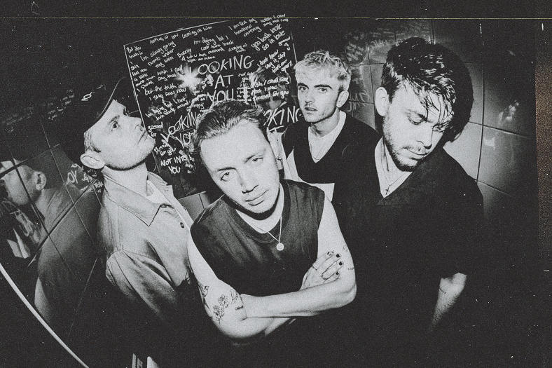
FOLLOWS ANNOUNCEMENT OF A 22-DATE EU TOUR IN 2024
“Their respect and appreciation for their fans feels genuine, and it’s never more apparent than when they share the room together” – CLASH
Today, alt-pop four-piece Only The Poets share new single ‘Every God I Pray To’. A highlight in their live set, they often perform this intimate track acoustically from within the audience, elevating the connection felt between the band and fans.
Frontman Tommy Longhurst says, “‘Every God I Pray To’ is about the breakup of a once seemingly perfect relationship, and the struggle that entails when having to come to terms with it. No matter how hard you try, and wherever you search to find that solace, you’re always led back to missing that person. The song was written in 2 hours before soundcheck on the Lewis Capaldi tour. It felt right to keep it stripped back to just vocal and keys, just as it was written. All year we’ve been playing it unplugged in the middle of the venue. It’s one my favourite moments of the set, there’s nowhere to hide singing in the middle of the room!”

Having played a huge sold-out EU tour in spring earlier this year which culminated in a triumphant sold-out slot at Shepherd’s Bush Empire, Only The Poets announced a small ‘Homecoming’ UK tour, taking in Glasgow, Newcastle, Leeds, Manchester, Bristol and London – all dates sold out.
The Reading four-piece, comprising Tommy Longhurst, bassist Andy “Roo” Burge, guitarist Clem Cherry and drummer Marcus Yates, have established themselves in just a few short years as one of the UK’s biggest emerging live acts. Unsigned until recently, the band’s DIY ethos saw them build things from the ground up, from playing student house parties, pub circuits and small venues to selling out 1,600-capacity venues in the UK and across Europe last year.
Last month the band celebrated the release of ‘Looking At You’ by playing the track at a student house party in Reading, in celebration of their early roots as a band. Single Crash fuses propulsive drums and driving guitar with an undercurrent of synth-pop elements and has seen huge support from the likes of Radio 1 including a recent Maida Vale session. Whilst previous track Jump is a rousing call to arms set to widescreen, galloping riffs, blending sparkling indie-pop and the everyman swagger of Bruce Springsteen and Sam Fender.

See ‘One More Night’ EU Tour 2024
Tue 6 Feb 2024 – Paris, Le Trabendo
Wed 7 Feb 2024 – Antwerp, Trix
Thu 8 Feb 2024 - Utrecht, TivoliVredenburg – Ronda
Fri 9 Feb 2024 – Luxembourg, Den Atelier
Sun 11 Feb 2024 – Hannover, Capitol
Mon 12 Feb 2024 – Stuttgart, Im Wizemann Club
Tue 13 Feb 2024 – Zurich, Dynamo
Thu 15 Feb 2024 – Milan, Santeria Toscana 31
Fri 16 Feb 2024 - Vienna, Flex
Sun 18 Feb 2024 – Kraków, Klub Studio
Mon 19 Feb 2024 – Poznan, TAMA
Tue 20 Feb 2024 – Berlin, Kesselhaus
Sun 24 Mar 2024 – Frankfurt, Zoom
Mon 25 Mar 2024 – Prague, MEETFACTORY
Tue 26 Mar 2024 – Munich, Technikum
Wed 27 Mar 2024 – Strasbourg, La Laiterie (Club)
Fri 29 Mar 2024 - Heerlen, Nieuwe Nor
Mon 1 Apr 2024 – Copenhagen, DR Koncerthuset, Studio 2
Wed 3 Apr 2024 – Stockholm, Fryshuset (Klubben)
Thu 4 Apr 2024 - Oslo, Vulkan Arena
Sat 6 Apr 2024 - Hamburg, Gruenspan
Mon 8 Apr 2024 – Leipzig, Taubchenthal
Tue 9 Apr 2024 - Cologne, Kantine
Wed 9 April - Cologne, Kantine
Thu 11 Apr 2024 – Lille, The Black Lab
OTP // INSTA // TWITTER // FB

For more information and press enquiries please contact

Jenny Entwistle
Jenny@chuffmedia.com

