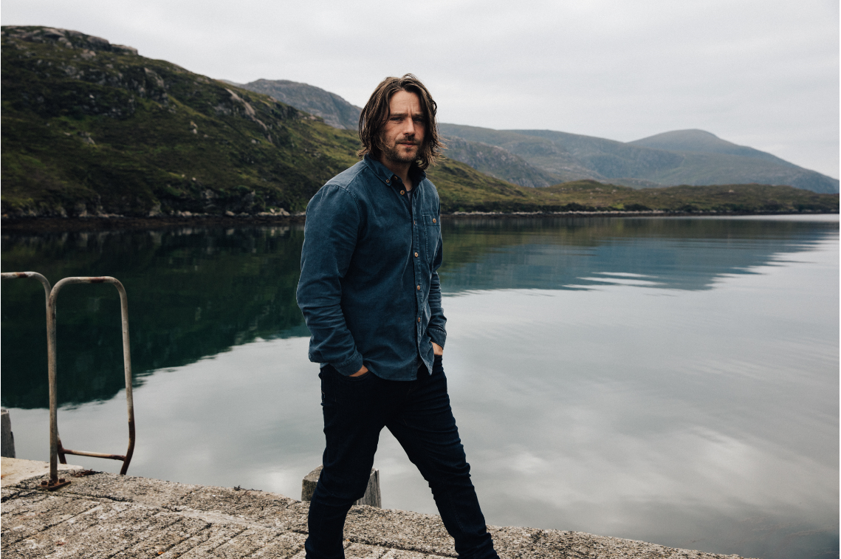

Colin Macleod: New album Hold Fast out 18th June 2021 featuring Sheryl Crow

Meet Colin Macleod: Resident of the Isle of Lewis in the remote Outer Hebrides in Scotland.

He keeps traditional farming and fishing techniques alive, owns 40 sheep between him and his father, surfs, and only leaves the island occasionally to hang out with Bruce Springsteen, tour with Robert Plant and Sheryl Crow, or perform on James Corden’s Late Late Show.
- Colin Macleod is a Scottish singer-songwriter, crofter ( old, traditional, sustainable form of farming), Gillie (form of fishing), and surfer – this is no hipster affectation, it is passed down through his family.
- He has toured across the world including supporting Robert Plant and performing on The Late Late Show in the U.S with James Corden.
- His new album Hold Fast out in June features two duets with Sheryl Crow who he has previously supported on various tours and has now become friends with.
- The album title ‘Hold Fast’ is the motto of the literal Clan Macleod from which he belongs.
- It is full of earthy, huge Americana sounding tracks, as well as softer introspective acoustic folk songs, and string laden love letters.
- His incredible dual lifestyle between the music business and traditional island life will be the subject of an episode of Ben Fogle’s new TV series out later this year (Macleod reached out to Fogle via social media who instantly wanted him in the show, and they’ve now struck up a friendship).
- This month he also presents two features on ‘Landward’, a BBC Scotland weekly production looking at farming and countryside issues.

Performance on Late Late Show with James Corden

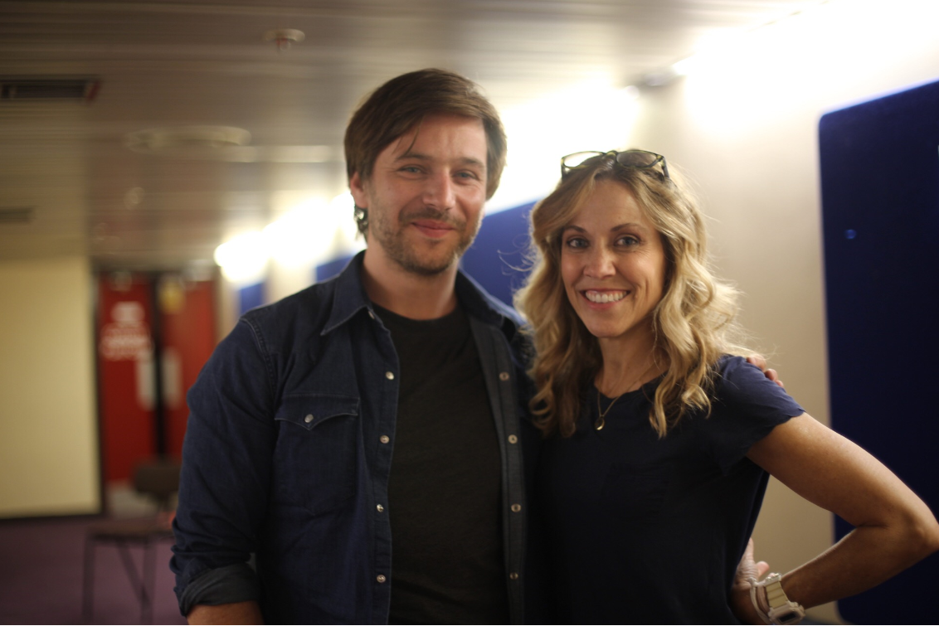
Colin with Sheryl Crow on tour

Official website
Spotify
Apple Music
YouTube
Instagram
Facebook
Twitter

For all media enquiries contact warren@chuffmedia.com on 07762 130510

